A generalized tool for deriving connectomes in support of computational neuroscience

By

David Mattie

Submitted in partial fulfillment of the

requirements for the degree of

Masters of Science in Computer Science

at

Saint Francis Xavier University

Antigonish, Nova Scotia

May 2019

© Copyright by David Mattie, 2019

Saint Francis Xavier University

Department of

Mathematics, Statistics and Computer Science

The undersigned hereby certify that they have read a thesis entitled “A Generalized Tool for Deriving Connectomes in Support of Computational Neuroscience” by David Mattie in partial fulfillment of the requirements for the degree of Masters of Science in Computer Science.

Dated:

Supervisor:

Dr. Jacob Levman

Second Reader:

Dr. TBD

St. Francis Xavier University

May 2019

Author: David Mattie

Title: A Generalized Tool for Deriving Connectomes in Support of Computational Neuroscience

Department: Mathematics, Statistics and Computer Science

Faculty: Science

Convocation: May 2019

Permission is herewith granted to Saint Francis Xavier University to circulate and to have copied for non-commercial purposes, at its direction, the above title upon request of individuals or institutions.

David Mattie

The author reserves other publication rights, and neither the thesis nor extensive extractions from it may be printed or otherwise reproduced without the author's written permission.

The Author attests that permissions has been obtained for the use any copyrighted material appearing in this thesis (other then of brief excerpts requiring only proper acknowledgement in scholarly writing) and that all such use is clearly acknowledged.

to Dad

Abstract

This research establishes a framework in which to perform connectomic measurements of 927,472 data points across 182 major brain regions. A user shell was developed to derive these connectomes and provides mechanisms to report on and analyze the calculated data of interest. Large scale univariate statistical analyses were performed to assess characteristics of the connectomic biomarkers extracted and machine learning models were constructed demonstrating their application in computational neuroscience through pattern discovery. The tool supports the extraction of data for multiple use cases, and provides mechanisms to integrate per patient data into the results. To demonstrate analysis capabilities, the software developed assesses the largest effect sizes between gender/sex in each of the measures and the biomarkers most correlated with patient age (and thus may act as measures of neural maturation). Findings have identified regional neural pathways with diffusion characteristics that may be indicative of pruning based fiber tract maturation.

Acknowledgements

I would like to express my gratitude to my advisor Dr. Jacob Levman PhD, for giving me the opportunity for this thesis. His sharing of knowledge across many facets of the material has been helpful and encouraging. I would also like to thank Dr. James Hughes for his knowledge of machine learning and data mining. Finally, Dr. Iker Gondra for his broad experience with image parcellation and artificial intelligence.

Contents

Introduction 1

Hyopthesis 2

Relevance 2

Tractography 2

Current technology landscape 4

Technology Roadmap 7

Current Landscape of Connectomics 8

Machine Learning Applications 10

Technology Landscape 11

Preliminary Discussion and Results 12

Implementation 13

Technology and Tools 13

CRUSH 13

User Interface 14

Measurement Extraction Pipeline 16

System Architecture 20

Data 21

Patient Data 21

Capture Hardware 21

Measurement Data 22

Extraction 23

SQL Access 24

Demonstration of Analysis 24

Summary Statistics 24

Effect Size 24

Mean FA 25

Findings 25

Mean ADC 26

Number of Tracts 28

Lines to Render 30

Tracts to Render 32

Standard Deviation ADC 34

Mean Standard Deviation FA 36

Mean FA – Asymmetry Index 39

Mean ADC – Asymmetry Index 40

Number of Tracts – Asymmetry Index 42

Lines to Render – Asymmetry Index 44

Tracts to Render – Asymmetry Index 46

Standard Deviation ADC – Asymmetry Index 48

Mean Standard Deviation FA – Asymmetry Index 49

Correlation 50

Brain-Stem to wm-lh-insua 51

ctx-lh-precentral to wm-lh-precentral 51

ctx-rh-precentral to wm-rh-precentral 52

Brain-Stem to ctx-lh-superiorfrontal 53

Brain-Stem to wm-lh-superiorfrontal 54

Brain-Stem to Left-VentralDC 55

Left-VentralDC to wm-lh-insula 56

Brain-Stem to wm-lh-precentral 57

Left-VentralDC to wm-lh-precentral 58

Brain-Stem to Right-Pallidum 59

ctx-lh-rostralmiddlefrontal to wm-lh-rostralmiddlefrontal 60

Left-Thalamus-Proper to Brain-Stem 61

ctx-lh-postcentral to wm-lh-postcentral 62

Right-Putamen to wm-rh-insula 63

Machine Learning 64

Conclusion 65

Insights from the data 65

Reliability 66

Challenges and Issues Encountered 68

Resource Limitations 68

CEDAR 70

GRAHAM 71

Alienware 71

Dell Precision Tower (40 core) 72

Disk Contention 72

Proposed Enhancements 73

Improved Parallelism on Data Recall 73

REDIS 73

Improved Fault Detection 74

Add Pre-Pipeline Phase 74

Service based execution on commodity hardware 75

Final Remarks 75

Appendix 1 76

crush.py 76

Patient.py 80

Visit.py 81

segmentMap.txt 104

# Introduction

The structure of the human brain is extraordinarily complicated, in part because of how interconnected neurons extend between brain regions. Patterns of neural development and neuronal migration make the assessment of fiber tracts in the developing brain particularly challenging. Studying the structure and synaptic connections within the brain has been in practice since the 1970s, however it has only recently become possible to acquire and process the unprecedented quantity of data and measurements produced at a macro level in the brains of real-world clinical patients. Analysis of the entire connectome (a representation of the physical connections apparent in a patient's brain) clinically is within reach as computational power, acquisition technologies and storage capabilities mature.

In recent years, there have been dozens of tools developed to extract measures from magnetic resonance imaging (MRI) data, such as FSL and TrackVis for conducting functional MRI (fMRI), MRI, diffusion tensor imaging (DTI), and fiber tract analyses. While diverse in functionality, these tools tend to be focused on specific functional capabilities, such as eddy_correct, a tool for correcting eddy currents from diffusion data. When combined with other tools to form a workflow pipeline, it becomes possible to achieve complex renderings of imaging data that may play a key role in improving our understanding of healthy brain development, abnormal brain development, to measure the brain's physical connections, and to potentially create the next generation of diagnostic technologies used clinically, which in turn can contribute to improving the standard of patient care.

This research leverages existing tools while implementing novel pipelines to accomplish two objectives: First, provide the capability to conduct a cartesian product fiber tract analysis among a wide range of regions of interest (ROIs). Second, to provide a mechanism for conducting an efficient extract of inter-ROI measurements from all sample data. This tool enables future research into understanding relationships among brain regions, the degree of connectivity associated with any two region pairs, and determining any possible correlation with physiological conditions such as gender, age. Eventually this work will be extended to the analysis of a variety of pathological disorders such as autism, multiple sclerosis, or any other conditions potentially related to fiber tract development.

## Hypothesis

It is possible to derive thousands of measures such as fiber tractography statistics, fractional anisotropy and apparent diffusion coefficient across an exhaustive list of fiber tracts connecting brain region pairs to support the neuroscientific analysis of brain development and towards the establishment of the next generation of diagnostic and disease characterization technologies.

## Relevance

### Tractography

Tractography is the only tool we have today that allows us to noninvasively model fiber tracts and their development exhaustively throughout the brain [4]. Tractography imaging has demonstrated itself to have considerable potential in neuroscientific analyses [5] [13] [6], however, tractography has yet to become a gold standard imaging technique relied upon clinically for the management of any given medical condition.

Although current tractography methods do not track axons directly (fiber tracking is based on inferring the tract's presence based on neighboring voxel diffusion profiles) and have varying accuracy by technique, there is clear potential value from mapping fiber bundles towards better understanding the structural organization of the brain [3] [8]. These analytic technologies can allow neuroscientists to test hypotheses, such as whether the autistic exhibit abnormally reduced or increased fiber tract connectivity between key brain regions relative to neurotypical controls. Until recently, this analysis could not previously have been accomplished in a living human, and only very recently has the emergence of clinical data of sufficient quality become available for mapping out fiber tract development as part of the delivery of patient care.

Common approaches to tractography involve tracking fiber tracts based on adjacent water diffusion profiles with the least angular deviations between voxels. This voxel-based imaging method is typically performed within a single volume that measures a few cubic millimeters. The MRI machines used for this research have a resolution of a 1 mm3 per voxel. There can be approximately 50,000 neurons in a cubic millimeter (Braitenberg, 1998), each establishing approximately 6000 synapses. Effectively, there are 300 million connections per cubic millimeter. The scale disparity between our cubic millimeter macro-scale voxel based measurements and the number of axons involved in the MRI signals acquired results in assumptions and approximations being made when researchers correlate structural connectivity and function.

Previous research has validated these assumptions by demonstrating reasonable agreement among structural, functional, and microanatomy fiber tracking results (Sotiropoulos, et al., 2013). This research suggests that a simple model of direct anatomical connectivity between regions of interest in the brain can be capable of explaining much of the observed correlations in neural activity[17], however, traditional diffusion tensor imaging based analyses have also been reported to be unreliable[9][4]. Unfortunately, there is no ability to detect the presence of synapses or to determine whether a pathway is functional when relying on diffusion MRI. False positives and negatives are inevitable given the spatial resolution, especially in regions of heavy fiber crossing or structural complexity [5].

#### Current technology landscape

There are a number of technologies actively used to perform tractography. There are currently three categories of automated tract segmentation:

* ROI based approaches use information from a common atlas space that is registered to the subject in order to perform ROI extraction. Streamlines can then be altered according to their spatial relation to the ROI using white matter atlases [15].
* Clustering-based segmentation groups streamline into spatially coherent clusters. These clusters are then either manually or automatically assigned to anatomically meaningful fiber tracts[3].
* Direct segmentation attempts to improve the efficiency and simplicity of tract segmentation by producing complete tract segmentation from the input images. While novel, the quality currently achieved by these approaches has been limited until recently. TractSeg has produced very accurate and efficient results using a Convolutional Neural Network to directly segment white matter tracts[16].

Each method approaches the problem differently, and so comparisons are challenging, however, an efficient way to assess segmentation performance is to use a Dice Score[13] as shown in Figure 1.1 . While it may make sense to choose the technology with the highest Dice Score and move on, there are advantages and disadvantages to each.

dicescore

Figure 1 Dice Score using Human Connectome Project Data

**TRACULA**

TRActs Constrained by Underlying Anatomy (TRACULA) uses probabilistic tracking and a predefined atlas of the underlying anatomy to segment tracts. This tool offers the opportunity to automatically reconstruct white matter bundles without requiring expert manual parcellation. This is valuable for its ability to derive white matter segments that deviate from standard atlases. For example, patients with brain injury such as hippocampal sclerosis where differences between the injured brain and healthy tract tissue characteristics can be studied[6]. Notably, TRACULA provides the weakest Dice Score of comparable tractography technologies. The weaknesses could stem from the probabilistic approach to parcellation.

**TractQuerier**

TractQuerier provides a White Matter Query Language

(WMQL) designed to extract tracts based on where streamlines start, end, and pass through. This method makes it possible to anatomically label white matter anatomy across patients. A key differentiator of this technology is found in its ability to textually

label anatomical structures that have not been catalogued. This is different from other

common approaches to automatic extraction of white matter tracts because it does not

rely on fixed sets of anatomical definitions [15].

**WhiteMatterAnalysis (WMA)**

WhiteMatterAnalysis clusters streamlines across subjects and generates a cluster atlas. Clusters are assigned to anatomical tracts manually, and future anatomical tract delineation is made by registering new subjects to the atlas. A pre-trained cluster atlas is provided by the tool, however there is only a small number of tracts (10) within the atlas. There are two weaknesses in this tool: The low tract count (and significant manual effort required to expand the atlas), as well as the computational resources required to identify new clusters [8].

**RecoBundles**

RecoBundles can be used to find streamlines in a subject based on tracts from a strong anatomical reference subject. One of the objectives of this tool is to reduce the number of invalid streamlines and white matter bundles to defend against biases in tracometry [1] analysis [3]. RecoBundles is useful for detecting deformed and interrupted bundles going through or around tumor areas due to its ability to adapt to sharp changes or incomplete data. RecoBundles uses supervised machine learning, and relies on a reliable bundle model as input to detect relevant bundles.

**Atlas Registration**

Fractional Anisotropy maps of several subjects can be averaged to an atlas to produce a probability map in which to base future subject segmentation. The pipeline steps needed to produce this atlas is complex, computationally intensive, and tedious to tune, however, it will produce a strong result if skilled anatomists are relied upon for quality checking to avoid propagation of subtle errors[16].

**Multi-Mask**

An alternative approach to atlas registration is to register the masks of single training subjects to a test subject instead of against an averaged atlas. This can reduce the blurring of details to some extent. While this may improve the blurring effect that can occur when registering to an atlas based on group averages, the complexity and tuning required to achieve a reliable outcome still requires a complex pipeline and care in the application of the technique[16].

**TractSeg**

TractSeg is the newest and most promising technology depicted in Figure 1. TractSeg has been used to provide complete and accurate segmentations using fully convolutional neural networks to directly segment white matter tracts (only). Not only is this method efficient, it is also less affected by the reduction in resolution seen in ROI and clustering based analyses[16]. This software deliberately avoids gray matter.

#### Technology Roadmap

While today's tractography methods are continually developing, they hold enormous potential value to neuroscience, even though we are still unable to directly identify and measure axon connections within the brain. This lack of fidelity certainly does not mean fiber tract discovery should be abandoned, rather it is expected to improve with ever-evolving techniques. As techniques improve, the data collected will play an important role in the assessment of neurological pathways and their development in the brain.

The fundamental weaknesses in today's technology lies in both the processing time required to uncover individual patient fiber tracts, the resolution and accuracy of those tracts and a lack of gold-standard connectomics analytic techniques to extract, process and analyze the many neural fiber tracts detectable in a patient imaged with MRI. As the neuroscience community works to achieve these goals, we are seeing novel approaches to image parcellation as advances using machine-learning (ML) techniques mature into this field. An important dynamic with regards to ML approaches lies in the ability to reduce the complexity of tractography pipelines. It is possible the strength of ML algorithms' ability to process and model diffusion data may one day result in performance levels that negate our need for a traditional tractographic-processing pipeline, possibly through future deep-learning architectures.

Tractography techniques may mature to the point where reliable and efficient performance can be obtained at high-resolution. Ideally, neuroscientists can simply run a computational program to retrieve a data rich array of tracts in which to interrogate for possible abnormalities associated with a pathology under investigation. This could not only involve a reduction of complexity of tractography, but could also enhance interoperability of solutions, improves flexibility, and provides a foundation in which to implement new uses of tractographic data. At some point, it may be possible to consolidate solutions that exist globally into a single library of computer programs, depending on the requirement. As solutions continue to evolve, a shared library or specific computer program will hopefully benefit the research community by encapsulating the internal complexity of the brain.

#### Current Landscape of Connectomics

**Human Connectome Project**

The Human Connectome Project's (HCP) stated goal is to build a “network map" that will shed light on the anatomical and functional connectivity within the heathy human brain, as well as produce a body of data that will facilitate research into brain disorders such as dyslexia, autism, Alzheimer's Disease, and schizophrenia [14] [12]. This is a 5-year project sponsored by sixteen components of the National Institutes of Health, and split into two consortia of research institutes. This consortium aims to characterize human brain connectivity and function in a population of 1200 healthy adults and to enable detailed comparison between brain circuits, behavior, and genetics at the level of individual subjects. The imaging data acquired for this project include four data modalities and is being made open access.

* rfMRI, resting state functional magnetic resonance imaging
* tfMRI, task-based functional magnetic resonance imaging
* dMRI, diffusion magnetic resonance imaging, and
* sMRI, structural magnetic resonance imaging

This data can be used with standard fiber reconstruction techniques to map individual

tractograms from patient samples. For example, probabilistic tractography has been applied to some of these datasets using FSL's existing probabilistic tractography approaches to generated connectomes[11].

**Thousand Functional Connectome Project**

There are a number of projects carrying out large scale brain MRI mapping on different populations, though none with the same aspirations as the Human Connectome

Project. The Thousand Functional Connectome project has published their dataset after gathering rfMRI images of 1,414 volunteers demonstrating a universal architecture of positive and negative functional connections [1]. The Alzheimer's Disease Neuroimaging

Initiative was initiated with the aim of advancing Alzheimer's Disease research with the distinct goals of studying each phase of the condition’s development. Depending on the sub-study, there are between 600 and 2000 participant samples that have been imaged. In comparison, the HCP is unique in terms of the diversity of imaging modalities and the richness of the behavioral and genetic information being collected.

**Clinical**

Since 2007, Boston Children's Hospital (BCH) has been collecting high angular resolution diffusion data clinically with a consistent set of 3 Tesla MRI magnets. This data provides a unique opportunity to investigate the potential for studying the use of connectomics technologies in the context of what can be accomplished with clinical data. Existing connectomics projects target healthy brain development (as in the

Human Connectome Project) or Alzheimer's Disease (as in the Thousand Functional Connectome project), however, clinical data provides unique opportunities for further analysis. Clinical data has been acquired at BCH for patients with a wide variety of medical conditions, including autism, attention-deficit hyperactivity disorder, cerebral palsy, multiple sclerosis etc. as well as including imaging of neurotypical patients. Thus, creating connectomics technologies that can be applied to real-world BCH data will facilitate the investigation of possible fiber tract-based structural abnormalities associated

with a variety of medical conditions and may represent a key component playing a role

in the next generation of diagnostic clinical technologies.

### Machine Learning Applications

Machine learning (ML) is a branch of artificial intelligence based on the idea that systems can learn from data by identifying patterns, making classifications, predictions, and ultimately making decisions about the data with minimal human involvement. ML solutions are typically organized into two categories: supervised and unsupervised learning.

The core objective of a ML algorithm is to generalize from data (learn) a model that can be reapplied to future data. Applications are wide reaching, especially in data rich research fields such as neuroscience or bioinformatics in general.

There are a number of ways in which machine learning can be leveraged from a neuroscience perspective. With respect tractography, TractSeg (previously discussed) has shown exciting promise both with speed of execution and accuracy. TractSeg uses a form of supervised machine learning called neural networks to uncover fiber bundles and tracts in the brain[16]. Machine Learning has been leveraged to diagnose Parkinson's disease based on supervised learning to detect sensitive biomarkers based on MR images[10].

#### Technology Landscape

There are currently two approaches to understanding the axonal connections found within the human brain. Anatomical studies (such as dissection or diffusion tensor imaging) and electrostimulation mapping investigations are used to map subcortical pathways as a way to model the human brain. Understanding this axonal connectivity is crucial to build models of cognition, behavior, and even consciousness[2]. Once connectomes are produced, it is the study of the data that is most valuable. This research is based on the theory that connectomic data can drive innovation, find opportunities for detection and diagnosis and provide insights into healthy brain development as well as developmental disorders.

There are a number of problems with the current state of related technology. Reliability, computational requirements and utility of the resultant technologies are a reflection of the broad and diverse expectations of neuroscience as we seek to learn new methods to improve accuracy and consistency of the known fiber tracts within the human brain.

This research seeks to provide a connectome reporting user shell that offers a layer of abstraction from a number of technologies employed in biomarker extraction, including MRI scanners, data processing techniques and brain atlases. The goal of this work is to provide the framework for a computational interface in which data can be quickly extracted and manipulated in data science tools such as Matlab, R, Python, and SPSS regardless of the state of evolution of underlying tractography techniques and connectomic data available. This research goal also involves the development of connectomic processing and analysis software tools that work on real-world clinical data from BCH.

### Preliminary Discussion and Results

In January 2018, research upon which this thesis is based [7] illustrated the investigative potential of performing connectomics style analysis and demonstrated the feasibility of creating novel pipelines that use current technologies to perform regionally focused clinical connectivity studies targeting the insula’s relationship with the rest of the brain. This research encouraged future functionality whereby clinical analysis of other major neural fiber tracts throughout the brain could become possible. This capability, when executed at scale would enable analysis across hundreds or thousands of patient samples as we seek to understand correlations and patterns among ROIs in the entire connectome. This will provide a mechanism to discover insights, make predictions, and ultimately may create new diagnostic and disease characterization technologies for patients with autism, attention deficit hyperactivity disorder, cerebral palsy and more.

# Implementation

## Technology and Tools

This research establishes a plug-in framework for implementing connectomics based computation pipelines. Depending on the pipeline implemented, dependencies on other neuroscience technology may exist such as FSL(Smith, 2004), Freesurfer (Fischl, 2012), and TrackVis (Wedeen, 2008). The pipeline demonstrated in this research extends Levman’s insula focused research to derive an exhaustive connectome between 182 regions of interest.

### CRUSH

Connectome Reporting User SHell is a console based command line utility, developed in Python3. The solution combines and integrates utilities from multiple freely available tools in order to orchestrate a data processing pipeline designed to collect a combined structural (T1) and high angular resolution diffusion imaging (HARDI) analysis of all major neural fiber tracts throughout the brain.

Python was chosen for its flexibility to interoperate at the OS level, and its wide developer adoption. The software was developed on Linux Mint 19 (Tara) using a Dell XPS13. Production code has been tested and executed on Ubuntu 18.04 standalone OS as well as Ubuntu 18.04 deployed via the Windows 10 Linux Subsystem. The ComputeCanada superclusters GRAHAM and CEDAR running CentoOS7 were also used for production execution.

The data processing pipeline used builds upon that developed for a previous study by Levman [###]. CRUSH is designed to be recoverable, and can the detect current state of pipeline execution. The command-line is relatively simple, leaving no command-line difference between an untouched set of T1 images and a partially processed set of patient data.

The extraction pipeline results in over 900,000 measurements (per patient MRI examination) in two passes (the first pass computes a variety of tractography statistics localized to specific pathways and the second pass calculates hemispheric asymmetry indeces), and stores those metrics for future recall.

CRUSH was applied against a large dataset of TI images spanning multiple patients and patient visits. The folder structure containing patient data is required to adhere to the standard outlined below:

.

├── PatientID

│   └── VisitID

│   ├── Freesurfer

│   │   ├── …

│   │   ├── mri

│   │   ├── …

│   ├── Tractography

│   │   ├── …

Figure 2 - Required directory hierarchy

Each visit has two mandatory directories for the T1 and DTI data. These directories are Freesurfer/mri and Tractography. CRUSH will ignore any directories that exist but don’t appear to be relevant. The user is expected to pass the root directory containing all patient samples as a required parameter.

#### User Interface

CRUSH has a command line interface intended for batch processing and scheduling. On current hardware using a 32-core CPU with 64GB of RAM and SSD drives, a single patient renders fully in approximately 8 hours if Trackvis logging is disabled, so the expectation is this tool will traditionally be executed and left alone to process the patient data.

**Command Line:**

usage: crush.py [-h] [-samples SAMPLES] [-status] [-recon] [-norender]

[-rebuild] [-patient PATIENT] [-voi VOI] [-recrush]

[-fixmissing] [-report] [-columnar] [-metadata METADATA]

[-maxcores MAXCORES] [-disable_log]

Connectomics and Reporting User Shell is used to iterrogate samples, generate

or extract measurements.

optional arguments:

-h, --help show this help message and exit

-samples SAMPLES Path to patient samples

-status Report back what is out there and what needs to be done

-recon Apply recon-all for any T1.mgz found beneath working

folder

-norender If there are incomplete connectomes, ignore the

outstanding work

-rebuild Recreate any intermediary files used for establishing

measurements. If this not specified, any intermetiate

files found with the appriate file name will be left

untouched.

-patient PATIENT Specify patient ID of interest if focusing on a single

patient

-voi VOI Values of Interest - Path to text file that lists values

of interest to extract. One column per line. Look at any

patient sample tractography\crush\tracts.txt file for

measures.

-recrush Ignore anything previosly crushed and re-extract tract

information

-fixmissing Ignore anything previosly crushed and extract only tract

information that has not been rendered yet

-report Extract a row-based table for analysis, 1 row per

measure

-columnar Extract a column-based table for analysis, 1 row per

patient

-metadata METADATA Path to metadata file about patient. The metadata file

should have the CSV format Patient,Visit,Attr1..AttrN

-maxcores MAXCORES Maximum number of cores to use while deriving

measurements. Use this if you want to leave a little CPU

room left for other processing. By default, all cores

will be used (36 cores on this machine).

-disable_log If specified, disable track_vis.log

Figure 3 - *crush* command line parameters

The tool is capable of processing all patients without specifying each patient to render (-patient switch), however given the heavy processing required, it has been helpful to split patient data into work packages across multiple nodes. For example, render all patients from 0100-0199 on a specific node or cluster. A basic bash script can accomplish this as seen below.

#!/bin/bash

PREFIX=""

for i in {621..629}

do

printf -v patientID "%04d" $i

echo "echo processing $patientID"

python3 ~/projects/crush/crush.py -maxcores 24 -samples \

~/projects/todo -patient ${patientID} \

-fixmissing -disable_log >~/projects/logs/${patientID}.log

done

Figure 4 - Sample bash script to invoke *crush*

## Measurement Extraction Pipeline

Figure 5 - Processing Pipeline

The measurement extraction pipeline demonstrated in this research is a novel approach to expanding the previously developed regionally focused analytic procedure (Levman, 2017). The sequence depicted in Figure 5 outlines the steps taken to derive tensor fiber tracts using a combination of FSL, FreeSurfer, and TrackVis command line tools.

Figure 6 - Processing Pipeline

CRUSH iterates a patient sample directory looking for opportunities to execute its pipeline. When a viable sample is detected, the pipeline is executed with the final goal of 100% measurement extraction.

Each ROI was assessed against every other ROI for the existence of fiber tracts. If a tract was not found, null measurements were stored. If a tract existed, the following aggregate measurement information was extracted and stored: [TODO] For each metric, include StdDev, avg, range – maybe a boxplot once data is complete

* Mean fractional anisotropy (FA) – a measure of diffusion directionality.
* Mean apparent diffusion coefficient (ADC) – a measure related to overall diffusion
* Number of tracts – a measure of the total number of fiber tracts found in the patient’s brain.
* Standard Deviation of Fractional Anisotropy – a measure of the variance of FA exhibited within the tract
* Standard Deviation of Apparent Diffusion Coefficient – a measure of the variance of ADC exhibited within the tract
* Number of Tracts to Render – the number of fiber tracts detected between two regions of interest
* Lines to Render – the number of strokes necessary to visually represent the tract

It is possible to extract specific ROI data if only specific ROIs or specific measurements are required. For example, of only the measurements **mean ADC between ROI 4018 and ROI 4035**, and **mean FA between ROI 0254 and ROI 2002** were required for patients, the –voi switch can be used to narrow the processing time. This switch requires a file to be passed specifying exactly which ROIs and measurements are sought. The file might look like Figure 3, in which case only those specific measures in those ROIs will be derived.

4018-4035-roi-stddevADC

0254-2002-roi-meanFA

Figure 7 - Sample voi file

Once a viable input sample is detected, the images were converted to Nifti format and then corrected for eddy currents and patient movement.

HARDI reconstruction was performed to create whole brain tract pathways by processing the diffusion MRI data in its native input space. ODF data is reconstructed and then fiber tracking is performed to produce a track file usable by TrackVis.

During the final TrackVis stage, regions of interest to be processed are defined in the segmentMap.csv file. This file is typically not expected to be changed, and represents the atlas numbers [TODO I need an origin of these numbers – it’s not color lut]. The TrackVis stage performs a cartesian product of all regions of interest (a 3D volume of interest represented as an ROI) and all TrackVis methods (roi and roi_end), resulting in approximately 65000 intesection points (180 ROIs x 180 ROIs x 2 methods). Each intersection point has 14 measurable values.

Figure 8 demonstrates a derived fiber tract (teal) between the left side insula (blue) and the left side lingual (pink) regions. This tract is measurable in each of the metrics described above. While this does not represent direct axonal connections, the diffusion of hydrogen throughout the streamline suggests directionality of diffusion, size of the tract, and diffusivity.

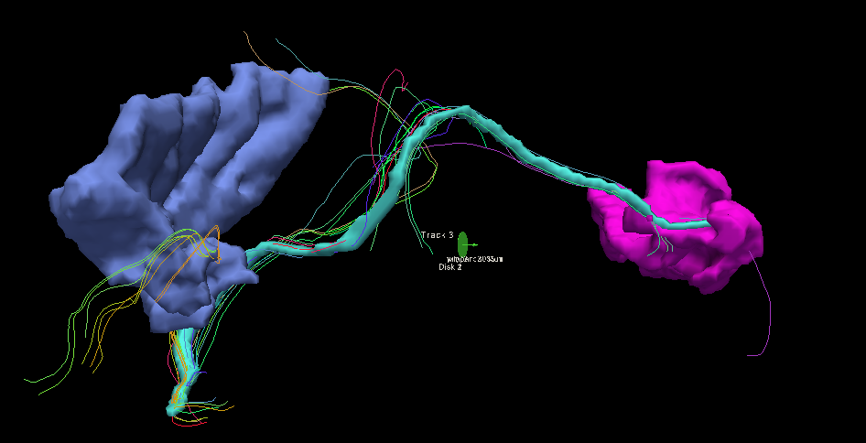

Figure 8 An example fiber tract connecting the left side insula t the left side lingual for a single patient

For each intersection computed, track_vis produced a text output that was parsed for measurements using regular expressions.

Number of tracks: 2454806

Number of tracks to render: 0

Number of line segments to render: 0

Mean track length: 0.00 +/- 0.00 mm

Volume dimension: 256 256 256

Voxel size: 1.000 1.000 1.000

There is a reliance on this text output being consistent within future versions of TrackVis. Due to the potential for version upgrades used by the rendering pipeline, CRUSH evaluates the version of utilities integrated in the pipeline and warns if the version of the utility is different than what was used for testing. This is intended to warn the user in the event the search terms used during regular expression evaluation need to be updated.

## System Architecture

Ent Arch

## Data

A clinical imaging database at Boston Children’s Hospital provided imaging data for 642 examinations that included 30 directional DTI with 5 b0 fields from patients retrospectively assessed as healthy (Levman, 2017). This dataset was subject to exclusions based on examinations with a high degree of motion or low quality images, external artifacts (such as metal dental work), samples without a useful T1 structured MRI volume, and unhealthy patients as assessed by BCH.

### Patient Data

All patients were between the age of 0.7 years and 23.5 years

[TODO Distribution histogram,gender by age]

### Capture Hardware

The clinical T1 imaging approach used in this study has been previously presented by (Levman et al., 2018) and was carried forward for this thesis so it could be extended beyond the focus of the insula. Aparticipants were imaged with clinical 3 Tesla MRI scanners (Skyra, Siemens Medical Systems, Erlangen, Germany) at Boston Children’s Hospital yielding T1 structural volumetric images accessed through the Children’s Research and Integration System (Pienaar *et al.*, 2014). Any samples with substantial motion artifacts or failure during FreeSurfer processing were previously removed.

The previous analysis (Levman, 2018) ncluded Diffusion MRI data acquired using diffusion-weighted spin-echo echo-planar imaging. Thirty diffusion-weighted measurements (b = 1,000 sec/mm2) and five non-diffusion-weighted measurements (b= 0 sec/mm2) were acquired with TR= 10 sec; TE= 88 msec; δ= 12.0 msec; Δ= 24.2 msec; field of view= 22 x 22 cm; matrix size= 128 x 128, iPAT= 2, spatial resolution 1.72 x 1.72 mm.

### Measurement Data

A new *crush* directory was produced beneath the Tractography directory during processing. This directory contains a single tracts.txt file representing each measurement derived during the pipeline processing for the specific sample. The first few lines of the tracts.txt file is shown in Figure 9. This data set was structured in the form of name-value pairs to ease future retrieval, and enable an individual measurement to be recalled with basic unix command line tools (awk,sed, or grep).

0013-3010-roi-LinesToRender=18645

2013-2015-roi_end-MeanTractLen=0

4018-4035-roi-stddevADC=0.00017615198858183018

0254-2002-roi-meanFA=0.3647475153452198

0049-2027-roi-LinesToRender=78612

2021-4015-roi-TractsToRender=786

0008-3028-roi_end-MeanTractLen=0

0046-0050-roi-meanADC=0.0007841976048825862

0062-1035-roi-LinesToRender=0

3029-5002-roi_end-VoxelSizeZ=1.000

…

Figure 9 - Sample tracts.txt file

Individual ROI-to-ROI-method files exist in .json format to support restartability or alternate methods of retrieval in future applications. The files are stored according to the beginning ROI. For example, to view all data relevent to the intersection of ROI 0013 and ROI END 3010 using the **roi** track_vis method, the file Tractography\crush\0013\calcs-0013-3010-roi.json may contain data similar to Figure 6.

{

"levman\0013-3010-roi-TractsToRender": "38",

"levman\0013-3010-roi-VoxelSizeX": "1.000",

"levman\0013-3010-roi-stddevADC": 0.00015906886621198937,

"levman\0013-3010-roi-stddevFA": 0.22448023841440762,

"levman\0013-3010-roi-NumTracts": "2454806",

"levman\0013-3010-roi-meanADC": 0.0007865246391972348,

"levman\0013-3010-roi-LinesToRender": "18645",

"levman\0013-3010-roi-VoxelSizeY": "1.000",

"levman\0013-3010-roi-meanFA": 0.4930457186118099,

"levman\0013-3010-roi-MeanTractLen": 0,

"levman\0013-3010-roi-MeanTractLen_StdDev": 0,

"levman\0013-3010-roi-VoxelSizeZ": "1.000"

}

Figure 10 Sample data file: calcs-0013-3010-roi.json

#### Extraction

A second phase of processing is provided by CRUSH to add computed measures and support a reconstitution of all patient data. CRUSH provides a command line parameter to extract all patient data to a single output file. It can do this in two ways, depending on the shape of the output desired. A columnar *–columnar* switch can be passed on the command line to extract output with one row representing a patient visit, and all measurements represented as columns. This is useful for scenarios such as PANDAS data manipulation in Python. There are over 900,000 columns produced in this format. The individual measurements as well as their computed left-right asymmetry indeces are returned. Traditional tools used for analysis (MATLAB, R, Tableau, etc.) did not perform well with a data set of this width.

If the *–report* switch is passed instead of the *–columnar* switch, all patient data is returned with one row representing a specific intersection of ROIs using one track_vis method (*–roi* or *–roiend*). E.g. ROI starting at 0254, ending at 2002 using the *–roi* method. The columns on that row represent all measurements retrieved for that intersection (shown in Figure 6 Sample data file: calcs-0013-3010-roi.json ) along with the left-right asymmetry indeces for each measure. This data format would be the equivalent of a “tall” table in MATLAB.

#### SQL Access

To make this data set more accessible, ETL using Microsoft SSIS was written to load the data into a MS SQL server database. Performance of data set manipulation can be significantly improved by offloading set manipulation to the SQL server database, leaving more memory and CPU resources available on the client. In fact, the most responsible and nimble access to data was best obtained when using Tableau with data loaded into an indexed table in SQL Server.

# Demonstration of Analysis

## Summary Statistics

### Effect Size based on differences between means

The mean difference between male and female patients for each of the derived measures were calculated, and those measures where more than 90% of patients with data were sorted by greatest effect size (+/-) when comparing across gender.

Effect size was calculated as:

$$∅=\frac{μ1-μ2}{σ}$$

Where µ1 is the mean of the male measure, and µ2 is the mean of the female measure, and $σ$ represents the standard deviation of the measure in both populations.

Those ROIs with the largest Effect Size are listed as well as corresponding visualizations for the top 10 with the strongest effect between genders. A large negative effect indicates females have a higher measured value. A large positive effect indicates males have a higher measured value.

Several of the figures below reflect on changes over life stages. The following table depicts the life stages and corresponding age ranges used. The high range of the age is excluded. For example, 0-5 years indicates birth to less than five years of age.

Table 1 - Life stages

|  |  |  |  |  |
| --- | --- | --- | --- | --- |
| Early childhood | Late childhood | Early adolescence | Late adolescence | Early adulthood |
| 0-5 years | 5-10 years | 10-15 years | 15-20 years | 20+ years |

#### Mean FA

Table 2 - Largest effect size for gender when measuring meanFA

|  |  |  |  |  |
| --- | --- | --- | --- | --- |
| ROI Start | ROI End | Method | Effect Size | Non Null Measures |
| wm-lh-medialorbitofrontal | wm-lh-middletemporal | roi | -0.495404461 | 522 |
| ctx-lh-medialorbitofrontal | wm-lh-middletemporal | roi | -0.489322398 | 496 |
| ctx-lh-rostralmiddlefrontal | wm-lh-middletemporal | roi | -0.396594776 | 498 |
| ctx-lh-medialorbitofrontal | wm-lh-insula | roi | -0.380086251 | 538 |
| wm-lh-bankssts | wm-lh-inferiortemporal | roi_end | -0.378921068 | 502 |
| ctx-lh-medialorbitofrontal | ctx-rh-frontalpole | roi_end | -0.377164213 | 483 |
| ctx-lh-medialorbitofrontal | ctx-lh-insula | roi | -0.374796717 | 536 |
| Left-Pallidum | wm-lh-caudalmiddlefrontal | roi | -0.365712411 | 485 |
| wm-lh-lateraloccipital | wm-lh-superiorparietal | roi | -0.365698044 | 540 |
| Right-Cerebellum-Cortex | wm-rh-lingual | roi_end | 0.361609121 | 533 |
| Left-Thalamus-Proper | Left-choroid-plexus | roi | -0.360246042 | 536 |
| Left-Putamen | wm-lh-middletemporal | roi | -0.360079159 | 536 |
| ctx-lh-lateraloccipital | ctx-lh-superiortemporal | roi | -0.359731432 | 493 |
| ctx-rh-cuneus | wm-rh-lateraloccipital | roi | -0.359013949 | 540 |
| ctx-rh-superiorfrontal | wm-lh-insula | roi | -0.358117323 | 475 |
| ctx-lh-medialorbitofrontal | wm-lh-superiortemporal | roi | -0.357126656 | 526 |

#### **Findings**

In most cases, greater fractional anisotropy in girls was shown to be higher where gender differences existed. Girls demonstrated the greatest difference near the left side medial orbito frontal region, and boys demonstrated greater FA in the right cerebellum. These differences may suggest girls have a lower degree of fiber crossing in these regions (which typically lowers FA), which may contribute to the higher directionality of diffusion observed between most of the regions summarized above.

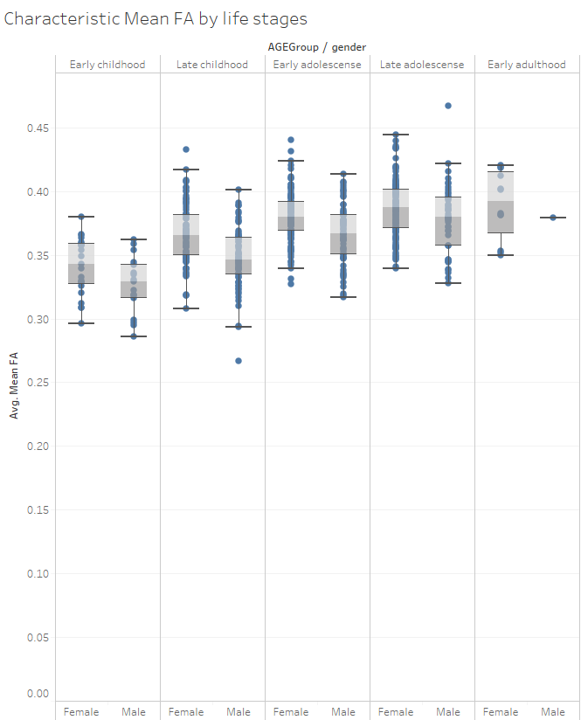

Figure 11 - Mean FA for each gender for top 16 effect sizes, breakdown by life stage

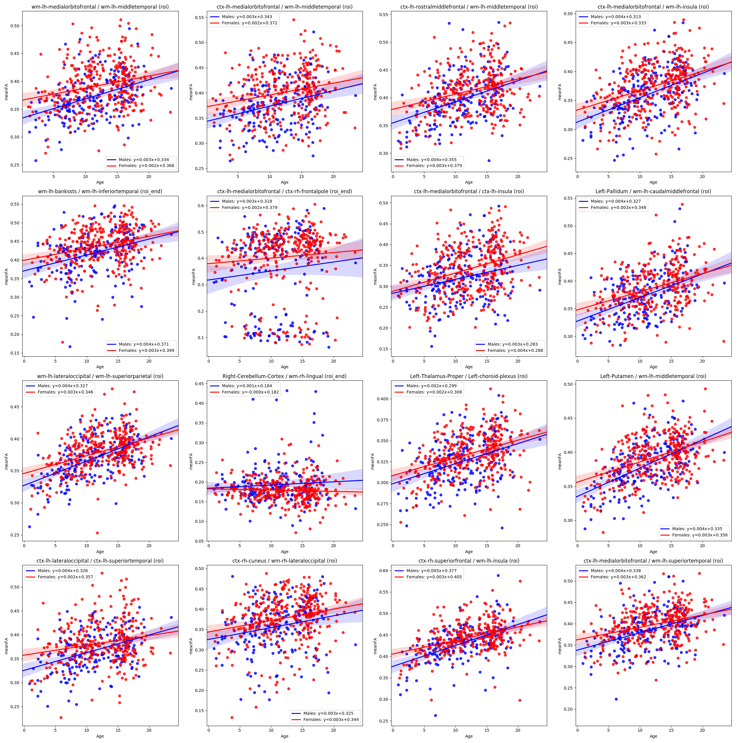

Figure 12 - Mean FA effect size per measure

#### **Mean ADC**

Table 3 - Largest effect size for gender when measuring meanADC

|  |  |  |  |  |
| --- | --- | --- | --- | --- |
| ROI Start | ROI End | Method | Effect Size | Non Null Measures |
| ctx-lh-insula | wm-lh-lateraloccipital | roi_end | 0.419007 | 461 |
| ctx-lh-medialorbitofrontal | ctx-lh-insula | roi | 0.414062 | 536 |
| ctx-lh-posteriorcingulate | wm-lh-rostralanteriorcingulate | roi | 0.410492 | 490 |
| wm-lh-lateraloccipital | wm-lh-superiortemporal | roi_end | 0.409295 | 526 |
| wm-lh-superiorparietal | wm-lh-superiortemporal | roi_end | 0.398237 | 470 |
| wm-lh-caudalmiddlefrontal | wm-rh-caudalanteriorcingulate | roi | 0.379981 | 510 |
| ctx-lh-middletemporal | wm-lh-inferiortemporal | roi | 0.362646 | 540 |
| ctx-lh-middletemporal | ctx-lh-temporalpole | roi | 0.360192 | 539 |
| ctx-lh-caudalanteriorcingulate | wm-lh-rostralanteriorcingulate | roi_end | 0.360015 | 514 |
| ctx-lh-lateraloccipital | ctx-lh-insula | roi | 0.358643 | 517 |
| wm-lh-fusiform | wm-lh-superiortemporal | roi_end | 0.358269 | 512 |
| ctx-lh-lateraloccipital | ctx-lh-superiortemporal | roi | 0.357273 | 493 |
| ctx-lh-middletemporal | wm-lh-fusiform | roi | 0.35638 | 539 |
| wm-lh-caudalanteriorcingulate | wm-lh-caudalmiddlefrontal | roi | 0.356376 | 509 |
| wm-rh-bankssts | wm-rh-inferiortemporal | roi_end | 0.356179 | 468 |
| ctx-lh-caudalanteriorcingulate | ctx-lh-precuneus | roi_end | 0.354776 | 463 |

##### **Findings**

ADC is highly uniform, with a very low standard deviation. Males have higher ADC than females 85% of the time for those cases where more than 90% of patients had measureable values at the selected tract.

There appears to be differences among each of the three stages of life found within the data, showing a lower impedance of water molecules in childhood years, a greater range of ADC in adolescent years, and a higher impedance of water molecules in adulthood.

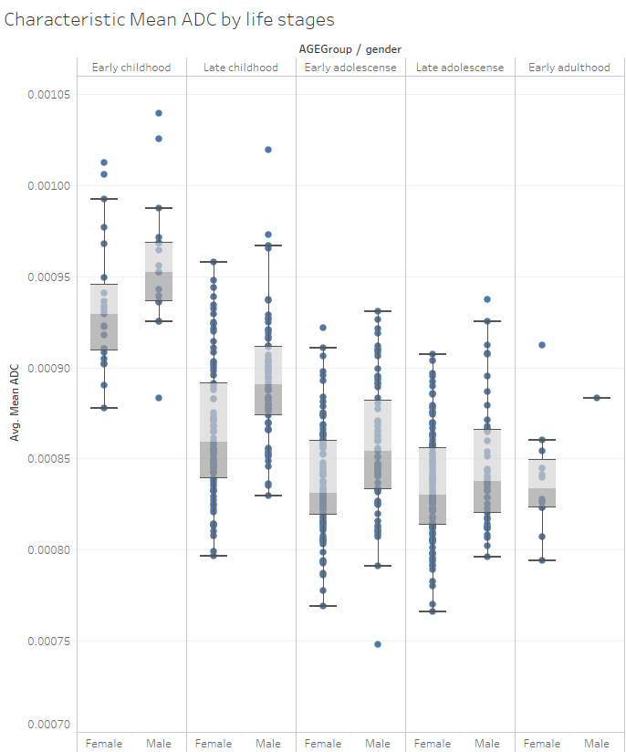

Figure 13 - Mean ADC for each gender for top 16 effect sizes, breakdown by life stage

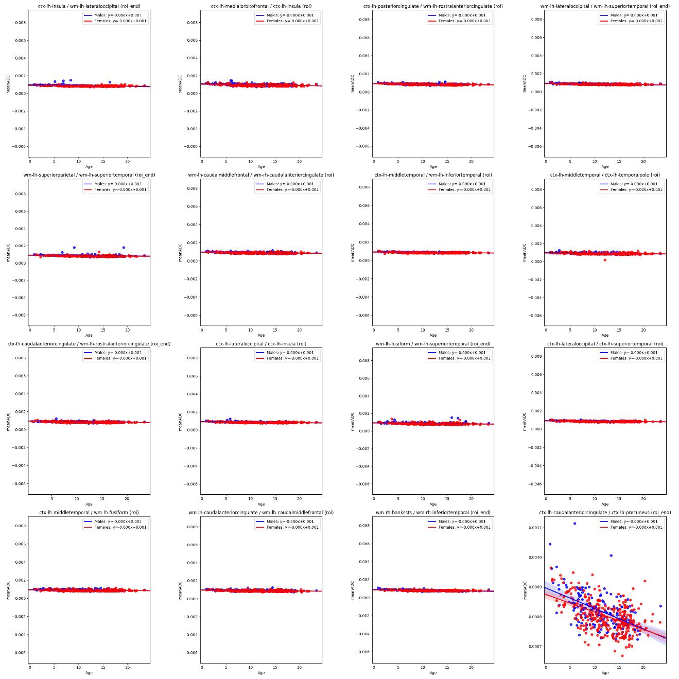

Figure 14 - Mean ADC effect size per measure

#### **Number of Tracts**

Table 4 - Largest effect size for gender when measuring NumTracts

|  |  |  |  |  |
| --- | --- | --- | --- | --- |
| ROI Start | ROI End | Method | Effect Size | Non Null Measures |
| Left-Cerebellum-White-Matter | Right-Cerebellum-White-Matter | roi_end | 0.508891479 | 539 |
| Left-Cerebellum-White-Matter | ctx-rh-supramarginal | roi_end | 0.508775929 | 539 |
| Left-Cerebellum-Cortex | ctx-lh-precentral | roi | 0.508737178 | 538 |
| Left-Cerebellum-Cortex | Brain-Stem | roi_end | 0.508737178 | 538 |
| Left-Inf-Lat-Vent | wm-rh-insula | roi_end | 0.508696777 | 539 |
| Right-Lateral-Ventricle | wm-rh-rostralmiddlefrontal | roi_end | 0.508397105 | 540 |
| Right-Cerebral-White-Matter | wm-rh-supramarginal | roi_end | 0.508397105 | 540 |
| Right-Hippocampus | ctx-lh-rostralmiddlefrontal | roi | 0.508397105 | 540 |
| CSF | wm-lh-postcentral | roi_end | 0.507291136 | 538 |
| ctx-lh-lingual | ctx-rh-parsopercularis | roi | 0.507144047 | 541 |
| ctx-rh-bankssts | wm-lh-superiorparietal | roi | 0.507144047 | 541 |
| CC_Central | ctx-rh-lingual | roi | 0.507144047 | 541 |
| ctx-lh-superiortemporal | wm-rh-superiorparietal | roi | 0.507144047 | 541 |
| ctx-lh-superiorfrontal | ctx-rh-medialorbitofrontal | roi_end | 0.507144047 | 541 |
| ctx-lh-fusiform | ctx-rh-temporalpole | roi | 0.507144047 | 541 |
| Right-Thalamus-Proper | wm-lh-rostralanteriorcingulate | roi_end | 0.507144047 | 541 |

##### **Findings**

Number of Tracts represents the overall total number of fiber tracts within the patient brain. Males appear to have more tracts than females at the same life stage, with average effect size of 0.25, and 37% of tracts demonstrating effect size over 0.5.

For all patient scans, there was evidence of increasing tract count at each progressive life stage, with the widest variability in the early adolescent stage.

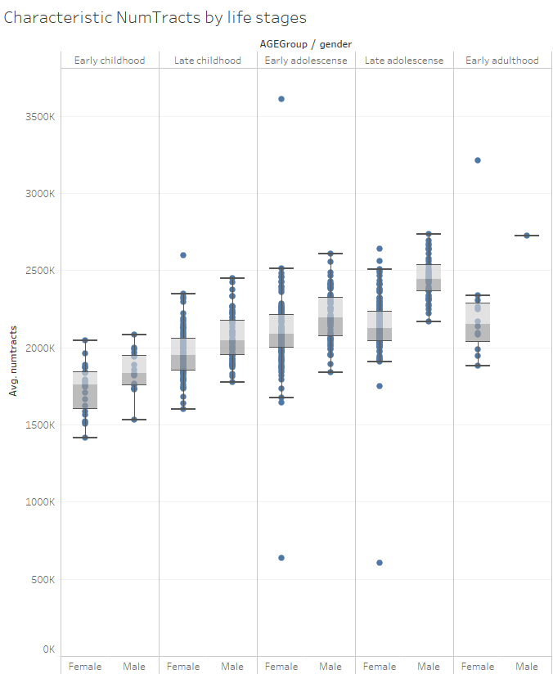

Figure 16 - Average of NumTracts for each gender for top 16 effect sizes, breakdown by life stage

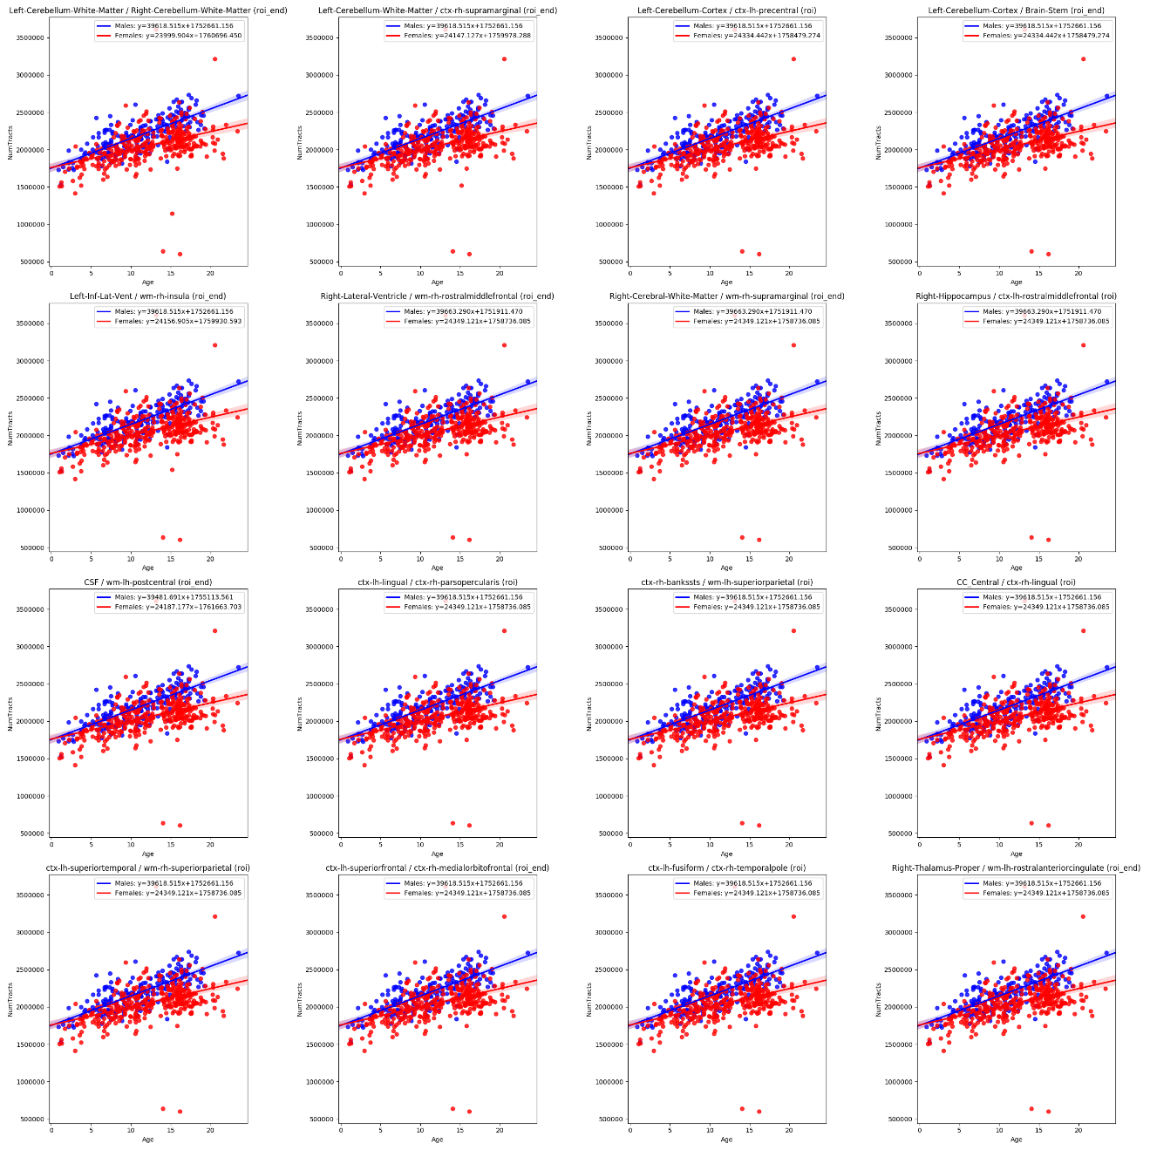

Figure 17 - NumTracts effect size per measure

#### **Lines to Render**

Table 5 - Largest effect size for gender when measuring LinesToRender

|  |  |  |  |  |
| --- | --- | --- | --- | --- |
| ROI Start | ROI End | Method | Effect Size | Non Null Measures |
| ctx-lh-precuneus | wm-lh-precuneus | roi_end | 0.585531706 | 541 |
| ctx-rh-cuneus | wm-rh-cuneus | roi_end | 0.573041338 | 541 |
| ctx-lh-superiortemporal | wm-lh-superiortemporal | roi_end | 0.572969309 | 541 |
| ctx-lh-superiorfrontal | wm-lh-superiorfrontal | roi_end | 0.56520813 | 541 |
| ctx-lh-supramarginal | wm-lh-supramarginal | roi | 0.533573546 | 541 |
| ctx-lh-lateraloccipital | wm-lh-lateraloccipital | roi_end | 0.529840633 | 541 |
| ctx-lh-supramarginal | wm-lh-superiortemporal | roi | 0.522189475 | 541 |
| ctx-lh-superiortemporal | ctx-lh-supramarginal | roi | 0.512758259 | 541 |
| wm-lh-inferiortemporal | wm-lh-parahippocampal | roi | 0.503050846 | 540 |
| ctx-rh-inferiortemporal | wm-rh-inferiortemporal | roi_end | 0.48999139 | 541 |
| ctx-lh-superiortemporal | wm-lh-superiortemporal | roi | 0.488430623 | 541 |
| ctx-lh-lingual | wm-lh-lingual | roi_end | 0.488001314 | 541 |
| ctx-lh-middletemporal | wm-lh-middletemporal | roi | 0.479631377 | 541 |
| ctx-rh-pericalcarine | wm-rh-cuneus | roi_end | 0.477232169 | 541 |
| ctx-rh-caudalanteriorcingulate | wm-rh-rostralanteriorcingulate | roi | 0.469183176 | 542 |
| ctx-rh-isthmuscingulate | wm-rh-isthmuscingulate | roi_end | 0.465403963 | 541 |

##### Findings

This is a 3D image rendering measure representing the glyphs or strokes used to draw the fiber tract visually. This measure will vary with more twists and turns, tract length and total number of tracts. This measure is included to support future assessment.

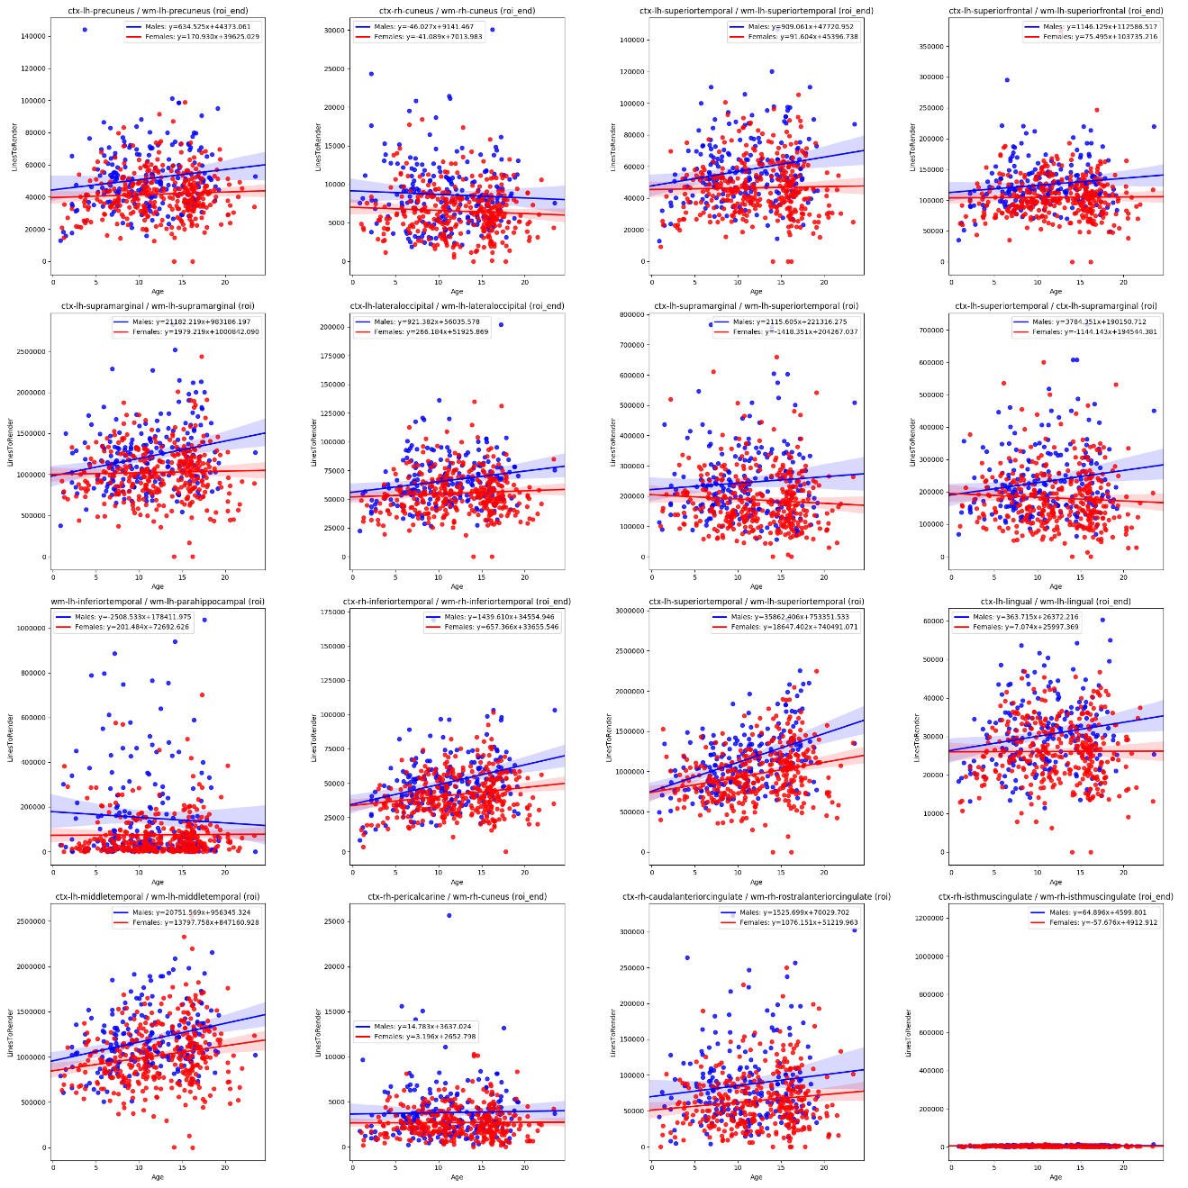

Figure 18 - Lines to Render effect size per measure

#### **Tracts to Render**

Table 6 - Largest effect size for gender when measuring TractToRender

|  |  |  |  |  |
| --- | --- | --- | --- | --- |
| ROI Start | ROI End | Method | Effect Size | Non Null Measures |
| ctx-lh-superiorfrontal | wm-lh-superiorfrontal | roi_end | 0.673362 | 541 |
| ctx-rh-fusiform | wm-rh-fusiform | roi_end | 0.644881 | 541 |
| ctx-lh-precuneus | wm-lh-precuneus | roi_end | 0.625481 | 541 |
| ctx-lh-superiortemporal | wm-lh-superiortemporal | roi | 0.624466 | 541 |
| ctx-lh-lateraloccipital | wm-lh-lateraloccipital | roi_end | 0.587301 | 541 |
| ctx-lh-parstriangularis | wm-lh-parstriangularis | roi | 0.579324 | 541 |
| ctx-lh-supramarginal | wm-lh-supramarginal | roi | 0.577071 | 541 |
| ctx-rh-fusiform | ctx-rh-inferiortemporal | roi | 0.575552 | 541 |
| ctx-lh-supramarginal | wm-lh-superiortemporal | roi | 0.572275 | 541 |
| ctx-rh-lateraloccipital | wm-rh-lateraloccipital | roi | 0.568799 | 541 |
| ctx-rh-superiorparietal | wm-rh-superiorparietal | roi | 0.567187 | 542 |
| ctx-lh-rostralmiddlefrontal | wm-lh-rostralmiddlefrontal | roi | 0.562876 | 541 |
| ctx-rh-precuneus | wm-rh-precuneus | roi | 0.554215 | 542 |
| ctx-lh-middletemporal | wm-lh-middletemporal | roi | 0.553279 | 541 |
| ctx-rh-fusiform | wm-rh-fusiform | roi | 0.54742 | 541 |
| ctx-rh-superiorfrontal | wm-rh-superiorfrontal | roi | 0.538995 | 541 |

##### **Findings**

White matter volume appears to increase faster in boys than in girls consistently across each of the measure shown in Figure 11. The largest increase in volume in boys appears in the left superior frontal, right fusiform, and left superior temporal. Girls showed more growth in the left accumbens area and left lingual gyrus (not shown).

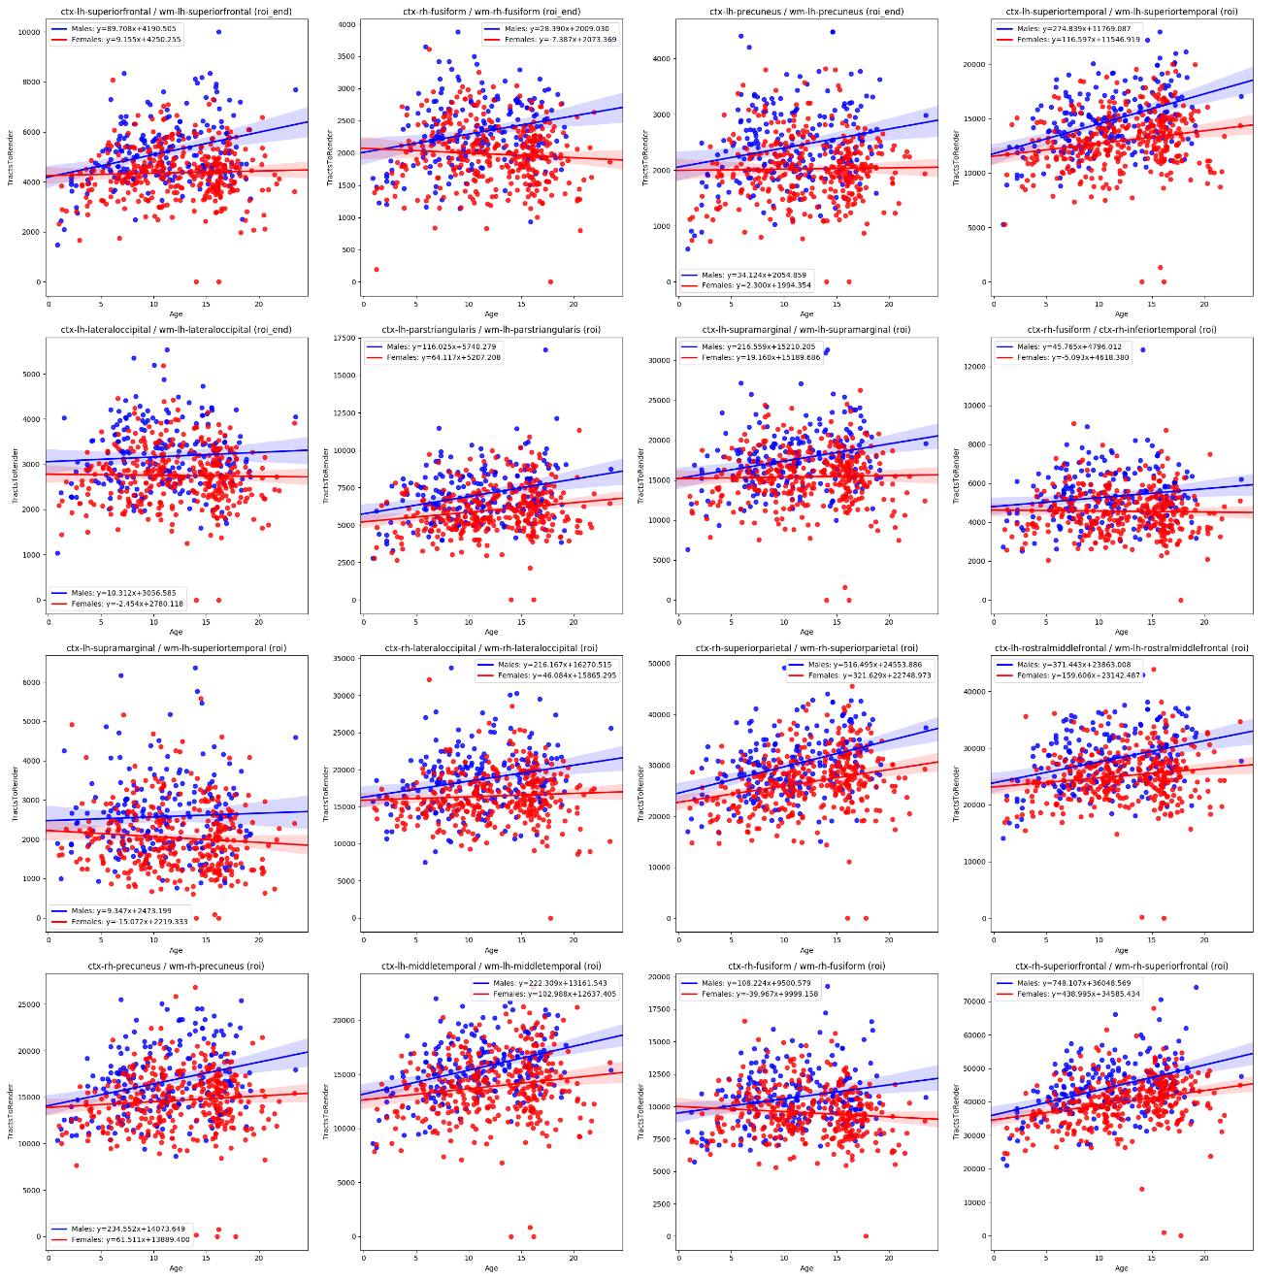

Figure 19 = TractsToRender effect size per measure

#### **Standard Deviation ADC**

Table 7 - Largest effect size for gender when measuring StdDev ADC

|  |  |  |  |  |
| --- | --- | --- | --- | --- |
| ROI Start | ROI End | Method | Effect Size | Non Null Measures |
| ctx-lh-transversetemporal | ctx-lh-insula | roi_end | -0.410886185 | 539 |
| ctx-lh-transversetemporal | wm-lh-insula | roi_end | -0.387978537 | 537 |
| ctx-rh-parsorbitalis | ctx-rh-parstriangularis | roi_end | -0.378045843 | 540 |
| ctx-rh-parstriangularis | ctx-rh-rostralmiddlefrontal | roi_end | -0.369305758 | 540 |
| ctx-lh-postcentral | ctx-lh-transversetemporal | roi_end | -0.366394061 | 535 |
| ctx-rh-rostralmiddlefrontal | wm-rh-insula | roi_end | -0.356918664 | 505 |
| ctx-lh-postcentral | ctx-lh-transversetemporal | roi | -0.355419823 | 539 |
| ctx-lh-postcentral | wm-lh-supramarginal | roi_end | -0.355010213 | 539 |
| Right-Caudate | wm-lh-lateralorbitofrontal | roi | -0.353646668 | 539 |
| ctx-lh-bankssts | ctx-lh-middletemporal | roi_end | -0.352352149 | 538 |
| wm-lh-lateralorbitofrontal | wm-rh-lateralorbitofrontal | roi | -0.350517033 | 536 |
| ctx-lh-parstriangularis | wm-lh-parstriangularis | roi_end | -0.350274158 | 539 |
| wm-lh-lateralorbitofrontal | wm-rh-rostralmiddlefrontal | roi | -0.34295549 | 529 |
| ctx-lh-superiortemporal | ctx-lh-supramarginal | roi_end | -0.342665436 | 539 |
| ctx-rh-parsorbitalis | wm-rh-parstriangularis | roi_end | -0.3374899 | 524 |

##### **Findings**

The effect size of the standard deviation of the apparent diffusion coefficient (ADC) represents the variability of the ADC between boys and girls. In most cases, there is negligible difference between genders, with a very small overall average effect size of 0.09. The greatest difference was found in girls’ variability of ADC between the left side transverse temporal and the left hand insula. Some variation with age was observed in the right hand parsorbitalis. For the most part however, variability with age was not observed for those tracts with the largest effect size.

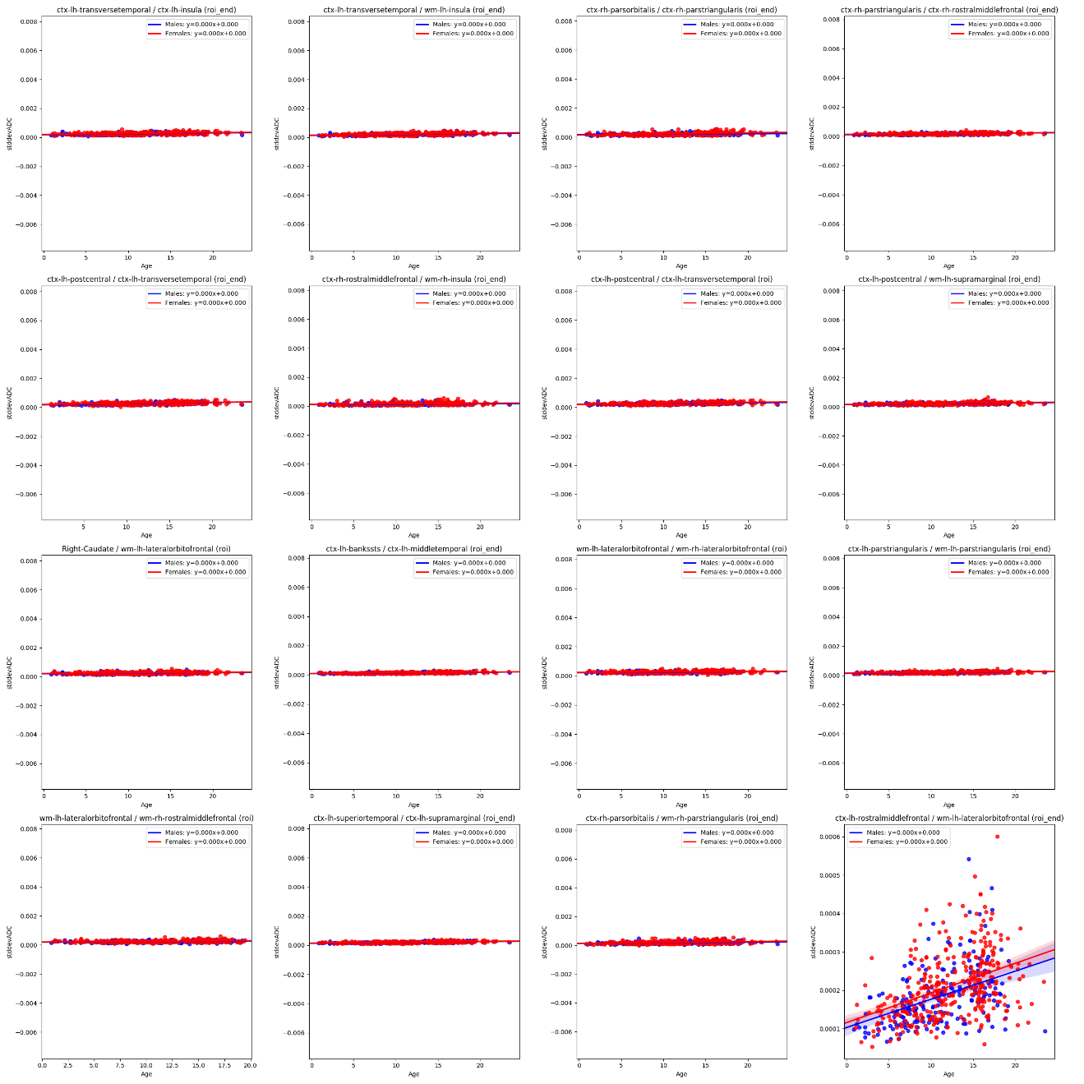

Figure 20 - StdDev ADC effect size per measure

#### Mean Standard Deviation FA

Table 8 - Largest effect size for gender when measuring StdDev FA

|  |  |  |  |  |
| --- | --- | --- | --- | --- |
| ROI Start | ROI End | Method | Effect Size | Non Null Measures |
| Left-Pallidum | ctx-lh-insula | roi | -0.5344 | 457 |
| ctx-rh-rostralmiddlefrontal | wm-lh-lateralorbitofrontal | roi | -0.46974 | 452 |
| wm-rh-inferiorparietal | wm-rh-lateraloccipital | roi_end | -0.45533 | 540 |
| Left-Caudate | wm-lh-insula | roi_end | -0.43558 | 506 |
| wm-lh-fusiform | wm-lh-lingual | roi_end | -0.43548 | 537 |
| ctx-lh-medialorbitofrontal | ctx-rh-frontalpole | roi_end | -0.43493 | 483 |
| ctx-lh-inferiorparietal | wm-lh-inferiortemporal | roi | -0.41015 | 539 |
| wm-rh-lateraloccipital | wm-rh-superiorparietal | roi | -0.40741 | 540 |
| ctx-lh-lateralorbitofrontal | wm-lh-middletemporal | roi | -0.40481 | 532 |
| wm-lh-middletemporal | wm-lh-insula | roi | -0.39986 | 540 |
| ctx-rh-inferiorparietal | wm-rh-lateraloccipital | roi_end | -0.39888 | 539 |
| Left-VentralDC | wm-lh-entorhinal | roi | -0.39522 | 538 |
| ctx-lh-lateraloccipital | wm-rh-superiorparietal | roi | -0.39312 | 512 |
| ctx-lh-middletemporal | wm-lh-bankssts | roi_end | -0.39083 | 538 |
| ctx-lh-inferiorparietal | ctx-lh-inferiortemporal | roi | -0.38999 | 536 |
| ctx-rh-lateraloccipital | wm-rh-inferiorparietal | roi_end | -0.3894 | 540 |

##### Findings

In the cases where there was a significant difference among genders, females demonstrated higher variability in fractional anisotropy. The variability also was shown to increase with age for all of the tracts with higher effect size.

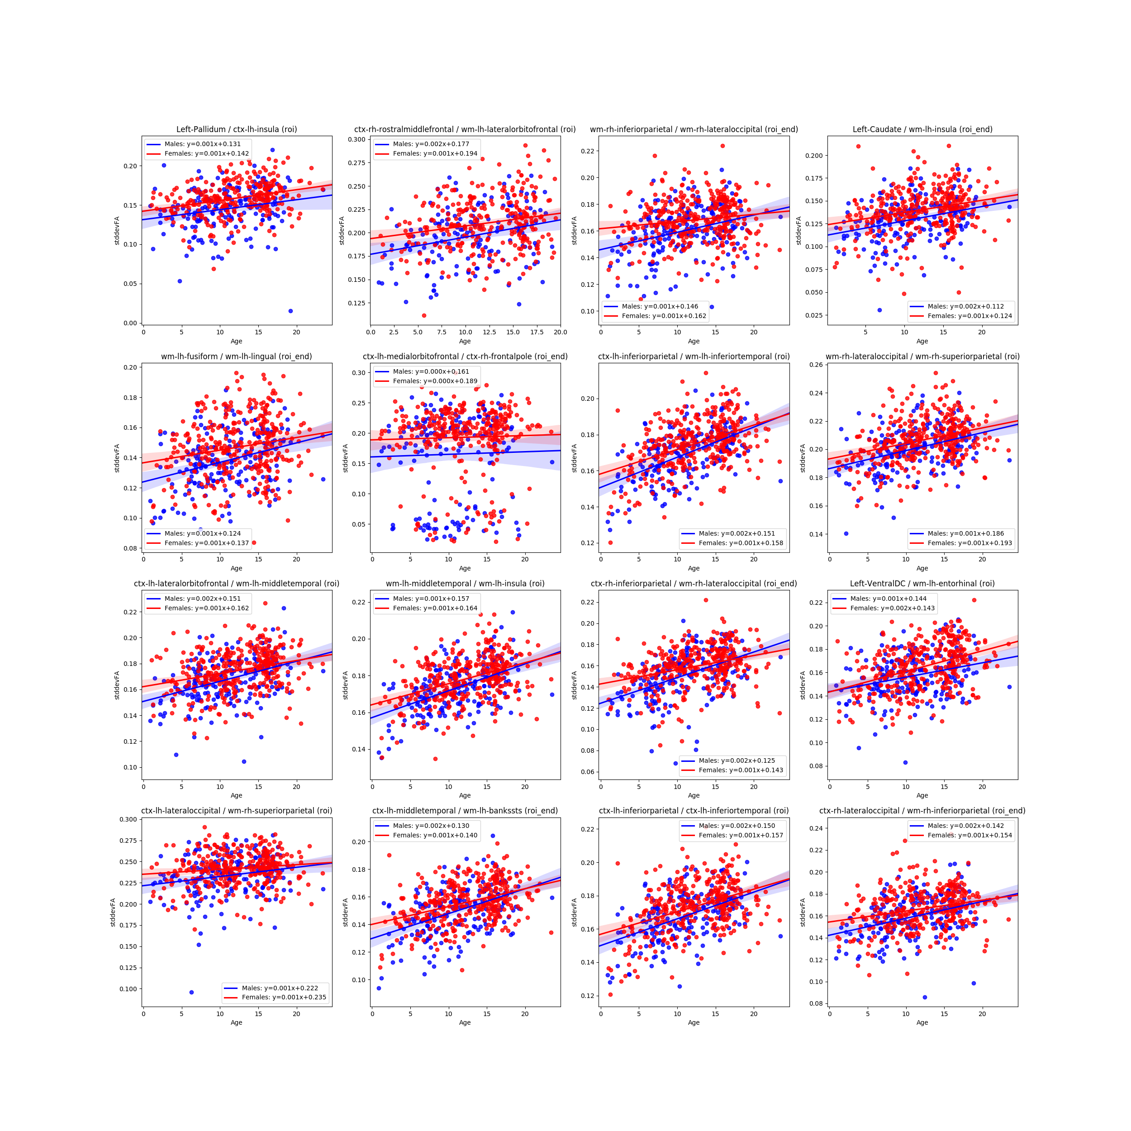

Figure 21 - StdDev FA effect size per measure

#### Mean FA – Asymmetry Index

Table 9 - Largest effect size for gender when measuring Mean FA Asymmetry

|  |  |  |  |  |
| --- | --- | --- | --- | --- |
| ROI Start | ROI End | Method | Effect Size | Non Null Measures |
| wm-rh-caudalanteriorcingulate | wm-rh-rostralanteriorcingulate | roi_end | 0.30589585 | 526 |
| Right-Thalamus-Proper | Right-choroid-plexus | roi | 0.299588801 | 537 |
| wm-lh-caudalanteriorcingulate | wm-lh-rostralanteriorcingulate | roi_end | -0.299530068 | 526 |
| wm-lh-inferiortemporal | wm-lh-temporalpole | roi | -0.295465783 | 538 |
| Right-Caudate | Right-choroid-plexus | roi_end | 0.289149101 | 497 |
| wm-rh-inferiortemporal | wm-rh-temporalpole | roi | 0.285637621 | 538 |
| ctx-lh-entorhinal | wm-lh-inferiortemporal | roi | -0.284216821 | 500 |
| Right-Cerebellum-Cortex | wm-rh-lingual | roi_end | 0.281873903 | 527 |
| Left-Thalamus-Proper | Left-choroid-plexus | roi | -0.274618588 | 536 |
| wm-lh-posteriorcingulate | wm-lh-rostralanteriorcingulate | roi | -0.27326477 | 524 |
| ctx-lh-bankssts | wm-lh-middletemporal | roi_end | 0.271276864 | 532 |
| ctx-rh-temporalpole | wm-rh-temporalpole | roi | 0.267972619 | 538 |
| ctx-rh-lateraloccipital | ctx-rh-superiortemporal | roi | 0.267833703 | 466 |
| wm-lh-superiortemporal | wm-lh-temporalpole | roi | -0.267550762 | 538 |
| ctx-lh-temporalpole | wm-lh-temporalpole | roi | -0.267146655 | 538 |
| ctx-rh-caudalanteriorcingulate | wm-lh-superiorfrontal | roi | 0.262364222 | 534 |

##### Findings

Lorem Ipsum

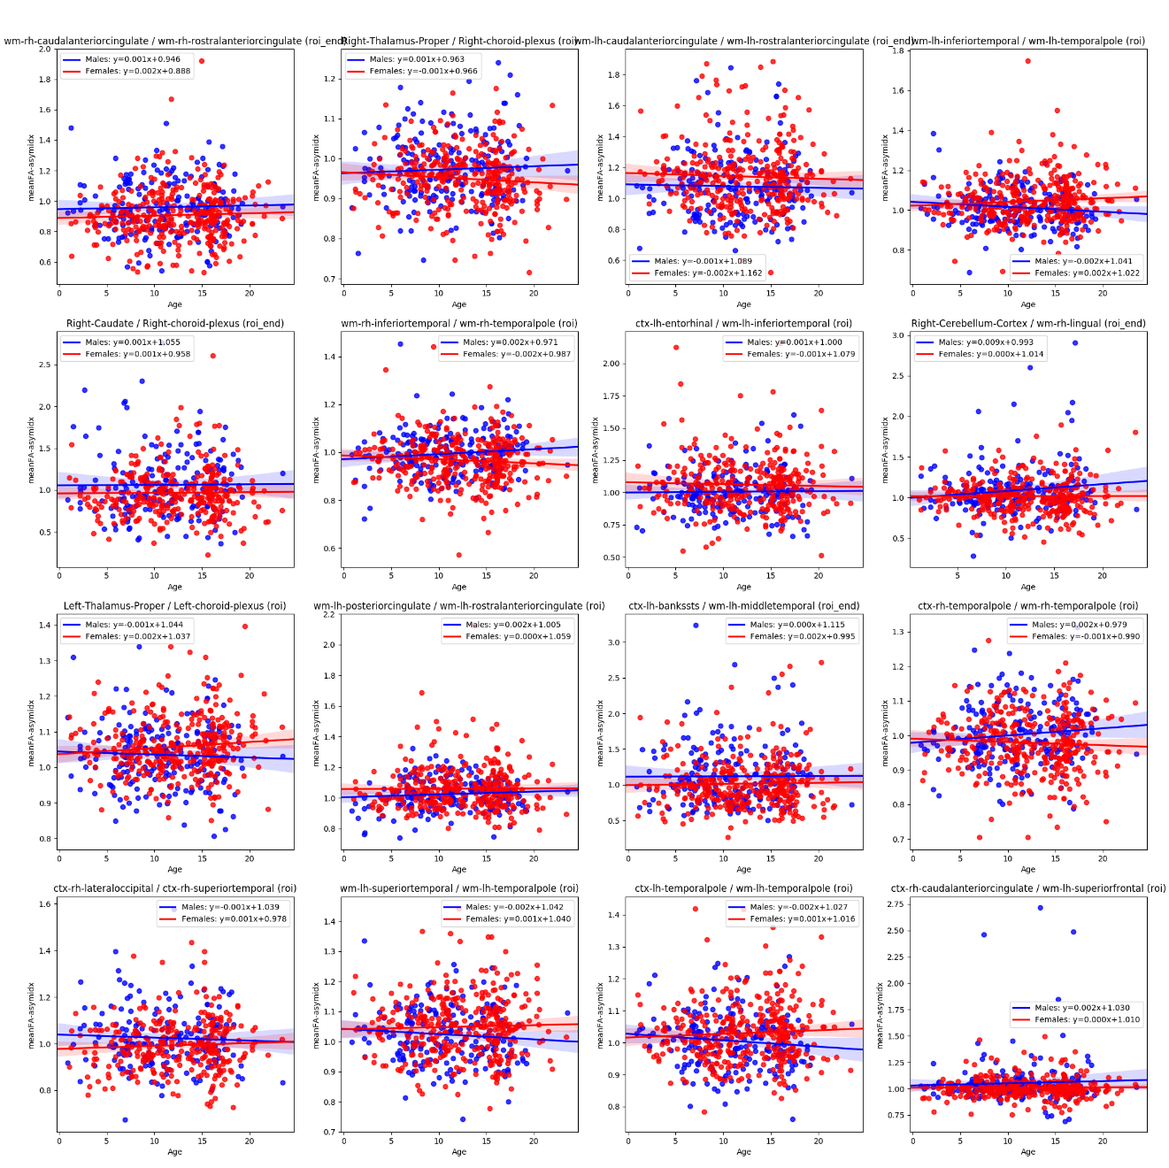

#### Mean ADC – Asymmetry Index

Table 10 - Largest effect size for gender when measuring Mean ADC Asymmetry

|  |  |  |  |  |
| --- | --- | --- | --- | --- |
| ROI Start | ROI End | Method | Effect Size | Non Null Measures |
| wm-lh-caudalanteriorcingulate | wm-lh-rostralanteriorcingulate | roi_end | 0.344801663 | 526 |
| Left-Cerebellum-Cortex | wm-lh-superiorfrontal | roi | 0.31588575 | 493 |
| wm-rh-caudalanteriorcingulate | wm-rh-rostralanteriorcingulate | roi_end | -0.309463746 | 526 |
| Right-Cerebellum-Cortex | wm-rh-superiorfrontal | roi | -0.308465622 | 494 |
| ctx-lh-inferiorparietal | ctx-lh-insula | roi | 0.305337381 | 481 |
| ctx-rh-inferiorparietal | ctx-rh-insula | roi | -0.295343012 | 481 |
| Right-Cerebral-White-Matter | ctx-lh-posteriorcingulate | roi | 0.282895023 | 494 |
| Right-Cerebral-White-Matter | wm-lh-cuneus | roi | 0.281851596 | 467 |
| Left-Cerebral-White-Matter | wm-rh-cuneus | roi | -0.281642196 | 466 |
| ctx-rh-precuneus | wm-lh-posteriorcingulate | roi_end | -0.281485877 | 481 |
| ctx-rh-precentral | wm-rh-supramarginal | roi_end | -0.270571013 | 528 |
| Right-Cerebellum-Cortex | ctx-rh-superiorfrontal | roi | -0.267668023 | 484 |
| Right-Accumbens-area | wm-rh-rostralanteriorcingulate | roi_end | -0.26645179 | 506 |
| Left-Cerebellum-Cortex | ctx-lh-superiorfrontal | roi | 0.266000101 | 483 |
| Left-VentralDC | ctx-lh-parahippocampal | roi | 0.265160641 | 455 |
| Left-Cerebral-White-Matter | ctx-rh-posteriorcingulate | roi | -0.264082395 | 494 |

##### **Findings**

Lorem ipsum ...

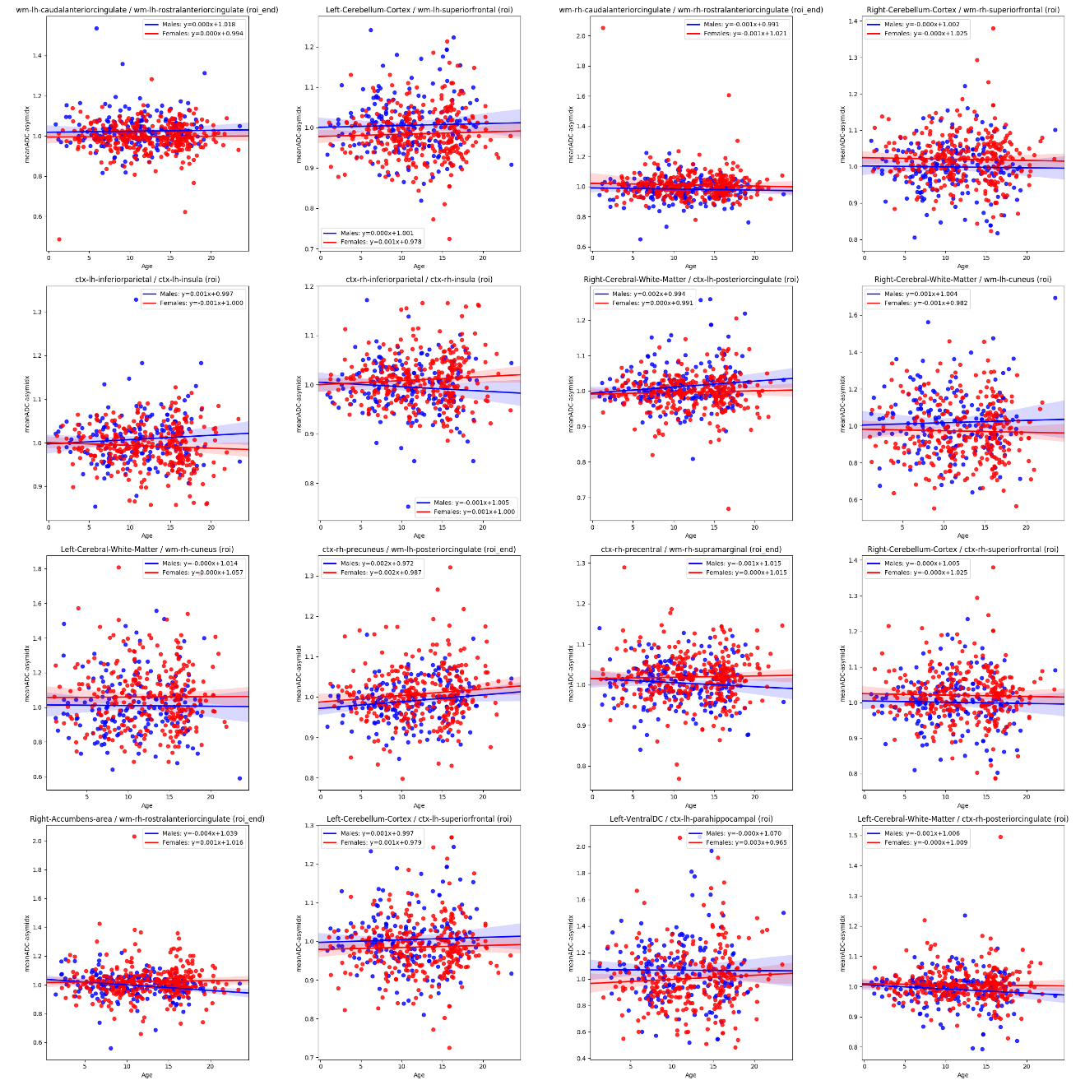

Figure 22 - Mean ADC Asymmetry Index effect size per measure

#### Number of Tracts – Asymmetry Index

Table 11 - Largest effect size for gender when measuring Number of Tracts Asymmetry

|  |  |  |  |  |
| --- | --- | --- | --- | --- |
| ROI Start | ROI End | Method | Effect Size | Non Null Measures |
| Right-Cerebral-White-Matter | Right-VentralDC | roi | 0.279673634 | 513 |
| Left-Cerebral-White-Matter | Left-Pallidum | roi | -0.229593396 | 538 |
| Right-Cerebral-White-Matter | Right-Cerebellum-Cortex | roi_end | 0.203619897 | 508 |
| Left-Cerebral-White-Matter | Left-Cerebellum-White-Matter | roi | -0.198771344 | 538 |
| Right-Cerebral-White-Matter | ctx-rh-caudalanteriorcingulate | roi_end | 0.198667112 | 526 |
| Left-Cerebral-White-Matter | Left-Putamen | roi | -0.197616528 | 538 |
| Left-Cerebral-White-Matter | Left-VentralDC | roi | -0.194508012 | 537 |
| Left-Cerebral-White-Matter | Left-Cerebellum-Cortex | roi_end | -0.179564247 | 537 |
| Right-Cerebral-White-Matter | Right-Accumbens-area | roi | 0.176198293 | 512 |
| Left-Cerebral-White-Matter | Left-Hippocampus | roi | -0.16897932 | 539 |
| Left-Cerebral-White-Matter | Left-Accumbens-area | roi | -0.168913862 | 539 |
| Left-Inf-Lat-Vent | Left-Hippocampus | roi | -0.16269043 | 539 |
| Left-Inf-Lat-Vent | Left-Cerebellum-Cortex | roi | -0.16269043 | 539 |
| Left-Lateral-Ventricle | wm-rh-insula | roi | -0.16269043 | 539 |
| Left-Lateral-Ventricle | wm-rh-pericalcarine | roi | -0.16269043 | 539 |
| Left-Inf-Lat-Vent | Left-Caudate | roi | -0.16269043 | 539 |

##### Findings

[[TODO There is a bug in this viz]

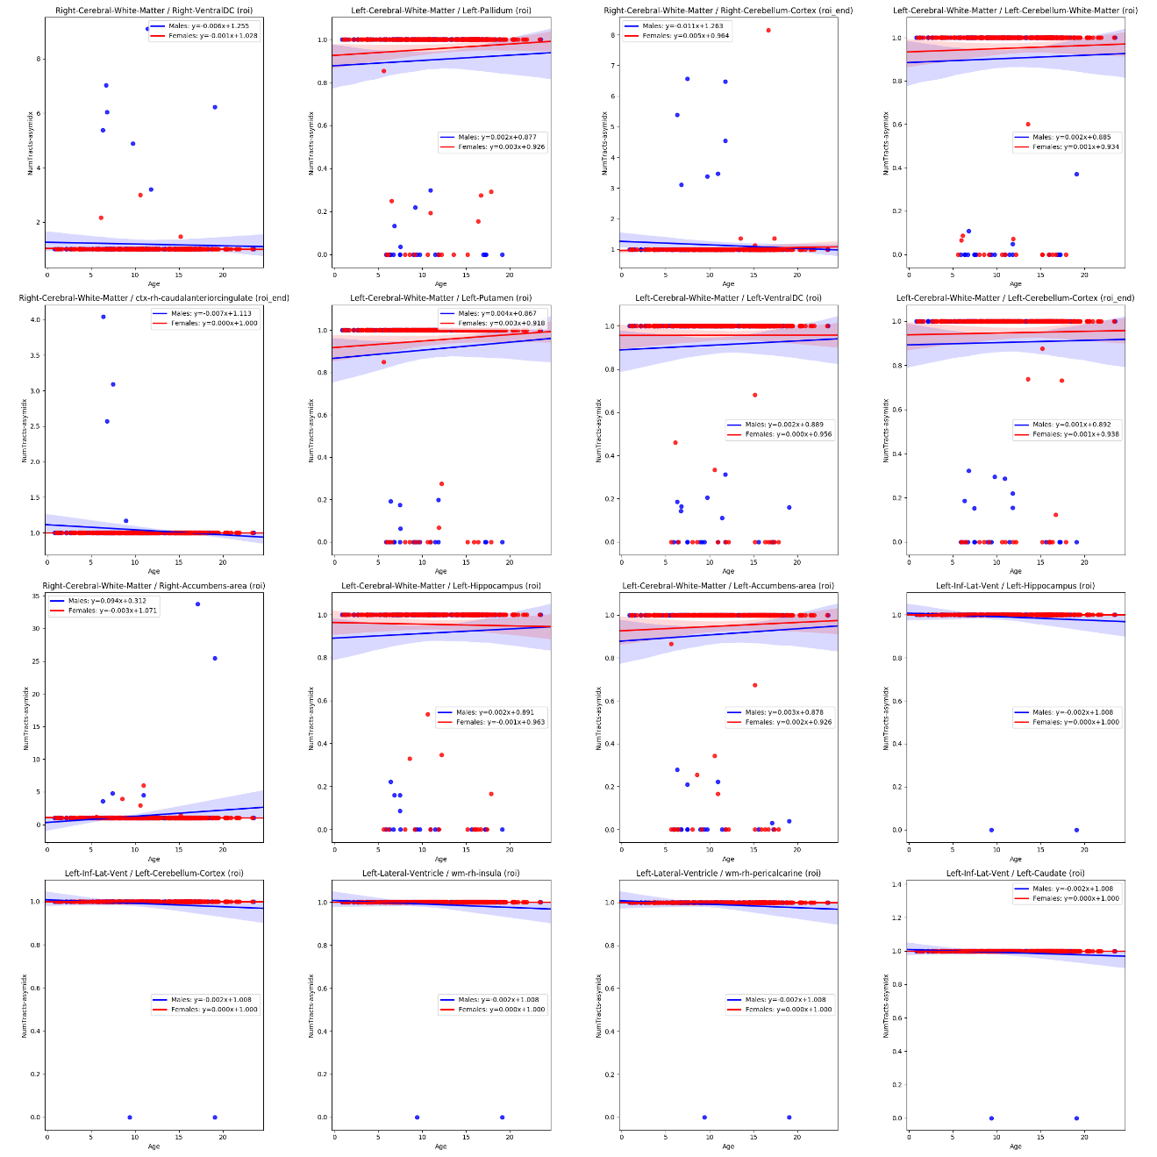

Figure 23 - NumTracts Asymmetry Index effect size per measure

#### Lines to Render – Asymmetry Index

Table 12 - Largest effect size for gender when measuring Lines to Render Asymmetry

|  |  |  |  |  |
| --- | --- | --- | --- | --- |
| ROI Start | ROI End | Method | Effect Size | Non Null Measures |
| ctx-lh-lateraloccipital | ctx-lh-middletemporal | roi | 0.313491537 | 540 |
| wm-rh-superiorfrontal | wm-rh-superiortemporal | roi | 0.310302643 | 489 |
| wm-rh-rostralmiddlefrontal | wm-rh-superiorparietal | roi | 0.306172862 | 533 |
| Left-choroid-plexus | wm-rh-superiortemporal | roi | 0.302760991 | 496 |
| ctx-rh-parsorbitalis | ctx-rh-parstriangularis | roi | -0.287230139 | 540 |
| ctx-lh-middletemporal | wm-lh-lateraloccipital | roi | 0.283641959 | 540 |
| ctx-lh-bankssts | ctx-lh-superiortemporal | roi_end | 0.276571236 | 541 |
| ctx-rh-superiortemporal | wm-rh-precentral | roi | 0.271911359 | 539 |
| ctx-lh-lateralorbitofrontal | ctx-lh-middletemporal | roi | 0.270917201 | 497 |
| ctx-lh-precentral | wm-lh-parstriangularis | roi | 0.269941514 | 526 |
| Right-Thalamus-Proper | Right-choroid-plexus | roi_end | 0.269831994 | 453 |
| ctx-rh-lateralorbitofrontal | wm-rh-rostralmiddlefrontal | roi_end | 0.269275461 | 461 |
| Right-Accumbens-area | Right-VentralDC | roi | 0.266105907 | 538 |
| Left-Pallidum | wm-lh-precentral | roi | 0.262424115 | 540 |
| Right-Lateral-Ventricle | Right-Caudate | roi_end | 0.261057699 | 533 |
| Right-Lateral-Ventricle | wm-rh-lateralorbitofrontal | roi | 0.260880963 | 537 |

##### **Findings**

Lorem ipsum

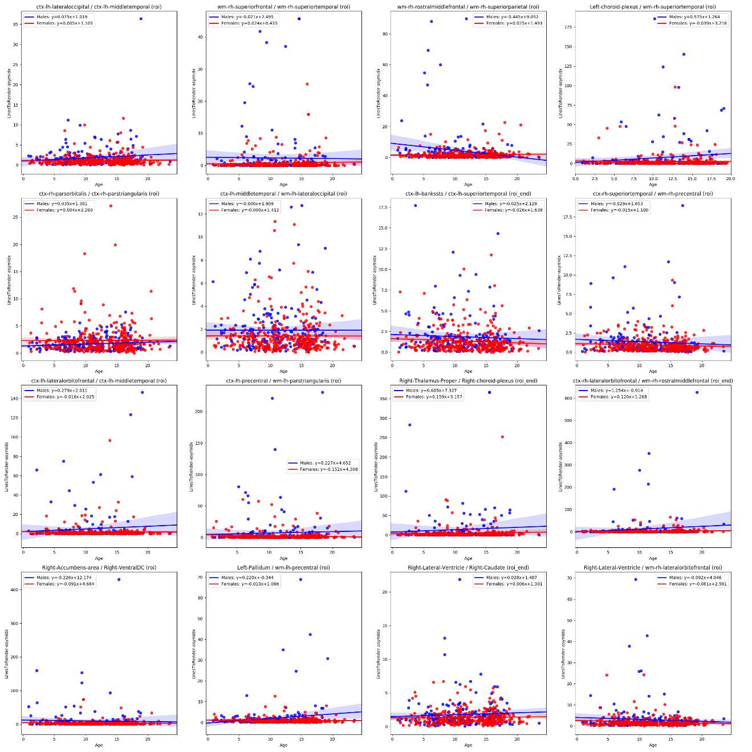

Figure 24 - Lines to Render Asymmetry Index effect size per measure

#### **Tracts to Render – Asymmetry Index**

Table 13 - Largest effect size for gender when measuring Tracts to Render Asymmetry

|  |  |  |  |  |
| --- | --- | --- | --- | --- |
| ROI Start | ROI End | Method | Effect Size | Non Null Measures |
| Right-Caudate | wm-rh-lateralorbitofrontal | roi | 0.326892033 | 540 |
| ctx-lh-bankssts | ctx-lh-superiortemporal | roi_end | 0.323394018 | 541 |
| Left-choroid-plexus | wm-rh-superiortemporal | roi | 0.305799141 | 496 |
| wm-rh-rostralmiddlefrontal | wm-rh-superiorparietal | roi | 0.304050826 | 533 |
| ctx-lh-lateraloccipital | ctx-lh-middletemporal | roi | 0.2974253 | 540 |
| wm-rh-superiorfrontal | wm-rh-superiortemporal | roi | 0.293029546 | 489 |
| ctx-lh-rostralmiddlefrontal | wm-rh-lateralorbitofrontal | roi | 0.291462302 | 452 |
| ctx-rh-lateralorbitofrontal | wm-rh-rostralmiddlefrontal | roi_end | 0.284597775 | 461 |
| ctx-lh-inferiorparietal | wm-lh-transversetemporal | roi | 0.282486003 | 503 |
| ctx-lh-middletemporal | wm-lh-lateraloccipital | roi | 0.281989463 | 540 |
| ctx-rh-entorhinal | ctx-rh-parahippocampal | roi | 0.274146482 | 539 |
| ctx-lh-precentral | wm-lh-parstriangularis | roi | 0.273650951 | 526 |
| ctx-lh-precuneus | wm-lh-lingual | roi | 0.27302815 | 540 |
| Left-Lateral-Ventricle | wm-rh-caudalanteriorcingulate | roi | 0.27165137 | 501 |
| wm-lh-postcentral | wm-lh-precentral | roi_end | 0.270888612 | 540 |
| ctx-lh-lingual | ctx-lh-precuneus | roi | 0.2704043 | 540 |

##### **Findings**

**Lorem ipsum**

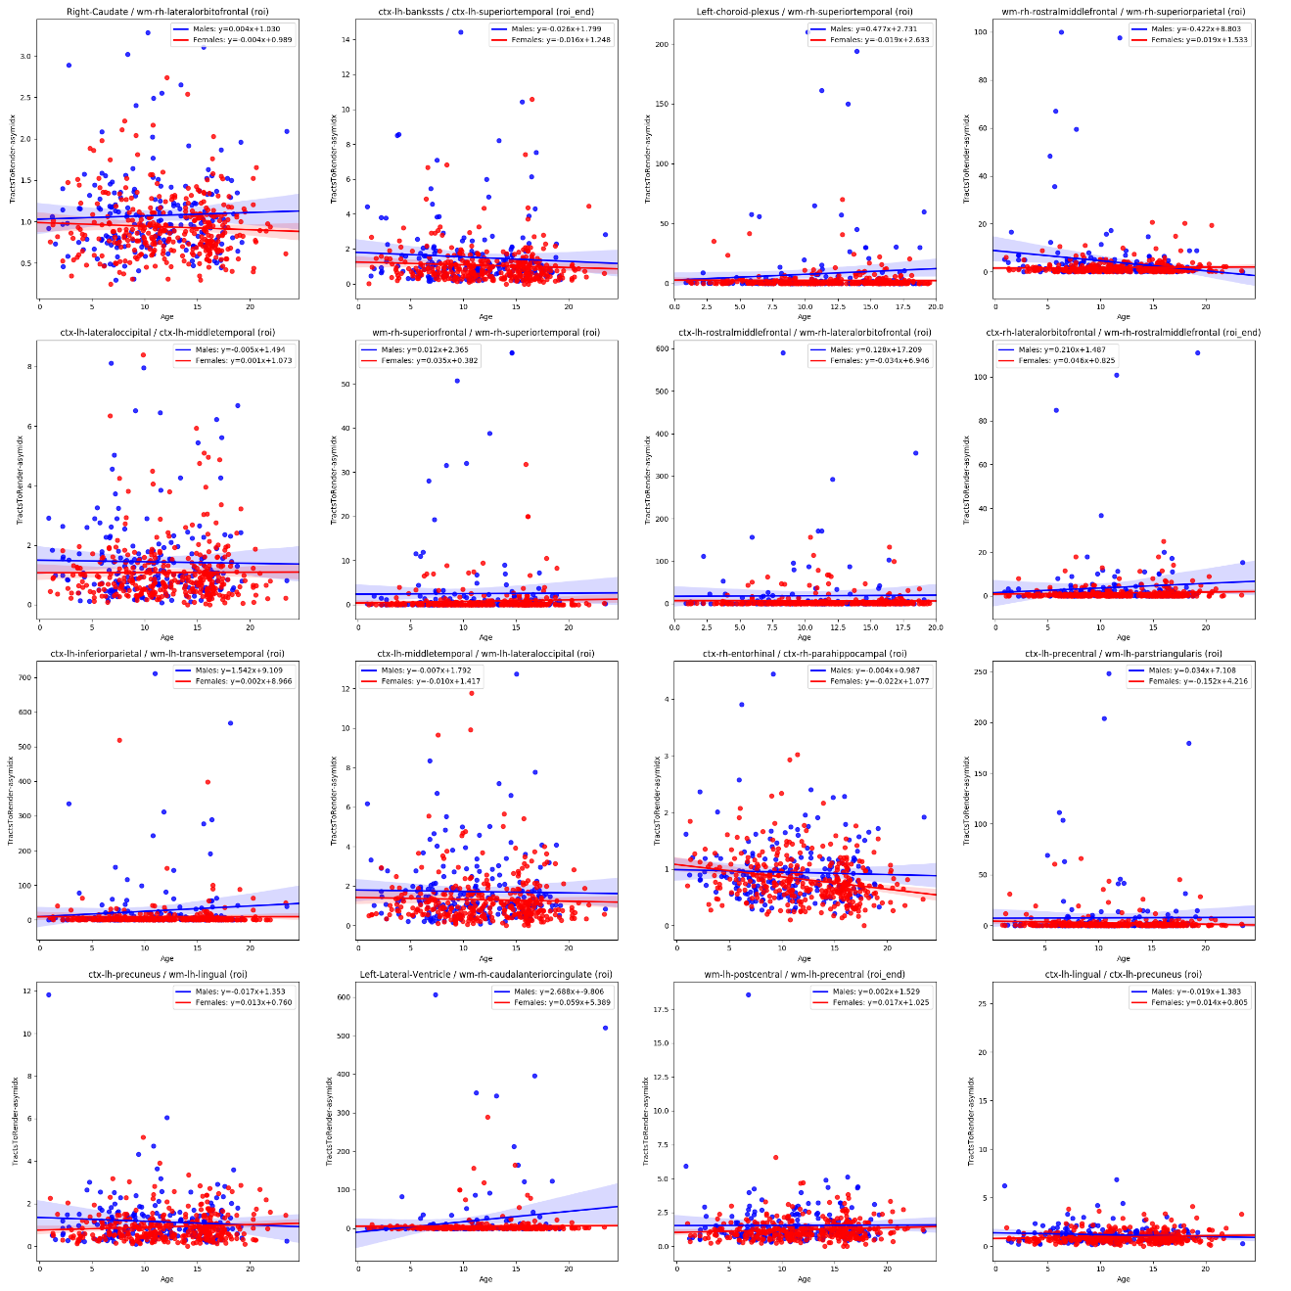

Figure 25 Tracts to Render Asymmetry Index Effect Size Per Measure

#### **Standard Deviation ADC – Asymmetry Index**

Table 14 - Largest effect size for gender when measuring StdDev ADC Asymmetry

|  |  |  |  |  |
| --- | --- | --- | --- | --- |
| ROI Start | ROI End | Method | Effect Size | Non Null Measures |
| Right-Cerebellum-Cortex | ctx-rh-fusiform | roi_end | 0.339637715 | 538 |
| ctx-rh-parsopercularis | wm-rh-postcentral | roi | 0.32519696 | 524 |
| Left-Cerebellum-Cortex | ctx-lh-fusiform | roi_end | -0.31852148 | 537 |
| ctx-rh-fusiform | ctx-rh-lingual | roi_end | 0.307432253 | 538 |
| ctx-rh-pericalcarine | wm-lh-cuneus | roi | 0.302989089 | 477 |
| Right-Caudate | Right-VentralDC | roi | -0.289220964 | 536 |
| Right-Cerebral-White-Matter | Right-Pallidum | roi | 0.288531031 | 499 |
| ctx-lh-parsopercularis | wm-lh-postcentral | roi | -0.280865463 | 524 |
| Left-Cerebral-White-Matter | wm-rh-pericalcarine | roi | -0.279573924 | 473 |
| Left-VentralDC | wm-lh-medialorbitofrontal | roi | -0.27896243 | 526 |
| ctx-lh-superiorparietal | wm-rh-lingual | roi | 0.277247319 | 489 |
| Left-Cerebellum-Cortex | wm-lh-fusiform | roi_end | -0.276356272 | 535 |
| Left-Caudate | Left-VentralDC | roi | 0.273523515 | 535 |
| Left-choroid-plexus | ctx-lh-superiorfrontal | roi | -0.271630616 | 481 |
| ctx-rh-precentral | wm-rh-supramarginal | roi_end | -0.270029705 | 528 |
| Left-Lateral-Ventricle | wm-rh-precuneus | roi | -0.269794178 | 534 |

##### Findings

Lorem Ipsum

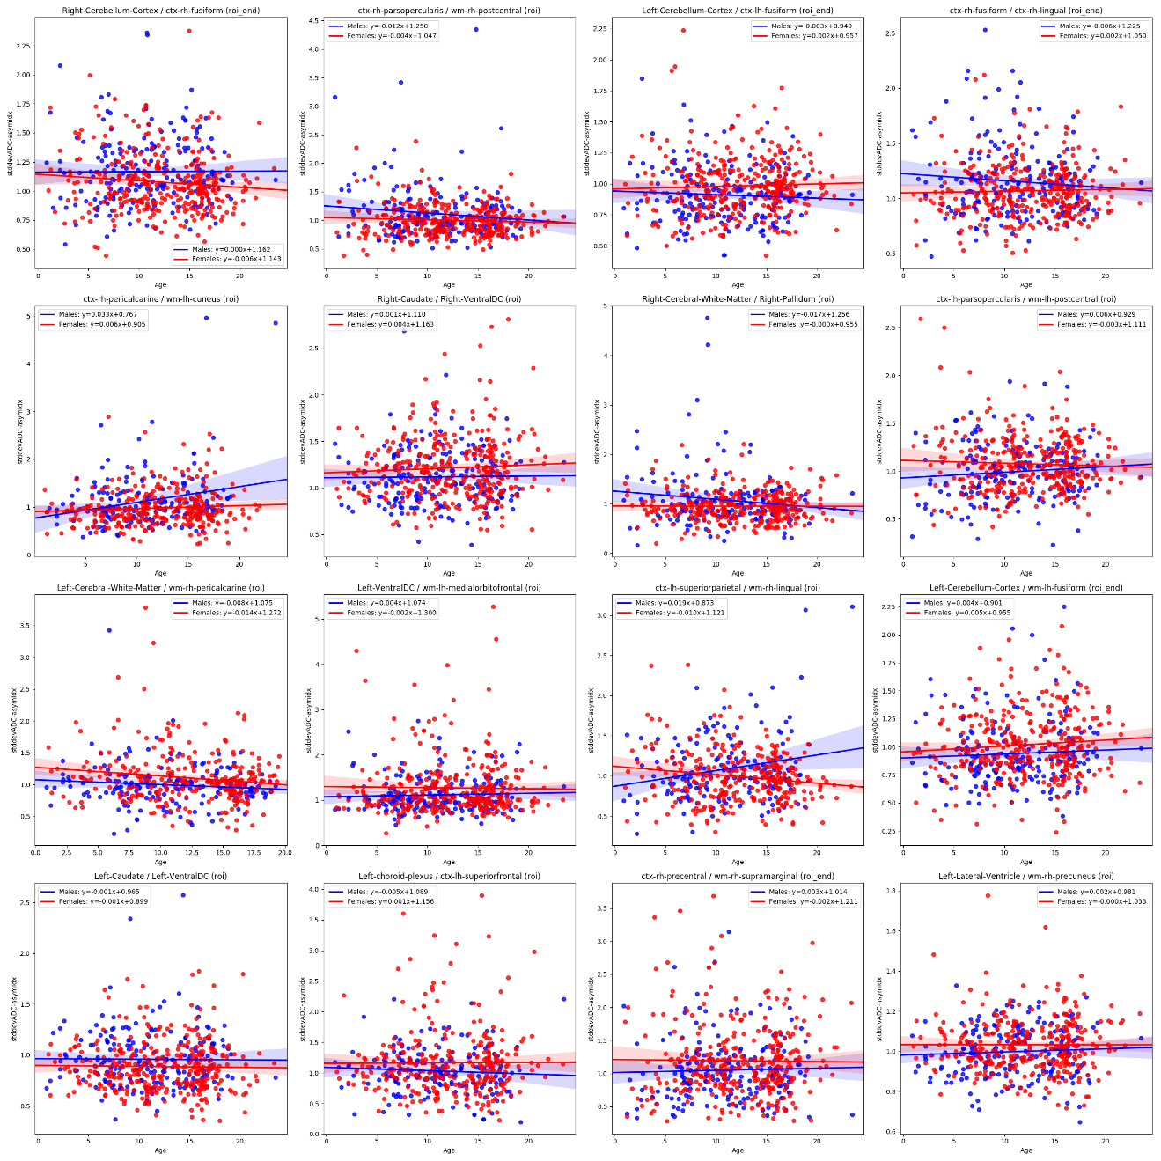

Figure 26 StdDev ADC Asymmetry Index Effect Size per Measure

#### Mean Standard Deviation FA – Asymmetry Index

Table 15 - Largest effect size for gender when measuring StdDev FA Asymmetry

|  |  |  |  |  |
| --- | --- | --- | --- | --- |
| ROI Start | ROI End | Method | Effect Size | Non Null Measures |
| ctx-lh-inferiorparietal | wm-lh-precentral | roi | 1.080233447 | 496 |
| ctx-lh-precentral | wm-lh-inferiorparietal | roi | 0.909896885 | 530 |
| ctx-rh-inferiorparietal | wm-rh-precentral | roi | -0.879608229 | 496 |
| wm-lh-inferiorparietal | wm-lh-precentral | roi | 0.850937118 | 538 |
| ctx-rh-inferiortemporal | wm-rh-bankssts | roi | 0.83131755 | 533 |
| ctx-rh-precentral | wm-rh-inferiorparietal | roi | -0.829078014 | 530 |
| wm-rh-inferiortemporal | wm-rh-supramarginal | roi | 0.825370366 | 530 |
| ctx-rh-superiorparietal | wm-rh-supramarginal | roi | 0.796100677 | 539 |
| ctx-lh-inferiorparietal | ctx-lh-postcentral | roi | 0.786141863 | 501 |
| wm-rh-bankssts | wm-rh-inferiortemporal | roi | 0.774215731 | 539 |
| wm-rh-inferiorparietal | wm-rh-precentral | roi | -0.770096342 | 538 |
| Right-Putamen | Right-Pallidum | roi | 0.754891546 | 540 |
| Right-Putamen | wm-rh-transversetemporal | roi | 0.750972164 | 472 |
| wm-lh-inferiortemporal | wm-lh-supramarginal | roi | -0.749793436 | 530 |
| wm-rh-middletemporal | wm-rh-postcentral | roi | 0.722347998 | 474 |
| Right-Pallidum | wm-rh-precentral | roi_end | 0.720020737 | 474 |

##### Findings

Lorem Ipsum

[TODO Figure for Mean STDDEVFA Asymmetry]

### Correlation

The correlation between patient age and each of the derived measurements across all ages were calculated. Those correlations where more than 80% of patients have data (non null) were sorted by highest correlation and listed below.

Table 16 Tract measurements most correlated to age

|  |  |  |  |  |  |  |
| --- | --- | --- | --- | --- | --- | --- |
| ROI Start | ROI End | Method | Measure | Pearson R | P-value | df |
| Brain-Stem | wm-lh-insula | roi | meanFA | 0.67 | 0.00 | 539 |
| ctx-lh-precentral | wm-lh-precentral | roi | stddevFA | 0.67 | 0.00 | 541 |
| ctx-rh-precentral | wm-rh-precentral | roi | stddevFA | 0.66 | 0.00 | 541 |
| Brain-Stem | ctx-lh-superiorfrontal | roi | meanFA | 0.66 | 0.00 | 583 |
| Brain-Stem | wm-lh-superiorfrontal | roi | meanFA | 0.65 | 0.00 | 539 |
| Brain-Stem | Left-VentralDC | roi | meanFA | 0.65 | 0.00 | 540 |
| Left-VentralDC | wm-lh-insula | roi | meanFA | 0.65 | 0.00 | 540 |
| Brain-Stem | wm-lh-precentral | roi | meanFA | 0.65 | 0.00 | 540 |
| Left-VentralDC | wm-lh-precentral | roi | meanFA | 0.65 | 0.00 | 540 |
| Brain-Stem | Right-Pallidum | roi | meanFA | 0.65 | 0.00 | 540 |
| ctx-lh-rostralmiddlefrontal | wm-lh-rostralmiddlefrontal | roi_ed | stddevFA | 0.65 | 0.00 | 539 |
| Left-Thalamus-Proper | Brain-Stem | roi | meanFA | 0.65 | 0.00 | 538 |
| ctx-lh-postcentral | wm-lh-postcentral | roi | stddevFA | 0.64 | 0.00 | 540 |
| Right-Putamen | wm-rh-insula | roi | meanFA | 0.64 | 0.00 | 541 |

#### Brain-Stem to wm-lh-insua

Method: roi

Measure: meanFA

Correlation with Age

|  |  |  |  |
| --- | --- | --- | --- |
|  | Pearson R | p-value | df |
| All Samples | 0.67 | 0.000 | 539 |
| Patients under 15 years | 0.66 | 0.000 | 363 |
| Patients under 10 years | 0.65 | 0.000 | 193 |
| Patients under 8 years | 0.65 | 0.000 | 120 |
| Patients under 6 years | 0.67 | 0.000 | 62 |
| Patients under 5 years | 0.68 | 0.000 | 40 |
| Patients under 4 years | 0.53 | 0.000 | 30 |
| Patients under 3 years | 0.34 | 0.174 | 17 |
| Patients under 2 years | -0.03 | 0.942 | 7 |

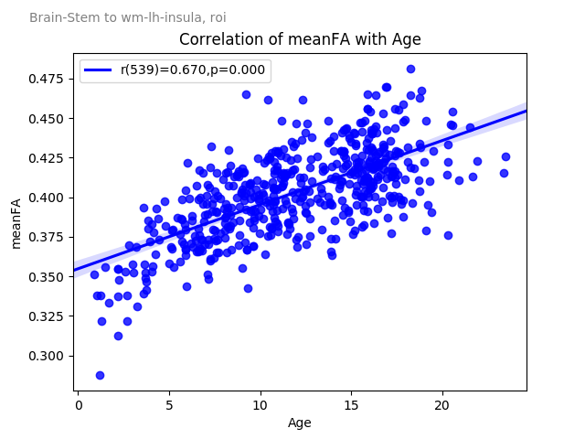

Figure 27 - Brain Stem to wm-lh-insula meanFA correlation with Age

#### ctx-lh-precentral to wm-lh-precentral

Method: roi

Measure: stddevFA

Correlation with Age

|  |  |  |  |
| --- | --- | --- | --- |
|  | Pearson R | p-value | df |
| All Samples | 0.669 | 0.000 | 541 |
| Patients under 15 years | 0.679 | 0.000 | 364 |
| Patients under 10 years | 0.585 | 0.000 | 194 |
| Patients under 8 years | 0.590 | 0.000 | 121 |
| Patients under 6 years | 0.631 | 0.000 | 63 |
| Patients under 5 years | 0.618 | 0.000 | 40 |
| Patients under 4 years | 0.589 | 0.001 | 30 |
| Patients under 3 years | 0.734 | 0.001 | 17 |
| Patients under 2 years | 0.525 | 0.226 | 7 |

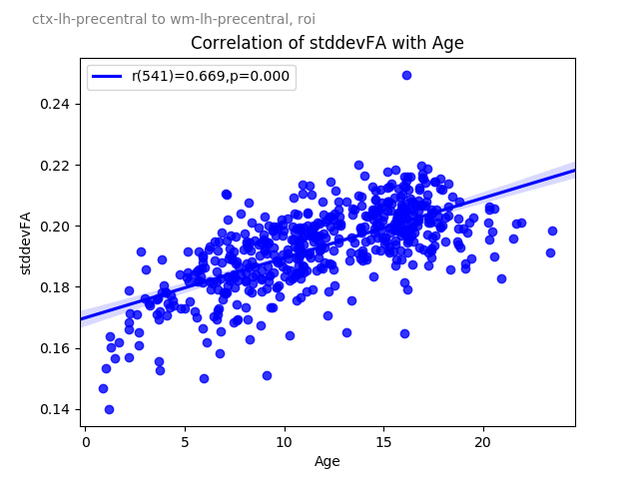

Figure 28 ctx-lh-precentral to wm-lh-precentral stddevFA correlation with age

#### ctx-rh-precentral to wm-rh-precentral

Method: roi

Measure: stddevFA

Correlation with Age

|  |  |  |  |
| --- | --- | --- | --- |
|  | Pearson R | p-value | df |
| All Samples | 0.664 | 0.000 | 540 |
| Patients under 15 years | 0.663 | 0.000 | 364 |
| Patients under 10 years | 0.582 | 0.000 | 194 |
| Patients under 8 years | 0.559 | 0.000 | 121 |
| Patients under 6 years | 0.507 | 0.000 | 63 |
| Patients under 5 years | 0.548 | 0.000 | 40 |
| Patients under 4 years | 0.502 | 0.005 | 30 |
| Patients under 3 years | 0.672 | 0.003 | 17 |
| Patients under 2 years | 0.543 | 0.208 | 7 |

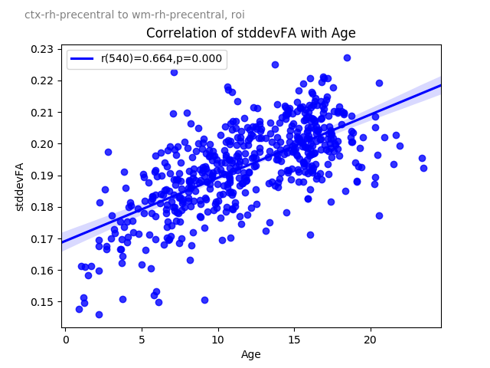

Figure 29 ctx-lh-precentral to w-rh-precentral stddevFA correlation with Age

#### Brain-Stem to ctx-lh-superiorfrontal

Method: roi

Measure: meanFA

Correlation with Age

|  |  |  |  |
| --- | --- | --- | --- |
|  | Pearson R | p-value | df |
| All Samples | 0.656 | 0.000 | 538 |
| Patients under 15 years | 0.607 | 0.000 | 362 |
| Patients under 10 years | 0.577 | 0.000 | 192 |
| Patients under 8 years | 0.518 | 0.000 | 120 |
| Patients under 6 years | 0.468 | 0.000 | 62 |
| Patients under 5 years | 0.654 | 0.000 | 40 |
| Patients under 4 years | 0.575 | 0.001 | 30 |
| Patients under 3 years | 0.349 | 0.169 | 17 |
| Patients under 2 years | 0.296 | 0.520 | 7 |

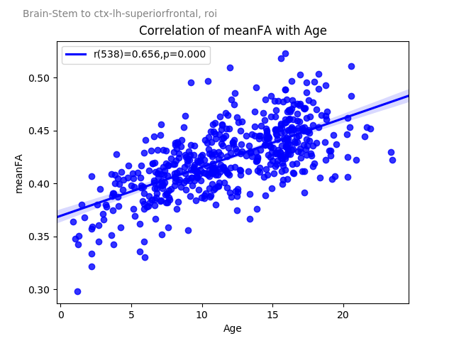

Figure 30 Brain-Stem to ctx-lh-superiorfrontal meanFA correlation wth age

#### Brain-Stem to wm-lh-superiorfrontal

Method: roi

Measure: meanFA

Correlation with Age

|  |  |  |  |
| --- | --- | --- | --- |
|  | Pearson R | p-value | df |
| All Samples | 0.654 | 0.000 | 539 |
| Patients under 15 years | 0.612 | 0.000 | 362 |
| Patients under 10 years | 0.592 | 0.000 | 192 |
| Patients under 8 years | 0.561 | 0.000 | 120 |
| Patients under 6 years | 0.541 | 0.000 | 62 |
| Patients under 5 years | 0.697 | 0.000 | 40 |
| Patients under 4 years | 0.612 | 0.000 | 30 |
| Patients under 3 years | 0.428 | 0.083 | 17 |
| Patients under 2 years | 0.260 | 0.573 | 7 |

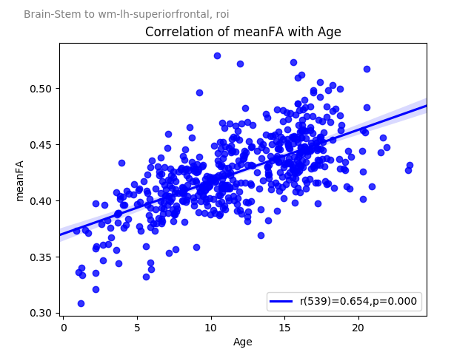

Figure 31 Brain-Stem to wm-lh-superiorfrontal meanFA correlation with age

#### Brain-Stem to Left-VentralDC

Method: roi

Measure: meanFA

Correlation with Age

|  |  |  |  |
| --- | --- | --- | --- |
|  | Pearson R | p-value | df |
| All Samples | 0.653 | 0.000 | 540 |
| Patients under 15 years | 0.655 | 0.000 | 363 |
| Patients under 10 years | 0.642 | 0.000 | 193 |
| Patients under 8 years | 0.614 | 0.000 | 120 |
| Patients under 6 years | 0.581 | 0.000 | 62 |
| Patients under 5 years | 0.642 | 0.000 | 40 |
| Patients under 4 years | 0.539 | 0.002 | 30 |
| Patients under 3 years | 0.338 | 0.184 | 17 |
| Patients under 2 years | -0.077 | 0.869 | 7 |

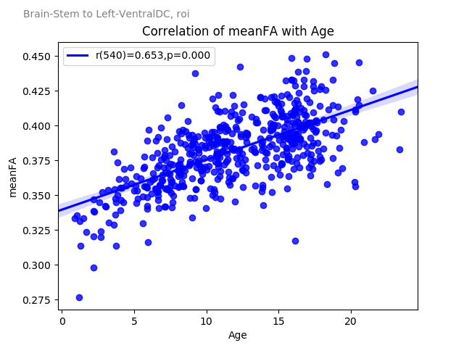

Figure 32 Brain-Stem to left-VentricalDC meanFA correlation with age

#### Left-VentralDC to wm-lh-insula

Method: roi

Measure: meanFA

Correlation with Age

|  |  |  |  |
| --- | --- | --- | --- |
|  | Pearson R | p-value | df |
| All Samples | 0.652 | 0.000 | 540 |
| Patients under 15 years | 0.664 | 0.000 | 364 |
| Patients under 10 years | 0.667 | 0.000 | 194 |
| Patients under 8 years | 0.667 | 0.000 | 121 |
| Patients under 6 years | 0.652 | 0.000 | 63 |
| Patients under 5 years | 0.598 | 0.000 | 40 |
| Patients under 4 years | 0.422 | 0.020 | 30 |
| Patients under 3 years | 0.352 | 0.166 | 17 |
| Patients under 2 years | -0.284 | 0.537 | 7 |

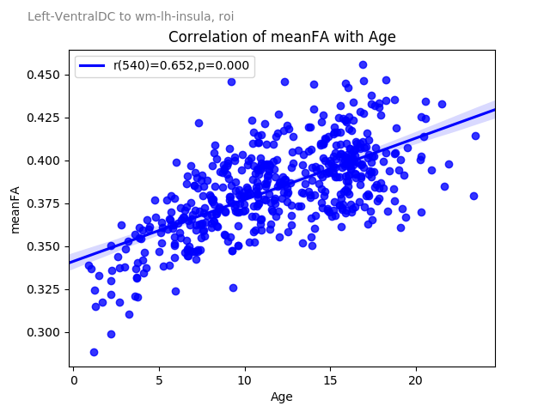

Figure 33 Left-VentricalDC to wm-lh-insula meanFA correlation with age

#### Brain-Stem to wm-lh-precentral

Method: roi

Measure: meanFA

Correlation with Age

|  |  |  |  |
| --- | --- | --- | --- |
|  | Pearson R | p-value | df |
| All Samples | 0.652 | 0.000 | 540 |
| Patients under 15 years | 0.649 | 0.000 | 363 |
| Patients under 10 years | 0.592 | 0.000 | 193 |
| Patients under 8 years | 0.538 | 0.000 | 120 |
| Patients under 6 years | 0.583 | 0.000 | 62 |
| Patients under 5 years | 0.553 | 0.000 | 40 |
| Patients under 4 years | 0.430 | 0.018 | 30 |
| Patients under 3 years | 0.377 | 0.136 | 17 |
| Patients under 2 years | 0.450 | 0.311 | 7 |

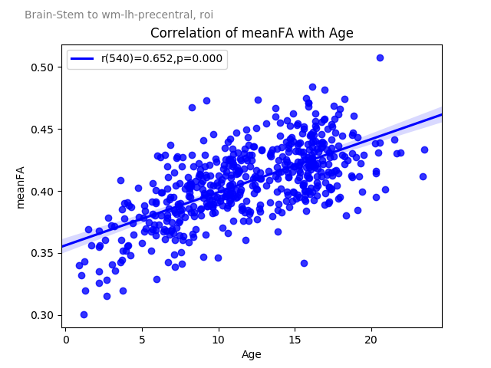

Figure 34 Brain-Stem to wm-lh-precentral meanFA correlation with age

#### Left-VentralDC to wm-lh-precentral

Method: roi

Measure: meanFA

Correlation with Age

|  |  |  |  |
| --- | --- | --- | --- |
|  | Pearson R | p-value | df |
| All Samples | 0.651 | 0.000 | 540 |
| Patients under 15 years | 0.655 | 0.000 | 363 |
| Patients under 10 years | 0.627 | 0.000 | 194 |
| Patients under 8 years | 0.576 | 0.000 | 121 |
| Patients under 6 years | 0.606 | 0.000 | 63 |
| Patients under 5 years | 0.564 | 0.000 | 40 |
| Patients under 4 years | 0.455 | 0.011 | 30 |
| Patients under 3 years | 0.529 | 0.029 | 17 |
| Patients under 2 years | 0.465 | 0.293 | 7 |

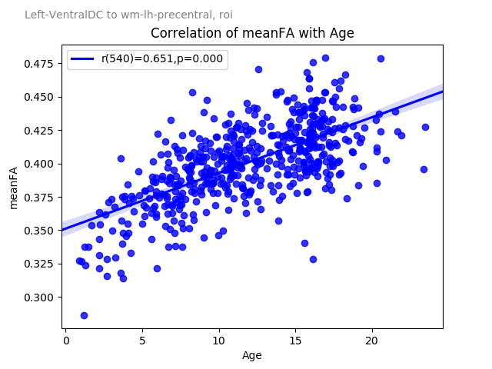

Figure 35 Left-VentralDC to wm-lh-precentral meanFA correlation with age

#### Brain-Stem to Right-Pallidum

Method: roi

Measure: meanFA

Correlation with Age

|  |  |  |  |
| --- | --- | --- | --- |
|  | Pearson R | p-value | df |
| All Samples | 0.650 | 0.000 | 540 |
| Patients under 15 years | 0.635 | 0.000 | 363 |
| Patients under 10 years | 0.635 | 0.000 | 193 |
| Patients under 8 years | 0.650 | 0.000 | 120 |
| Patients under 6 years | 0.622 | 0.000 | 62 |
| Patients under 5 years | 0.638 | 0.000 | 40 |
| Patients under 4 years | 0.546 | 0.002 | 30 |
| Patients under 3 years | 0.409 | 0.103 | 17 |
| Patients under 2 years | -0.003 | 0.995 | 7 |

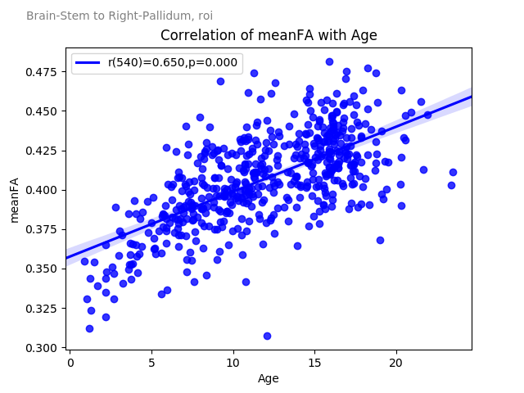

Figure 36 Brain-Stem to Right-Palladium meanFA correlation with age

#### ctx-lh-rostralmiddlefrontal to wm-lh-rostralmiddlefrontal

Method: roi_end

Measure: stddevFA

Correlation with Age

|  |  |  |  |
| --- | --- | --- | --- |
|  | Pearson R | p-value | df |
| All Samples | 0.648 | 0.000 | 539 |
| Patients under 15 years | 0.640 | 0.000 | 363 |
| Patients under 10 years | 0.472 | 0.000 | 194 |
| Patients under 8 years | 0.468 | 0.000 | 121 |
| Patients under 6 years | 0.487 | 0.000 | 63 |
| Patients under 5 years | 0.633 | 0.000 | 40 |
| Patients under 4 years | 0.682 | 0.000 | 30 |
| Patients under 3 years | 0.663 | 0.004 | 17 |
| Patients under 2 years | 0.575 | 0.177 | 7 |

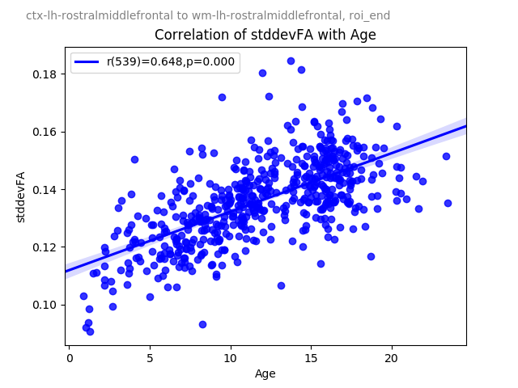

Figure 37 ctxlh-rostralmiddlefrontal to wm-lh-rostralmiddlefrontal stddevFA correlation with age

#### Left-Thalamus-Proper to Brain-Stem

Method: roi

Measure: meanFA

Correlation with Age

|  |  |  |  |
| --- | --- | --- | --- |
|  | Pearson R | p-value | df |
| All Samples | 0.646 | 0.000 | 538 |
| Patients under 15 years | 0.651 | 0.000 | 362 |
| Patients under 10 years | 0.635 | 0.000 | 192 |
| Patients under 8 years | 0.607 | 0.000 | 120 |
| Patients under 6 years | 0.577 | 0.000 | 62 |
| Patients under 5 years | 0.657 | 0.000 | 40 |
| Patients under 4 years | 0.525 | 0.003 | 30 |
| Patients under 3 years | 0.258 | 0.318 | 17 |
| Patients under 2 years | -0.106 | 0.820 | 7 |

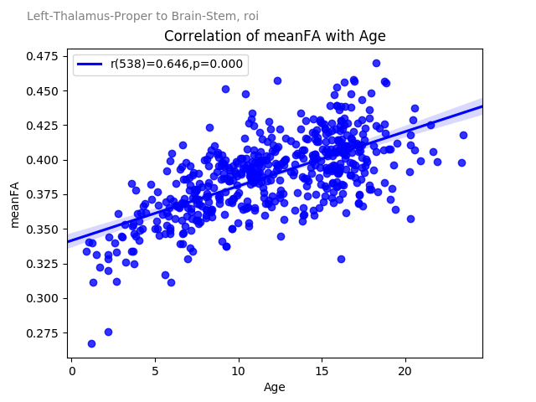

Figure 38 Left-Thalmus-Proper to Brain-Stem meanFA correlation with age

#### ctx-lh-postcentral to wm-lh-postcentral

Method: roi

Measure: stddevFA

Correlation with Age

|  |  |  |  |
| --- | --- | --- | --- |
|  | Pearson R | p-value | df |
| All Samples | 0.644 | 0.000 | 540 |
| Patients under 15 years | 0.658 | 0.000 | 364 |
| Patients under 10 years | 0.576 | 0.000 | 194 |
| Patients under 8 years | 0.559 | 0.000 | 121 |
| Patients under 6 years | 0.633 | 0.000 | 63 |
| Patients under 5 years | 0.452 | 0.003 | 40 |
| Patients under 4 years | 0.407 | 0.025 | 30 |
| Patients under 3 years | 0.626 | 0.007 | 17 |
| Patients under 2 years | 0.887 | 0.008 | 7 |

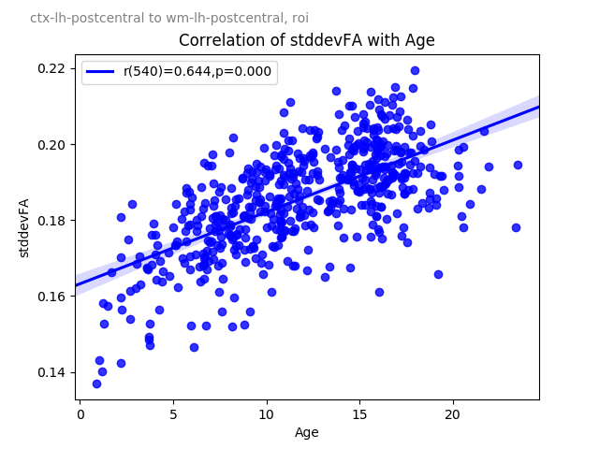

Figure 39 ctx-lh-postcentral to wm-lh-postcentral stddevFA correlation with age

#### Right-Putamen to wm-rh-insula

Method: roi

Measure: meanFA

Correlation with Age

|  |  |  |  |
| --- | --- | --- | --- |
|  | Pearson R | p-value | df |
| All Samples | 0.644 | 0.000 | 541 |
| Patients under 15 years | 0.642 | 0.000 | 364 |
| Patients under 10 years | 0.642 | 0.000 | 194 |
| Patients under 8 years | 0.594 | 0.000 | 121 |
| Patients under 6 years | 0.540 | 0.000 | 63 |
| Patients under 5 years | 0.420 | 0.007 | 60 |
| Patients under 4 years | 0.252 | 0.179 | 30 |
| Patients under 3 years | 0.287 | 0.263 | 17 |
| Patients under 2 years | 0.243 | 0.600 | 7 |

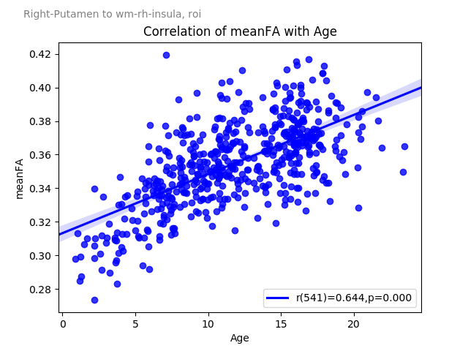

Figure 40 Right-Putamen to wm-rh-insula meanFA correlation with age

## Machine Learning

[TODO] demonstration of ML techniques here, showing KNN, then PCA+KNN, then hand-selected top-correlated to age with lift charts using traditional prediction algs

# Conclusion

## Insights from the data

Working out a connectome is an engineering project that spans a number of diverse domains. The resulting software solution has been used to measure whole brain tractography by scaling across several infrastructure topologies, and has produced a dataset well suited for analytical and statistical studies. With more patient data, research into finding biomarkers becomes possible for any disease or condition that is related to brain tractography

Creating a plugin framework within the solution was a flexible way to achieve a platform that is sufficiently versatile to accommodate different skills and interests of researchers with different data requirements and pipelines. New pipelines to establish new measurements enables a wide variety of research projects and is capable of implementing machine learning functionality to perform classification and predictions of patient conditions.

The data derived from this initiative is both revealing and novel. For example, there are several instances where we can see how our measurements could be representing actual learning. Figure 37 depicts a strong correlation between fractional anisotropy of the tract between the Right Putamen and the Right Insula with a patients’ age The putamen is responsible for helping the body with physical movement, and the insula plays a diverse role in emotions, self-awareness, and the body’s homeostatis. In theory, we are seeing a refinement in brain development as the tract that connectects those two regions becomes more diffusion directed with use, where the tracts that are less useful or less needed get pruned. Are we seeing patients learn the benefits of improved motor control?

We have identified how formative and important the first two years of life are, where the brain is still very fluid and flexible, not yet limited (or trained) from life’s experiences. As we move into the development stage of life, we see significant expansion and change in the degree of diffusion directed axonal fibers. This non-invasice technology can be useful in measuring some early-stage brain development issues, as it does not require interaction from patients.

In some cases, we have seen significant differences in gender, opening the door to future research that studies how gender plays a role in brain development, learning opportunities, capabilities, and opportunity.

## Reliability

This is a big data problem with a high potential to fail given the resource requirements to render each patient data. [TODO indicate scale of patient samples] Left unattended, this process would have produced almost a petabyte of data. It was important to make decisions on where to prune, what data to leave out, and what data to keep. Much of the intermediate data rendered during the pipeline was discarded because of the ability to re-create if needed. This had a consequence of delaying recovery in the event of failure, since this each intermediate file had to be recreated.

Reliable multi-core computing hardware with lots of disk space is necessary to be able to achieve computation in a reasonable timeline. The ideal computing environment is one with a large number of high memory multi-core machines connected to a SAN through fibre across multiple controller cards. Since we didn’t have that technology, we had to design the code to be fault tolerant, versatile and recoverable. The Compute Canada infrastructure would serve this purpose, however the high performance scratch disk limits were too limited to render all data at once. This meant a considerable amount of inventory control and movement of folders to and from staging areas. If access to a permanent large capacity data store with temporary RAM drives were available, the processing would have been much simpler.

On a well performing 40-core node with dedicated storage and sufficient RAM to provide a 16GB RAM drive, a patient visit can be rendered in approximately 5 hours. On compute Canada resources with the same number of cores and memory, a slower disk and no RAM drive, it took approximately 10-12 hours to complete a single patient. The high-IO performance is a key factor in computing a large number of patient visits reliably. Without the availability of large high-speed storage, there is considerable baby-sitting necessary to deliver an outcome on a timely manner.

Occasionally, issues were found after some patient visits were rendered. In the very early stages it was necessary to start again. In some cases, it was possible to correct specific measures without having to re-compute the entire pipeline. Using a plugin framework allowed the flexibility to write adapted code separate from the main “levman plugin” written initially. As changes were made, regression testing was necessary to ensure changes didn’t impact already executed code which would have invalidated some of the results.

One of the challenges with testing this big data problem was the large amount of white space in the data. Since we are looking for intersections between each ROI to every other ROI, we saw a considerable amount of NULL data, indicating there was no measurable connection. It easy to become accustomed to seeing no data, and as a result it may feel normal. This exercise would have been improved by writing automated test cases first to improve the reliability of regression testing.

An additional characteristic of data is found in the complexity added due to the large number of features. There were 1589952 features to this dataset, with only 541 rows (24 measures x 182 roi starting points x 182 roi end points x 2 methods). Performing factor reduction techniques improved the ability of ML algorithms to predict Age for example, but we were able to improve the predictive model ____TODO____ by manually identifying ROIs that are correlated to age, and then establishing a predictive model on age.

## Challenges and Issues Encountered

### Resource Limitations

The most significant challenge with this initiative was finding enough compute resources to process the pipeline. Each phase of the leman pipeline has different computing requirements, depending on the phase. Further, each type of hardware used to compute the results performed differently. As a result, the resources requested on Compute Canada clusters tended to appear under-utilized after completion. There were times when we requested 32 cores and only used 1 core over several hours. This resulted in requesting more resources than necessary (when viewed in aggregate), and having to wait for time on the scheduler to receive those resources. E.g. a request for a whole node (32 core, 128GB memory) was the least likely to abend, but also hardest to obtain from the scheduler.

For the early phases of the pipeline (1-8), the tasks do not take advantage of parallelism because of the interdependency of the data, each step building off the previous. As well, the utilities used in the pipeline do not provide parallelism switches to take advantage of multiple cores. A perfect machine for phases 1-8 has a CPU with a high clock speed and RAID 0 or RAID10 disk. Multiple cores are wasted in this phase since all of the tasks are single threaded.

The fibre tracking step (step 9) was written to take advantage of all cores available on the computer. An optional switch (-maxcores) was provided to force a maximum number of cores used to allow the machine to perform adequately for other functions. The perfect machine in this phase is a high number of cores, 2GB RAM per core. Configurations with less than 2GB memory/core resulted in out of memory errors.

Table 17 - Pipeline Compute Requirements

|  |  |  |  |  |
| --- | --- | --- | --- | --- |
| **#** | **Phase** | **Step** | **Duration** | **Computing Requirements** |
| 1 | 1 | Convert input files to NIFTI format | [TODO] | Serial, high CPU, low I/O, 1 core |
| 2 | 1 | Correction for distortion and subject motion |  | Serial, high CPU, low I/O, 1 core |
| 3 | 1 | Calculate the reconstruction matrix from a given gradient table |  | Serial, high CPU, low I/O, 1 core |
| 4 | 1 | Reconstruct raw images to ODF with a given pre-calculated recon matrix |  | Serial, high CPU, low I/O, 1 core |
| 5 | 1 | Perform fiber tracking from the reconstructed odf data and output a track file for TrackVis |  | Serial, high CPU, low I/O, 1 core |
| 6 | 1 | Brain image registration using FSL |  | Serial, high CPU, low I/O, 1 core |
| 7 | 1 | Transform the tract using registration matrix |  | Serial, high CPU, low I/O, 1 core |
| 8 | 1 | Reconstruct raw analyze images to tensors |  | Serial, high CPU, low I/O, 1 core |
| 9 | 2 | Perform fiber tracking from the reconstructed tensors |  | Parallel, High CPU, low I/O unless restart required. |
| 10 | 3 | Extract data set |  | Serial, High CPU, high I/O. |

#### CEDAR

Available disk space to stage the data was very limited on the CEDAR cluster. The maximum number of patient visits that could fit on the available scratch space was 10. The project disk space was larger but considerably slower. It took approximately 48 hours to process a single sample when project disk was used. To rsync the data from project to scratch took approximately 5 hours per patient. If using rsync to scratch, to compute a single sample on cedar after mirroring data to the scratch disk took approximately 26 hours of elapsed time. This became further complicated if the task failed (e.g. scheduled time expired or out of memory errors). Keeping a partially rendered sample and restarting from the point of failure was challenging because it required individual investigation to understand root cause, and assessment of whether a restart is viable. In some cases it was necessary to perform a manual repair if needed (e.g. corrupt output file due to out-of-memory) to not lose time.

#### GRAHAM

The GRAHAM cluster was more reliable than CEDAR and offered more space on the scratch disk, however not all patient samples could fit, and it was not safe to leave samples on scratch, since that space is routinely purged of untouched files after 60 days. As a result, only 100 samples were put on GRAHAM. Requesting a whole node to compute samples introduced time delays, since the SLURM scheduler could go days without providing a single job execution.

#### Alienware

There were three Alienware servers available near the end of the project. These machines were configured with Windows 10 Pro and the Ubuntu linux sub-system. Ubuntu 18.04 was available, and the recommended OS for FSL, Freesurfer, and Trackvis. There were technical issues with the available version, and required some OS configuration to ensure shared objects were available. Once configured, the system could render a patient sample in approximately 11 hours, 45 minutes. This configuration was reliable and predictable, but there were only three nodes (initially only one), which meant 12 samples could be completed per day. Uninterrupted, it would take approximately 2 years to complete all samples using those nodes. Since these machines were on-domain, they frequently required windows updates, which required a restart approximately every few weeks.

#### Dell Precision Tower (40 core)

The most stable platform to execute the pipeline was the Dell Precision Tower (40 core) running Linux Mint 19 (Tara). This unit is capable of rendering the entire pipeline in just over 8 hours. This unit was only available in the last two months of the project, and a second was available in the past few weeks.

### Disk Contention

None of the compute resources available had disks configured for high I/O performance, and there were a number of cases where a high degree of spindles across multiple controller cards could have greatly improved performance. Step 9 of the pipeline writes output of each intersection point to support recoverability of the process. This is a highly parallel step, processing 32000 intersections per sample. Each process executed in this step performed a disk read, then CPU intensive activity, then a disk write to store the result. 32,000 files are produced in total. In early versions of the code, searching the inode table for the correct files appeared to be adding disk contention and high disk-waits. The code was modified to use a taxonomy structure for these temporary files, which somewhat improved the performance of step 9.

Additionally, there is limited documentation online for the track_vis utility command line switches. It wasn’t apparent until late in the project that a –disable_log switch existed. This allowed the trackvis.log file to be ignored, and significantly improved performance and reduced disk waits.

## Proposed Enhancements

### Improved Parallelism on Data Recall

Each patient sample dataset is stored separately in a tracts.txt file. This provides a level of independence between patients and reduces the dependency on infrastructure to store aggregate data. In addition, there are computed measures (left-right asymmetry indexes) computed during recall. The consequence of this storage approach is that retrieval can be slow, depending on the number of samples being retrieved.

A possible improvement to this model is to fetch each patient sample as a separate parallel process during data recall, and reassemble the dataset once the additional measure are computed.

### REDIS

Since each patient sample is stored in a text file beneath the sample directory, I/O contention can arise as data is written and recalled in several steps of the processing pipelnie. Since data is stored in name-value pairs, a REDIS repository may be useful. REDIS is known for high efficiency data storage and recall on data of this nature, and would allow data to be stored separately if desired. This could allow the solution to scale, and improve the accessibility of the data. A drawback of this approach is that REDIS is not available on traditional research technology like the environments available on Compute Canada. One of the objectives of this initiative was to produce a tool that could be widely adopted by other researchers without burdening them with extensive software configuration. The current solution relies only on the toolsets needed by the pipeline (Freesurfer, TrackVis, etc).

### Improved Fault Detection

The ability for CRUSH to sense what phase of the pipeline hasn’t been completed is limited to simple file detection. If a file exists, it is used for determining what steps need to be completed. CRUSH does not evaluate the file for data corruption. For example, if during the first phase of the pipeline, images were being converted to Nifti format but an out-of-memory error cause the process to abend, a partial Nifti file may exist, but be invalid. On restart, CRUSH will determine the file exist and not reconvert the files, moving ahead to step 2. The process will still fail at step 2, but manual intervention will need to occur to correct the issue. A log file with clear chroma-coded warning messages supports debugging, but the novice user may not be able to get past the issue.

### Add Pre-Pipeline Phase

As seen in Table 1 - Pipeline Compute Requirements, there are two major steps of the processing pipeline: Phase 1 prepares the sample data for ROI-ROI feature extraction, and is largely serial in nature due to how each steps builds on the last. This interdependency of data results in a compute node being underutilized – using only one core of the entire node for most of this phase. In phase 2, at the point where ROI-ROI feature extraction is spawned, CRUSH begins using all cores available (unless limited with *–maxcores*). One way to improve processing performance is to conduct phase 1 of each sample in parallel to other samples. This can be achieved using the *–norender* switch. This switch effectively turns off Phase 2, where the cartesian product of each ROI is spawned for measurement. After phase 1 of all samples completes, phase 2 of all samples could be conducted. The current CRUSH solution does not easily support a daisy chaining of phase 1 and phase 2.

### Service based execution on commodity hardware

One of the largest hindrances of this exercise was the limited availability of computing resources. I can imagine a docker-style container running on underused lab computers that activates during low periods and runs a payload of execution tasks, similar to SETI-at-home meets Hadoop. This could allow data to remain on premise, leverage hundreds of low-use compute nodes, and execute discardable (or recoverable) execution pipelines.

## Final Remarks

This technology provides the capability to performing research on the human connectome without requiring extensive coding experience. It enables users to focus their attention on novel tractography pipelines, data, and machine learning algorithms, and removes them from the burden of the orchestration of parallelism, file management, and data extraction. By providing an extensible plugin-based architecture, the core codebase can remain relatively stable while exposing the capability to write new and sharable plugins between academic researchers.

It is my aspiration that CRUSH matures into a freely available product and becomes a tool used routinely by neuroscientists.

# Bibliography

Braitenberg, V. a. (1998). *Statistics and Geometry of Neuronal Connectivity (Second Edition).* Berlin: Springer-Verlag.

Smith, S. M.-B. (2004). Advances in functional and structural MR image analysis and implementation as FSL. *Neuroimage*, 23 (Suppl. 1), S208-S219.

Wedeen, V. J. (2008). Diffusion spectrum magnetic resonance imaging (DSI) tractography of crossing fibers. *Neuroimage*, 41, 1267–1277.

# Appendix 1

## crush.py

import os, sys, argparse,re

from tractcrush.samples import Samples

from tractcrush.ux import MsgUser

import numpy

from multiprocessing import cpu_count

class readable_dir(argparse.Action):

def __call__(self, parser, namespace, values, option_string=None):

prospective_dir = values

if not os.path.isdir(prospective_dir):

MsgUser.failed("-samples path ({0}) is not a valid path".format(prospective_dir))

exit(1)

#raise argparse.ArgumentTypeError("readable_dir:{0} is not a valid path".format(prospective_dir))

if os.access(prospective_dir, os.R_OK):

setattr(namespace, self.dest, prospective_dir)

else:

MsgUser.failed("-samples path ({0}) is not a readable dir".format(prospective_dir))

exit(1)

#raise argparse.ArgumentTypeError("readable_dir:{0} is not a readable dir".format(prospective_dir))

def VersionCheck():

fsFile = "%s/build-stamp.txt" % (os.environ['FREESURFER_HOME'])

if os.path.isfile(fsFile) == False:

MsgUser.failed("FreeSurfer is MISSING (%s)" % (fsFile))

with open(fsFile, "r") as f:

fsv_content = f.readlines()

m = re.search(r'freesurfer-.*-stable-pub-(\w+)', fsv_content[0]) # -[a-zA-Z0-9]{7}

if m:

fsversion = m.group(1).strip()

if fsversion == "v6":

MsgUser.ok("Freesurfer Version v6 detected and supported")

else:

MsgUser.warning("Freesurfer Version %s detected. CRUSH wasn't tested with this version" % fsversion)

else:

MsgUser.warning("Unable to determine valid FreeSurfer version in file (%s)" % fsFile)

def StatusReport(args,S):

l_v = 0

print("Sample size:%i" % (len(S.Patients)))

for p in S.Patients:

if (args.patient is not None and args.patient != p.PatientId):

continue

l_v += len(p.Visits)

for p in S.Patients:

if (args.patient is not None and args.patient != p.PatientId):

continue

for v in p.Visits:

if v.ReconComplete:

l_reconall_message = "Cortical Reconstruction Complete"

else:

l_reconall_message = "Cortical Reconstruction INCOMPLETE"

if not v.ReconComplete:

l_parcellation_message = "NOT Parcellated"

else:

l_parcellation_message = "Parcellated"

if not v.MeasurementComplete:

l_measurement_message = "NO Measurements"

else:

l_measurement_message = "Measurement Complete"

print("%s/%s %s, %s, %s" % (

p.PatientId, len(p.Visits), l_reconall_message, l_parcellation_message, l_measurement_message))

def ProcessSamples(args,S):

print("no render")

for p in S.Patients:

if (args.patient is not None and args.patient != p.PatientId):

continue

for v in p.Visits:

if v.ReconComplete != True:

MsgUser.warning("\t%s recon incomplete" % (v.VisitId))

else:

v.Render()

v.Measure()

def main():

ldir = "."

parser = argparse.ArgumentParser(

description='Connectomics and Reporting User Shell is used to iterrogate samples, generate or extract measurements.')

parser.add_argument('-samples', action=readable_dir, default=ldir, help="Path to patient samples")

parser.add_argument('-status', action="store_true", help="Report back what is out there and what needs to be done")

parser.add_argument('-recon', action='store_true', help='Apply recon-all for any T1.mgz found beneath working folder')

parser.add_argument('-norender', action='store_true', default='n',

help='If there are incomplete connectomes, ignore the outstanding work')

parser.add_argument('-rebuild', action='store_true',

help='Recreate any intermediary files used for establishing measurements. If this not specified, any intermetiate files found with the appriate file name will be left untouched.')

parser.add_argument('-patient', action='store',

help='Specify patient ID of interest if focusing on a single patient')

parser.add_argument('-voi', action='store',

help='Values of Interest - Path to text file that lists values of interest to extract. One column per line. Look at any patient sample tractography\\crush\\tracts.txt file for measures.')

parser.add_argument('-recrush',action='store_true',

help='Ignore anything previosly crushed and re-extract tract information')

parser.add_argument('-fixmissing',action='store_true',

help='Ignore anything previosly crushed and extract only tract information that has not been rendered yet')

parser.add_argument('-report',action='store_true',

help='Extract a row-based table for analysis, 1 row per measure')

parser.add_argument('-columnar',action='store_true',

help='Extract a column-based table for analysis, 1 row per patient')

parser.add_argument('-metadata',action='store',

help='Path to metadata file about patient. The metadata file should have the CSV format Patient,Visit,Attr1..AttrN')

parser.add_argument('-maxcores',action='store',type=int,

help='Maximum number of cores to use while deriving measurements. Use this if you want to leave a little CPU room left for other processing. By default, all cores will be used (%s cores on this machine).' %(cpu_count()))

parser.add_argument('-disable_log',action='store_true',

help='If specified, disable track_vis.log')

args = parser.parse_args()

S = Samples(args.samples, args.rebuild, args.voi, args.recrush,args.metadata,args.fixmissing,args.maxcores,args.disable_log)

if (args.report):

S.Report()

exit()

if (args.columnar):

S.Columnar()

exit()

# Read VOI into array

if (args.voi):

if os.path.isfile("%s" % (args.voi)):

# Print Header

row=[]

row.append("PatientID")

row.append("VisitID")

with open(args.voi) as f:

content = f.readlines()

content = [x.strip() for x in content] # Remove Whitespace

for c in content:

row.append(c)

print(",".join(row))

for p in S.Patients:

if (args.patient is not None and args.patient != p.PatientId):

continue

# Print values from each patient visit

for v in p.Visits:

v.Report2()

#print(v.data)

else:

print("voi file not found (%s)" % (args.voi))

else:

VersionCheck()

print("\n################## CRUSH ##################")

print("# Connectomics and Reporting User Shell #")

print("###########################################\n")

if S.Patients is None:

print("No patient samples found in path [%s]. Specify -samples for alternate path." % (args.samples))

else:

# STATUS REPORT ############################################################

if (args.status):

StatusReport(args,S)

# RENDER ANYTHING OUTSTANDING ##############################################

if ((args.status is None or args.status==False) and (args.norender is None or args.norender != 'y')):

ProcessSamples(args,S)

MsgUser.ok("We are done")

if __name__ == '__main__':

main()

## Patient.py

import os, sys,inspect

import subprocess

#from pathlib import Path

from tractcrush.ux import MsgUser

from tractcrush.visit import Visit

class Patient:

def __init__(self,path,rebuild,voi,recrush,fixmissing,maxcores,disable_log):

self.PatientId=os.path.basename(path)

self.rebuild=rebuild

self.voi=voi

self.recrush=recrush

self.fixmissing=fixmissing

self.maxcores=maxcores

self.disable_log=disable_log

self.Visits=[]

visits = os.listdir( path )

for v in visits:

visitPathTest="%s/%s/Freesurfer/mri" % (path,v)

if os.path.exists(visitPathTest) and v!="fsaverage":

visitPath="%s/%s" %(path,v)

thisVisit = Visit(visitPath,self.rebuild,voi,recrush,fixmissing,maxcores,self.disable_log)

self.Visits.append(thisVisit)

## Visit.py

import os, sys,inspect

#from gevent import monkey

#monkey.patch_all()

#from gevent.pool import Pool

import subprocess

import numpy as np

import re

import time

#from threading import Thread

import uuid

#from pathlib import Path

from tractcrush.ux import MsgUser

import nibabel as nib

from shutil import copyfile

from multiprocessing import Pool,cpu_count

import csv

import warnings

from collections import defaultdict

import json

class Visit:

def unicode_csv_reader(utf8_data, dialect=csv.excel, **kwargs):

csv_reader = csv.reader(utf8_data, dialect=dialect, **kwargs)

for row in csv_reader:

yield [unicode(cell, 'utf-8') for cell in row]

def __init__(self,path,rebuild,voi,recrush,fixmissing,maxcores,disable_log):

self.VisitId=os.path.basename(path)

self.path=path

self.rebuild=rebuild

self.voi=voi

self.recrush=recrush

self.fixmissing=fixmissing

if maxcores:

self.maxcores=maxcores

else:

self.maxcores=9999

self.data = defaultdict(list)#{}

self.PatientId=os.path.split(os.path.dirname(self.path))[1]

reconTest= "%s/Freesurfer/mri/wmparc.mgz" % (path)

self.disable_log=disable_log

if os.path.isfile(reconTest):

self.ReconComplete=True

else:

self.ReconComplete=False

measurementTest = "%s/Tractography/crush/tracts.txt" % (path)

#print(measurementTest)

if os.path.isfile(measurementTest):

self.MeasurementComplete=True

else:

self.MeasurementComplete=False

self.Segments = []#{}

i=1

segmentMap="%s/%s" %(os.path.dirname(os.path.abspath(inspect.getfile(inspect.currentframe()))),"segmentMap.txt")

with open(segmentMap) as fin:

reader=csv.reader(fin, skipinitialspace=True, quotechar="'")

p = re.compile('^ *#') # if not commented

for row in reader:

#print("%s,%s" %(i,row))

if(not p.match(row[0])):

self.Segments.append({'roi':row[0],'roiname':row[1],'asymmetry':row[2]})

i=i+1

def is_number(self,s):

try:

float(s)

return True

except ValueError:

return False

def Render(self):

#Lets Render as needed

MsgUser.message("Rendering %s" % self.path)

self.mgz2nifti()

self.eddy_correct()

self.hardi_mat()

self.odf_recon()

self.odf_tracker()

self.flirt()

self.tract_transform()

self.dti_recon()

self.dti_tracker()

def Measure(self):

self.track_vis()

def GetMeasurements(self):

Measurements={}

#print(self.Segments)

self.data[self.PatientId]={}

self.data[self.PatientId][self.VisitId]={}

if os.path.isfile("%s/Tractography/crush/tracts.txt" %(self.path)):

with open("%s/Tractography/crush/tracts.txt" %(self.path)) as fMeasure:

for line in fMeasure:

if line.strip() != "":

nvp=line.split("=")

self.data[self.PatientId][self.VisitId][nvp[0]]=nvp[1].strip()

if self.is_number(nvp[1].strip()) and nvp[1].strip()!="nan":

Measurements[nvp[0]]=nvp[1].strip()

else:

Measurements[nvp[0]]="" #convert nan to missing value

## Add derived measures here

#print("Deriving Asymmetry Indexes")

asymMeasuresToAdd = {}

for m in self.data[self.PatientId][self.VisitId]:

if m[-8] != "-asymidx":

m0 = re.match("^(\w+)-(\w+)-(\w+)-(\w+)",m)

if m0:

l_roi = m0.group(1)

l_roiE = m0.group(2)

l_method = m0.group(3)

l_measure = m0.group(4)

l_roiC=""

l_roiEC=""

#print("%s, %s" %(l_roi,l_roiE))

for s in self.Segments:

if s['roi']==l_roi:

l_roiC = s['asymmetry']

if s['roi']==l_roiE:

l_roiEC = s['asymmetry']

asymCounterpart = "%s-%s-%s-%s" %(l_roiC,l_roiEC,l_method,l_measure)

if asymCounterpart in self.data[self.PatientId][self.VisitId]:

if self.is_number(self.data[self.PatientId][self.VisitId][m]) and self.is_number(self.data[self.PatientId][self.VisitId][asymCounterpart]) and float(self.data[self.PatientId][self.VisitId][asymCounterpart]) != 0:

asymIdx=float(self.data[self.PatientId][self.VisitId][m]) / float(self.data[self.PatientId][self.VisitId][asymCounterpart])

asymMeasuresToAdd["%s-asymidx" %(m)] = asymIdx

for newm in asymMeasuresToAdd:

if self.is_number(str(asymMeasuresToAdd[newm])):

Measurements[newm]=str(asymMeasuresToAdd[newm])

## End of derived measures

return Measurements

def MeasurementAudit(self):

tasks = []

for s in self.Segments:

segment=s['roi']

segmentName=s['roiname']

for c in self.Segments:

counterpart=c['roi']

counterpartName=c['roiname']

if (segment!=counterpart and segment<counterpart):

methods=[] #Methods represents the possible ROI switches to trackvis, e.g methods = ["roi","roi_end"]

methodFile="%s/%s" %(os.path.dirname(os.path.abspath(inspect.getfile(inspect.currentframe()))),"methods.txt")

with open(methodFile) as fin:

reader=csv.reader(fin, skipinitialspace=True, quotechar="'")

p = re.compile('^ *#') # if not commented

for row in reader:

if(not p.match(row[0])):

methods.append(row[0])

for method in methods:

#print("Rendering segment %s counterpart %s method %s" %(segment, counterpart, method))

if segment != counterpart:

completeInd = self.MeasurementAudit_worker(segment,counterpart,method)

if completeInd:

#Get into global data array

for m in completeInd:

self.data[self.PatientId][self.VisitId][m] = completeInd[m]

MsgUser.ok("Measurement complete: %s %s %s" %(segment,counterpart,method))

else:

MsgUser.failed("Measurement incomplete: %s %s %s" %(segment,counterpart,method))

tasks.append(completeInd)

l=len(tasks)

positives = 0

for t in tasks:

if t:

positives += 1

print("%s/%s is %s percent complete. %s positives" %(self.PatientId, self.VisitId,positives/l*100,positives))

return completeInd

def MeasurementAudit_worker(self,segment,counterpart,method):

calcs={}

calcsJson = "%s/Tractography/crush/%s/calcs-%s-%s-%s.json" % (self.path,segment,segment,counterpart,method)

if os.path.isfile(calcsJson):

with open(calcsJson, 'r') as f:

calcs = json.loads(f.read())

return calcs

else:

#Check for and Fix legacy structure and put JSON in segment folders

calcsOldJson = "%s/Tractography/crush/calcs-%s-%s-%s.json" % (self.path,segment,counterpart,method)

if os.path.isfile(calcsOldJson):

with open(calcsOldJson, 'r') as f:

calcs = json.loads(f.read())

if not os.path.isdir("%s/Tractography/crush/%s" % (self.path,segment)):

os.mkdir("%s/Tractography/crush/%s" % (self.path,segment))

os.rename(calcsOldJson,calcsJson)

return calcs

l_NumTracts = False

l_TractsToRender = False

l_LinesToRender = False

l_MeanTractLen = False

l_MeanTractLen_StdDev = False

l_VoxelSizeX = False

l_VoxelSizeY = False

l_VoxelSizeZ = False

l_meanFA = False

l_stddevFA = False

l_meanADC = False

l_stddevADC = False

p = "%s-%s-%s-NumTracts" %(segment,counterpart,method)

if(p in self.data[self.PatientId][self.VisitId]):

l_NumTracts=True

calcs[p]= self.data[self.PatientId][self.VisitId][p]

p = "%s-%s-%s-TractsToRender" %(segment,counterpart,method)

if(p in self.data[self.PatientId][self.VisitId]):

l_TractsToRender=True

calcs[p] = self.data[self.PatientId][self.VisitId][p]

p = "%s-%s-%s-LinesToRender" %(segment,counterpart,method)

if(p in self.data[self.PatientId][self.VisitId]):

l_LinesToRender=True

calcs[p] = self.data[self.PatientId][self.VisitId][p]

p = "%s-%s-%s-MeanTractLen" %(segment,counterpart,method)

if(p in self.data[self.PatientId][self.VisitId]):

l_MeanTractLen=True

calcs[p] = self.data[self.PatientId][self.VisitId][p]

p = r"%s-%s-%s-MeanTractLen_StdDev" %(segment,counterpart,method)

if(p in self.data[self.PatientId][self.VisitId]):

l_MeanTractLen_StdDev=True

calcs[p] = self.data[self.PatientId][self.VisitId][p]

p = "%s-%s-%s-VoxelSizeX" %(segment,counterpart,method)

if(p in self.data[self.PatientId][self.VisitId]):

l_VoxelSizeX=True

calcs[p] = self.data[self.PatientId][self.VisitId][p]

p = "%s-%s-%s-VoxelSizeY" %(segment,counterpart,method)

if(p in self.data[self.PatientId][self.VisitId]):

l_VoxelSizeY=True

calcs[p] = self.data[self.PatientId][self.VisitId][p]

p = "%s-%s-%s-VoxelSizeZ" %(segment,counterpart,method)

if(p in self.data[self.PatientId][self.VisitId]):

l_VoxelSizeZ=True

calcs[p] = self.data[self.PatientId][self.VisitId][p]

p = "%s-%s-%s-meanFA" %(segment,counterpart,method)

if(p in self.data[self.PatientId][self.VisitId]):

l_meanFA=True

calcs[p] = self.data[self.PatientId][self.VisitId][p]

p = "%s-%s-%s-stddevFA" %(segment,counterpart,method)

if(p in self.data[self.PatientId][self.VisitId]):

l_stddevFA=True

calcs[p] = self.data[self.PatientId][self.VisitId][p]

p = "%s-%s-%s-meanADC" %(segment,counterpart,method)

if(p in self.data[self.PatientId][self.VisitId]):

l_meanADC=True

calcs[p] = self.data[self.PatientId][self.VisitId][p]

p = "%s-%s-%s-stddevADC" %(segment,counterpart,method)

if(p in self.data[self.PatientId][self.VisitId]):

l_stddevADC=True

calcs[p] = self.data[self.PatientId][self.VisitId][p]

if(l_NumTracts and l_TractsToRender and l_LinesToRender and l_MeanTractLen

and l_MeanTractLen_StdDev and l_VoxelSizeX and l_VoxelSizeY and l_VoxelSizeZ

and l_meanFA and l_stddevFA and l_meanADC and l_stddevADC):

#We have everything in the tract file

return calcs

else:

#We don't have everything we need from the tract file

#Lets see if we cached it the last time we processed this sample

#else:

#Can't find any residue - looks like this is a new calc

return {}

def Report2(self):

#MsgUser.bold("Reporting values of interest")

if os.path.isfile("%s" %(self.voi)):

#Determine my interests

with open(self.voi) as f:

voi_interests = f.readlines()

voi_interests = [x.strip() for x in voi_interests] #Remove Whitespace

#Get everything

self.data[self.PatientId]={}

self.data[self.PatientId][self.VisitId]={}

if os.path.isfile("%s/Tractography/crush/tracts.txt" %(self.path)):

with open("%s/Tractography/crush/tracts.txt" %(self.path)) as fMeasure:

for line in fMeasure:

nvp=line.split("=")

self.data[self.PatientId][self.VisitId][nvp[0]]=nvp[1].strip()

## Add derived measures here

#print("Deriving Asymmetry Indexes")

for s in self.Segments:

roi=s['roi']

asymmetry=s['asymmetry']

if asymmetry:

for p in self.data:

for v in self.data[p]:

asymMeasuresToAdd = {}

for m in self.data[p][v]:

#For all measures

searchEx="%s-%s" %(roi,r'(\d+)')

roiGrp = re.search(searchEx, m)

if roiGrp:

ma=m.replace(roi,asymmetry)

if ma in self.data[p][v] and float(self.data[p][v][ma]) != 0:

asymIdx=float(self.data[p][v][m]) / float(self.data[p][v][ma])

else:

asymIdx=0

#self.data[self.PatientId][self.VisitId][ma]=asymIdx

asymMeasuresToAdd["%s-asymidx" %(ma)]=asymIdx

#print("%s [%s] has aymmetry with %s [%s]. ASYM IDX=[%s]" %(m,self.data[p][v][m],ma,self.data[p][v][ma],asymIdx))

#print("%s is %s" %(ma,asymIdx))

for ma in asymMeasuresToAdd:

#print("XX-%s" %(ma))

self.data[p][v][ma] = str(asymMeasuresToAdd[ma])

## End of derived measures

#Print report

for p in self.data:

for v in self.data[p]:

row=[]

row.append(p)

row.append(v)

for m in voi_interests:

if m in self.data[p][v]:

row.append(self.data[p][v][m])

if "%s-asymidx" %(m) in self.data[p][v]:

row.append(self.data[p][v]["%s-asymidx" %(m)])

else:

row.append("")

print(",".join(row))

def Report(self):

#MsgUser.bold("Reporting values of interest")

if os.path.isfile("%s" %(self.voi)):

#Determine my interests

with open(self.voi) as f:

content = f.readlines()

content = [x.strip() for x in content] #Remove Whitespace

#Read the measures that have been pre-derived

measures={}

measures["PatientVisit"]=self.path

if os.path.isfile("%s/Tractography/crush/tracts.txt" %(self.path)):

with open("%s/Tractography/crush/tracts.txt" %(self.path)) as fMeasure:

for line in fMeasure:

nvp=line.split("=")

measures[nvp[0]]=nvp[1]

row=[]

row.append(os.path.split(os.path.dirname(self.path))[1])

row.append(self.VisitId)

#self.data['key'].append

for cell in content:

if cell in measures:

row.append(measures[cell].strip())

# self.data[(os.path.split(os.path.dirname(self.path))[1])][self.VisitId][cell]=measures[cell].strip()

else:

row.append("")

print(",".join(row))

def mgz2nifti(self):

MsgUser.bold("mgz2nifti")

if self.rebuild!=True and os.path.isfile("%s/Freesurfer/mri/brainmask.nii" % (self.path)):

self.NiftiComplete=True

MsgUser.skipped("All Nifti files exist")

else:

MsgUser.warning("\tNifti Incomplete, rendering nii files...")

mgzFiles=['aseg','aparc+aseg', 'aparc.a2009s+aseg', 'lh.ribbon', 'rh.ribbon', 'nu', 'orig', 'ribbon', 'wm.asegedit', 'wm', 'wm.seg', 'brain', 'brainmask']

for mgz in mgzFiles:

if os.path.isfile("%s/Freesurfer/mri/%s.nii" % (self.path,mgz)) :

MsgUser.skipped("\t%s.nii exists" % (mgz))

else:

MsgUser.message("Create or replace %s.nii" % (mgz))

subprocess.call(['mri_convert','-rt','nearest','-nc','-ns','1',"%s/Freesurfer/mri/%s.mgz" %(self.path,mgz),"%s/Freesurfer/mri/%s.nii" % (self.path,mgz)])

def eddy_correct(self):

MsgUser.bold("eddy_correct")

#eddy_correct ~/HealthyTractography/%s/%s/DTI35.nii ~/HealthyTractography/%s/%s/DTI35_eddy.nii 0

if self.rebuild!=True and os.path.isfile("%s/Tractography/DTI35_eddy.nii.gz" %(self.path)):

MsgUser.skipped("eddy_correct output exists")

else:

cmdArray=["eddy_correct","%s/Tractography/DTI35.nii" % (self.path),"%s/Tractography/DTI35_eddy.nii.gz" % (self.path),"0"]

print (cmdArray)

subprocess.call(cmdArray)

MsgUser.ok("eddy_correct Completed")

def hardi_mat(self):

MsgUser.bold("hardi_mat")

if self.rebuild!=True and os.path.isfile("%s/Tractography/temp_mat.dat" %(self.path)):

MsgUser.skipped("hardi_mat output exists")

else:

defaultGradientMatrix ="%s/%s" %(os.path.dirname(os.path.abspath(inspect.getfile(inspect.currentframe()))),"gradientMatrix.txt")

cmdArray=["hardi_mat",defaultGradientMatrix,"%s/Tractography/temp_mat.dat" % (self.path), "-ref","%s/Tractography/DTI35_eddy.nii.gz" % (self.path),"-oc"]

print(cmdArray)

subprocess.call(cmdArray)

MsgUser.ok("HARDIReconstruction Completed")

def odf_recon(self):

MsgUser.bold("odf_recon")

#output: DTI35_Recon_max.nii.gz

if self.rebuild!=True and os.path.isfile("%s/Tractography/DTI35_Recon_max.nii.gz" %(self.path)):

#odf_, max_, dwi_, b0 files should exist

MsgUser.skipped("odf_recon output exists")

else:

cmdArray=["odf_recon","%s/Tractography/DTI35_eddy.nii.gz" %(self.path),"31","181","%s/Tractography/DTI35_Recon" %(self.path),"-b0", "5","-mat","%s/Tractography/temp_mat.dat" %(self.path),"-p","3","-sn", "1", "-ot", "nii.gz"]

print(cmdArray)

subprocess.call(cmdArray)

MsgUser.ok("odf_recon Completed")

def odf_tracker(self):

MsgUser.bold("odf_tracker")

#output: DTI35_Recon_max.nii.gz

if (self.rebuild!=True and os.path.isfile("%s/Tractography/DTI35_Recon_dwi.nii.gz" %(self.path)) == False):

MsgUser.failed("odf_tracker cannot be completed, odf_recon did not finish, missing DTI35_Recon files")

return

if self.rebuild!=True and os.path.isfile("%s/Tractography/DTI35_preReg.trk" %(self.path)):

#odf_, max_, dwi_, b0 files should exist

MsgUser.skipped("odf_tracker output exists")

else:

cmdArray=["odf_tracker","%s/Tractography/DTI35_Recon" %(self.path),"%s/Tractography/DTI35_preReg.trk" %(self.path),"-at","45","-m", "%s/Tractography/DTI35_Recon_dwi.nii.gz" %(self.path),"-it","nii.gz"]

print(cmdArray)

subprocess.call(cmdArray)

MsgUser.ok("odf_tracker Completed")

def flirt(self):

MsgUser.bold("flirt")

#output: RegTransform4D

if self.rebuild!=True and os.path.isfile("%s/Tractography/RegTransform4d" %(self.path)):

MsgUser.skipped("flirt output exists")

else:

#flirt -in ./DTI35_eddy.nii.gz -ref ./brainmask.nii -omat ./RegTransform4D

cmdArray=["flirt","-in","%s/Tractography/DTI35_eddy.nii.gz" %(self.path),"-ref","%s/Freesurfer/mri/brainmask.nii" %(self.path),"-omat","%s/Tractography/RegTransform4d" %(self.path)]

print(cmdArray)

subprocess.call(cmdArray)

MsgUser.ok("flirt Completed")

def tract_transform(self):

MsgUser.bold("tract_transform")

#output: DTI35_postReg.trk

if self.rebuild!=True and os.path.isfile("%s/Tractography/DTI35_postReg.trk" %(self.path)):#TODO Need correct filename

#odf_, max_, dwi_, b0 files should exist

MsgUser.skipped("tract_transform output exists")

else:

#track_transform DTI35_preReg.trk DTI35_postReg.trk -src DTI35_Recon_dwi.nii.gz -ref brainmask.nii -reg RegTransform4D

cmdArray=["track_transform","%s/Tractography/DTI35_preReg.trk" %(self.path),"%s/Tractography/crush.trk" %(self.path),"-src","%s/Tractography/DTI35_Recon_dwi.nii.gz"%(self.path),"-ref", "%s/Freesurfer/mri/brainmask.nii" %(self.path),"-reg","%s/Tractography/RegTransform4D"%(self.path)]

print(cmdArray)

subprocess.call(cmdArray)

MsgUser.ok("tract_transform Completed")

def dti_recon(self):

MsgUser.bold("dti_recon")

if self.rebuild!=True and os.path.isfile("%s/Tractography/DTI35_Reg2Brain_fa.nii" %(self.path)):#TODO we could test for all files to be sure

#odf_, max_, dwi_, b0 files should exist

MsgUser.skipped("dti_recon output exists")

else:

defaultGradientMatrix ="%s/%s" %(os.path.dirname(os.path.abspath(inspect.getfile(inspect.currentframe()))),"gradientMatrix.txt")

#dti_recon "%s/Tractography/DTI35_eddy.nii.gz" %(self.path) "%s/Tractography/dave/DTI35_Reg2Brain" %(self.path) -gm "%s" %(defaultGradientMatrix) -b 1000 -b0 5 -p 3 -sn 1 -ot nii

cmdArray=["dti_recon","%s/Tractography/DTI35_eddy.nii.gz" %(self.path),"%s/Tractography/DTI35_Reg2Brain" %(self.path),"-gm",defaultGradientMatrix,"-b", "1000","-b0","5","-p","3","-sn","1","-ot","nii"]

print(cmdArray)

subprocess.call(cmdArray)

MsgUser.ok("dti_recon Completed")

def dti_tracker(self):

MsgUser.bold("dti_tracker")

if self.rebuild!=True and os.path.isfile("%s/Tractography/crush.trk" %(self.path)):

MsgUser.skipped("dti_tracker output exists")

else:

#dti_tracker DTI35_Reg2Brain DTI35_postReg.trk -m DTI35_Reg2Brain_fa.nii 0.15

cmdArray=["dti_tracker","%s/Tractography/DTI35_Reg2Brain" %(self.path),"%s/Tractography/crush.trk" %(self.path),"-m","%s/Tractography/DTI35_Reg2Brain_fa.nii"%(self.path),"-at","35","-m","%s/Tractography/DTI35_Reg2Brain_dwi.nii" %(self.path),"-it","nii"]

print(cmdArray)

subprocess.call(cmdArray)

MsgUser.ok("dti_tracker Completed")

def trackvis_create_nii(self,segment,counterpart,method):

if os.path.isfile("%s/Tractography/wmparc%s.nii.gz" %(self.path,segment)) and os.path.isfile("%s/Tractography/wmparc%s.nii.gz" %(self.path,counterpart)):

if self.disable_log:

trackvis = ["track_vis","%s/Tractography/crush.trk" %(self.path),"-%s"%(method),"%s/Tractography/wmparc%s.nii.gz" %(self.path,segment),"-%s2" %(method),"%s/Tractography/wmparc%s.nii.gz" %(self.path,counterpart),"-nr", "-ov","%s/Tractography/crush/%s-%s-%s.nii" %(self.path,segment,counterpart,method),"-disable_log"]

else:

trackvis = ["track_vis","%s/Tractography/crush.trk" %(self.path),"-%s"%(method),"%s/Tractography/wmparc%s.nii.gz" %(self.path,segment),"-%s2" %(method),"%s/Tractography/wmparc%s.nii.gz" %(self.path,counterpart),"-nr", "-ov","%s/Tractography/crush/%s-%s-%s.nii" %(self.path,segment,counterpart,method)]

if not os.path.isfile("%s/Tractography/crush/%s-%s-%s.nii" %(self.path,segment,counterpart,method)):

with open("%s/Tractography/crush/%s-%s-%s.nii.txt" %(self.path,segment,counterpart,method), "w") as track_vis_out:

proc = subprocess.Popen(trackvis, stdout=track_vis_out)

proc.communicate()

# os.remove("%s/Tractography/crush.%s.trk" %(self.path,tmpFile))

with open ("%s/Tractography/crush/%s-%s-%s.nii.txt" %(self.path,segment,counterpart,method), "r") as myfile:

data=myfile.read()

return data

else:

return ""

def trackvis_cleanup_nii(self,segment,counterpart,method):

nii = "%s/Tractography/crush/%s-%s-%s.nii" %(self.path,segment,counterpart,method)

datafile = "%s/Tractography/crush/%s-%s-%s.nii.txt" %(self.path,segment,counterpart,method)

oldcalcsfile = "%s/Tractography/crush/calcs-%s-%s-%s.json" %(self.path,segment,counterpart,method)

if os.path.isfile(nii):

os.unlink(nii)

if os.path.isfile(datafile):

print("Cleanup %s" %(datafile))

os.unlink(datafile)

if os.path.isfile(oldcalcsfile):

print("Cleanup %s" %(oldcalcsfile))

os.unlink(oldcalcsfile)

def trackvis_worker(self,parr):#segment,counterpart,method):

segment=parr[0]

counterpart=parr[1]

method=parr[2]

calcs={}

#track_vis ./DTI35_postReg_Threshold5.trk -roi_end ./wmparc3001.nii.gz -roi_end2 ./wmparc3002.nii.gz -nr

if os.path.isfile("%s/Tractography/wmparc%s.nii.gz" %(self.path,segment)) and os.path.isfile("%s/Tractography/wmparc%s.nii.gz" %(self.path,counterpart)):

render = True

if self.fixmissing:

calcs = self.MeasurementAudit_worker(segment,counterpart,method)

if len(calcs)>0:

MsgUser.ok("Previous calculations detected for %s,%s,%s" %(segment,counterpart,method))

calcsJson = "%s/Tractography/crush/%s/calcs-%s-%s-%s.json" % (self.path,segment,segment,counterpart,method)

if not os.path.isdir("%s/Tractography/crush/%s" % (self.path,segment)):

os.mkdir("%s/Tractography/crush/%s" % (self.path,segment))

with open(calcsJson, "w") as calcs_file:

json.dump(calcs,calcs_file)

self.trackvis_cleanup_nii(segment,counterpart,method)

#MsgUser.skipped("SKIPPING already calculated measures for %s-%s-%s" %(segment,counterpart,method))

return calcs

else:

MsgUser.ok("Rendering missing measures for %s-%s-%s" %(segment,counterpart,method))

data = self.trackvis_create_nii(segment,counterpart,method)

m = re.search(r'Number of tracks: (\d+)', data)

if m:

NumTracts = m.group(1).strip()

else:

NumTracts = 0

calcs["%s-%s-%s-NumTracts" %(segment,counterpart,method)]=NumTracts

############

m = re.search(r'Number of tracks to render: (\d+)', data)

if m:

TractsToRender = m.group(1).strip()

else:

TractsToRender = 0

calcs["%s-%s-%s-TractsToRender" %(segment,counterpart,method)]=TractsToRender

############

m = re.search(r'Number of line segments to render: (\d+)', data)

if m:

LinesToRender = m.group(1).strip()

else:

LinesToRender = 0

calcs["%s-%s-%s-LinesToRender" %(segment,counterpart,method)]=LinesToRender

############

m = re.search(r'Mean track length: (\d+.\d+) +/- (\d+.\d+)', data)

if m:

MeanTractLen = m.group(1).strip()

MeanTractLen_StdDev = m.group(2).strip()

else:

MeanTractLen = 0

MeanTractLen_StdDev = 0

calcs["%s-%s-%s-MeanTractLen" %(segment,counterpart,method)]=MeanTractLen

calcs["%s-%s-%s-MeanTractLen_StdDev" %(segment,counterpart,method)]=MeanTractLen_StdDev

############

m = re.search(r'Voxel size: (\d*[.,]?\d*) (\d*[.,]?\d*) (\d*[.,]?\d*)', data)

if m:

VoxelSizeX = m.group(1).strip()

VoxelSizeY = m.group(2).strip()

VoxelSizeZ = m.group(3).strip()

else:

VoxelSizeX = 0

VoxelSizeY = 0

VoxelSizeZ = 0

calcs["%s-%s-%s-VoxelSizeX" %(segment,counterpart,method)]=VoxelSizeX

calcs["%s-%s-%s-VoxelSizeY" %(segment,counterpart,method)]=VoxelSizeY

calcs["%s-%s-%s-VoxelSizeZ" %(segment,counterpart,method)]=VoxelSizeZ

#FA Mean

meanFA=self.nonZeroMean("%s/Tractography/DTI35_Reg2Brain_fa.nii" %(self.path),"%s/Tractography/crush/%s-%s-%s.nii" %(self.path,segment,counterpart,method))

calcs["%s-%s-%s-meanFA" %(segment,counterpart,method)]=meanFA

#FA Std Dev

stddevFA=self.nonZeroStdDev("%s/Tractography/DTI35_Reg2Brain_fa.nii" %(self.path),"%s/Tractography/crush/%s-%s-%s.nii" %(self.path,segment,counterpart,method))

calcs["%s-%s-%s-stddevFA" %(segment,counterpart,method)]=stddevFA

#ADC Mean

meanADC=self.nonZeroMean("%s/Tractography/DTI35_Reg2Brain_adc.nii" %(self.path),"%s/Tractography/crush/%s-%s-%s.nii" %(self.path,segment,counterpart,method))

calcs["%s-%s-%s-meanADC" %(segment,counterpart,method)]=meanADC

#ADC Std Dev

stddevADC=self.nonZeroStdDev("%s/Tractography/DTI35_Reg2Brain_adc.nii" %(self.path),"%s/Tractography/crush/%s-%s-%s.nii" %(self.path,segment,counterpart,method))

calcs["%s-%s-%s-stddevADC" %(segment,counterpart,method)]=stddevADC

else:

MsgUser.failed("Parcellation (wmparc####.nii) files missing (%s or %s)"%(segment,counterpart))

# Cache CALCS to temp file because it's not written to tracts.txt until the join (after all ROIs finish)

if not os.path.isdir("%s/Tractography/crush/%s" % (self.path,segment)):

os.mkdir("%s/Tractography/crush/%s" % (self.path,segment))

calcsJson = "%s/Tractography/crush/%s/calcs-%s-%s-%s.json" % (self.path,segment,segment,counterpart,method)

with open(calcsJson, "w") as calcs_file:

json.dump(calcs,calcs_file)

############# CLEANUP #################

self.trackvis_cleanup_nii(segment,counterpart,method)

return calcs

def track_vis(self):

MsgUser.bold("track_vis")

#output: crush.txt

self.GetMeasurements()

if self.rebuild!=True and os.path.isfile("%s/Tractography/crush/tracts.txt" %(self.path)):

if(self.fixmissing!=True):

if(self.recrush):

print("Deleting previous crush output")

folder = '%s/Tractography/crush' %(self.path)

for the_file in os.listdir(folder):

file_path = os.path.join(folder, the_file)

try:

if os.path.isfile(file_path):

os.unlink(file_path)

except Exception as e:

print(e)

else:

MsgUser.skipped("track_vis output exists")

return

else:

MsgUser.skipped("some track_vis output exists, I will crush anything missing")

if not os.path.exists("%s/Tractography/crush/" % (self.path)):

os.makedirs("%s/Tractography/crush/" % (self.path))

#self.MeasurementAudit()

#print(self.data)

#return

tasks = []

methods=[] #Methods represents the possible ROI switches to trackvis, e.g methods = ["roi","roi_end"]

methodFile="%s/%s" %(os.path.dirname(os.path.abspath(inspect.getfile(inspect.currentframe()))),"methods.txt")

with open(methodFile) as fin:

reader=csv.reader(fin, skipinitialspace=True, quotechar="'")

p = re.compile('^ *#') # if not commented

for row in reader:

if(not p.match(row[0])):

methods.append(row[0])

for s in self.Segments:

segment=s['roi']

segmentName=s['roiname']

for c in self.Segments:

counterpart=c['roi']

counterpartName=c['roiname']

if (segment!=counterpart):

for method in methods:

#print("Rendering segment %s counterpart %s method %s" %(segment, counterpart, method))

if segment != counterpart:

MsgUser.ok("Setting up %s %s %s" %(segment,counterpart,method))

t = [segment,counterpart,method]

print("Rendering %s against %s using method %s" % (segment,counterpart,method))

tasks.append(t)

no_of_procs = cpu_count()

if(no_of_procs>self.maxcores):

no_of_procs = self.maxcores

print("Multiprocessing across %s async procs" %(no_of_procs))

pool = Pool(no_of_procs)

for t in tasks:

pool.apply_async(self.trackvis_worker, (t,))

pool.close()

pool.join()

MsgUser.ok("@@@@ LETS JOIN IT ALL TOGETHER @@@@ ")

self.MeasurementAudit()

# #calcsPath = "%s/Tractography/crush/calcs-%s-%s-%s.json" % (self.path,segment,counterpart,method)

# calcsPath = "%s/Tractography/crush" % (self.path)

# calcs=[]

# #onlycalcfiles = [f for f in os.listdir(calcsPath) if f[-5:] == ".json" ]

# for f in os.listdir(calcsPath):

# if f[-5:] == ".json":

# #read and add file_path = os.path.join(folder, the_file)

# with open(os.path.join(calcsPath,f), "r") as calcs_file:

# calcs = json.loads(calcs_file.read())

# for m in calcs:

# self.data[self.PatientId][self.VisitId][m] = calcs[m]

# #print("%s=%s" %(m,self.data[self.PatientId][self.VisitId][m]))

# print(self.data[self.PatientId][self.VisitId].)

print("Patient measure count: %s" %(len(self.data[self.PatientId][self.VisitId])))

with open("%s/Tractography/crush/tracts.txt" % (self.path), "w") as crush_file:

for m in self.data[self.PatientId][self.VisitId]:

if m[-8:] !="-asymidx":

crush_file.write("%s=%s\n" % (m,self.data[self.PatientId][self.VisitId][m]))

self.MeasurementComplete=True

MsgUser.ok("track_vis Completed")

def nonZeroMean(self,faFile,roiFile):

if os.path.isfile(faFile) == False:

MsgUser.failed("%s is MISSING" %(faFile))

return

if os.path.isfile(roiFile) == False:

MsgUser.failed("%s is MISSING" %(roiFile))

return

imgFA = nib.load(faFile) #Untouched

dataFA = imgFA.get_data()

img = nib.load(roiFile)

roiData = img.get_data()

indecesOfInterest = np.nonzero(roiData)

#I expect to see runtime warnings in this block, e.g. divide by zero

with warnings.catch_warnings():

warnings.simplefilter("ignore", category=RuntimeWarning)

mean =np.mean(dataFA[indecesOfInterest],dtype=np.float64)

return mean

def nonZeroStdDev(self,faFile,roiFile):

if os.path.isfile(faFile) == False:

MsgUser.failed("%s is MISSING" %(faFile))

return

if os.path.isfile(roiFile) == False:

MsgUser.failed("%s is MISSING" %(roiFile))

return

imgFA = nib.load(faFile) #Untouched

dataFA = imgFA.get_data()

img = nib.load(roiFile)

roiData = img.get_data()

indecesOfInterest = np.nonzero(roiData)

#I expect to see runtime warnings in this block, e.g. Degrees of freedom <= 0 for slice

with warnings.catch_warnings():

warnings.simplefilter("ignore", category=RuntimeWarning)

std =np.std(dataFA[indecesOfInterest],dtype=np.float64)

return std

## segmentMap.txt

#ParcellationId,Label,Asymetry counterpart,Left or Right,White or Grey,Common Name

0002,Left-Cerebral-White-Matter,,Left,White,left cerebral white matter

0004,Left-Lateral-Ventricle,,Left,Neither,left lateral ventricle

0005,Left-Inf-Lat-Vent,,Left,Neither,left inferior lateral ventricle

0007,Left-Cerebellum-White-Matter,0008,Left,White,left cerebellum white matter

0008,Left-Cerebellum-Cortex,0007,Left,Neither,left cerebellum cortex

0010,Left-Thalamus-Proper,,Left,Neither,left thalamus proper

0011,Left-Caudate,,Left,Neither,left caudate

0012,Left-Putamen,,Left,Neither,left putamen

0013,Left-Pallidum,,Left,Neither,left pallidum

0014,3rd-Ventricle,,Neither,Neither,third ventricle

0015,4th-Ventricle,,Neither,Neither,fourth ventricle

0016,Brain-Stem,,Neither,Neither,brain stem

0017,Left-Hippocampus,,Left,Neither,left hippocampus

0018,Left-Amygdala,,Left,Neither,left amygdala

0024,CSF,,Neither,Neither,cerebrospinal fluid

0026,Left-Accumbens-area,,Left,Neither,left accumbens area

0028,Left-VentralDC,,Left,Neither,left ventral diencephalon

0030,Left-vessel,,Left,Neither,left vessel

0031,Left-choroid-plexus,,Left,Neither,left choroid plexus

0041,Right-Cerebral-White-Matter,,Right,White,right cerebral white matter

0043,Right-Lateral-Ventricle,,Right,Neither,right lateral ventricle

0044,Right-Inf-Lat-Vent,,Right,Neither,right inferior lateral ventricle

0046,Right-Cerebellum-White-Matter,0047,Right,White,right cerebellum white matter

0047,Right-Cerebellum-Cortex,0046,Right,Neither,right cerebellum cortex

0049,Right-Thalamus-Proper,,Right,Neither,right thalamus proper

0050,Right-Caudate,,Right,Neither,right caudate

0051,Right-Putamen,,Right,Neither,right putamen

0052,Right-Pallidum,,Right,Neither,right pallidum

0053,Right-Hippocampus,,Right,Neither,right hippocampus

0054,Right-Amygdala,,Right,Neither,right amygdala

0058,Right-Accumbens-area,,Right,Neither,right accumbens area

0060,Right-VentralDC,,Right,Neither,right ventral diencephalon

0062,Right-vessel,,Right,Neither,right vessel

0063,Right-choroid-plexus,,Right,Neither,right choroid plexus

0077,WM-hypointensities,,Neither,White,white matter hypointensities

0085,Optic-Chiasm,,Neither,Neither,optic chiasm

0251,CC_Posterior,,Neither,Neither,posterior corpus callosum

0252,CC_Mid_Posterior,,Neither,Neither,mid posterior corpus callosum

0253,CC_Central,,Neither,Neither,central corpus callosum

0254,CC_Mid_Anterior,,Neither,Neither,mid anterior corpus callosum

0255,CC_Anterior,,Neither,Neither,anterior corpus callosum

1000,ctx-lh-unknown,,Left,Grey,unknown left hemisphere grey matter

1001,ctx-lh-bankssts,3001,Left,Grey,left banks of superior temporal sulcus grey matter

1002,ctx-lh-caudalanteriorcingulate,3002,Left,Grey,left caudal anterior cingulate grey matter

1003,ctx-lh-caudalmiddlefrontal,3003,Left,Grey,left caudal middle frontal grey matter

1005,ctx-lh-cuneus,3005,Left,Grey,left cuneus grey matter

1006,ctx-lh-entorhinal,3006,Left,Grey,left entorhinal grey matter

1007,ctx-lh-fusiform,3007,Left,Grey,left fusiform grey matter

1008,ctx-lh-inferiorparietal,3008,Left,Grey,left inferior parietal grey matter

1009,ctx-lh-inferiortemporal,3009,Left,Grey,left inferior temporal grey matter

1010,ctx-lh-isthmuscingulate,3010,Left,Grey,left isthmus cingulate grey matter

1011,ctx-lh-lateraloccipital,3011,Left,Grey,left lateral occipital grey matter

1012,ctx-lh-lateralorbitofrontal,3012,Left,Grey,left lateral orbitofrontal grey matter

1013,ctx-lh-lingual,3013,Left,Grey,left lingual grey matter

1014,ctx-lh-medialorbitofrontal,3014,Left,Grey,left medial orbitofrontal grey matter

1015,ctx-lh-middletemporal,3015,Left,Grey,left middle temporal grey matter

1016,ctx-lh-parahippocampal,3016,Left,Grey,left parahippocampal grey matter

1017,ctx-lh-paracentral,3017,Left,Grey,left paracentral grey matter

1018,ctx-lh-parsopercularis,3018,Left,Grey,left pars opercularis grey matter

1019,ctx-lh-parsorbitalis,3019,Left,Grey,left pars orbitalis grey matter

1020,ctx-lh-parstriangularis,3020,Left,Grey,left pars triangularis grey matter

1021,ctx-lh-pericalcarine,3021,Left,Grey,left pericalcarine grey matter

1022,ctx-lh-postcentral,3022,Left,Grey,left postcentral grey matter

1023,ctx-lh-posteriorcingulate,3023,Left,Grey,left posterior cingulate grey matter

1024,ctx-lh-precentral,3024,Left,Grey,left precentral grey matter

1025,ctx-lh-precuneus,3025,Left,Grey,left precuneus grey matter

1026,ctx-lh-rostralanteriorcingulate,3026,Left,Grey,left rostral anterior cingulate grey matter

1027,ctx-lh-rostralmiddlefrontal,3027,Left,Grey,left rostral middle frontal grey matter

1028,ctx-lh-superiorfrontal,3028,Left,Grey,left superior frontal grey matter

1029,ctx-lh-superiorparietal,3029,Left,Grey,left superior parietal grey matter

1030,ctx-lh-superiortemporal,3030,Left,Grey,left superior temporal grey matter

1031,ctx-lh-supramarginal,3031,Left,Grey,left supramarginal grey matter

1032,ctx-lh-frontalpole,3032,Left,Grey,left frontal pole grey matter

1033,ctx-lh-temporalpole,3033,Left,Grey,left temporal pole grey matter

1034,ctx-lh-transversetemporal,3034,Left,Grey,left transverse temporal grey matter

1035,ctx-lh-insula,3035,Left,Grey,left insula grey matter

2000,ctx-rh-unknown,,Right,Grey,right hemisphere unknown grey matter

2001,ctx-rh-bankssts,4001,Right,Grey,right banks of superior temporal sulcus grey matter

2002,ctx-rh-caudalanteriorcingulate,4002,Right,Grey,right caudal anterior cingulate grey matter

2003,ctx-rh-caudalmiddlefrontal,4003,Right,Grey,right caudal middle frontal grey matter

2005,ctx-rh-cuneus,4005,Right,Grey,right cuneus grey matter

2006,ctx-rh-entorhinal,4006,Right,Grey,right entorhinal grey matter

2007,ctx-rh-fusiform,4007,Right,Grey,right fusiform grey matter

2008,ctx-rh-inferiorparietal,4008,Right,Grey,right inferior parietal grey matter

2009,ctx-rh-inferiortemporal,4009,Right,Grey,right inferior temporal grey matter

2010,ctx-rh-isthmuscingulate,4010,Right,Grey,right isthmus cingulate grey matter

2011,ctx-rh-lateraloccipital,4011,Right,Grey,right lateral occipital grey matter

2012,ctx-rh-lateralorbitofrontal,4012,Right,Grey,right lateral orbitofrontal grey matter

2013,ctx-rh-lingual,4013,Right,Grey,right lingual grey matter

2014,ctx-rh-medialorbitofrontal,4014,Right,Grey,right medial orbitofrontal grey matter

2015,ctx-rh-middletemporal,4015,Right,Grey,right middle temporal grey matter

2016,ctx-rh-parahippocampal,4016,Right,Grey,right parahippocampal grey matter

2017,ctx-rh-paracentral,4017,Right,Grey,right paracentral grey matter

2018,ctx-rh-parsopercularis,4018,Right,Grey,right pars opercularis grey matter

2019,ctx-rh-parsorbitalis,4019,Right,Grey,right pars orbitalis grey matter

2020,ctx-rh-parstriangularis,4020,Right,Grey,right pars triangularis grey matter

2021,ctx-rh-pericalcarine,4021,Right,Grey,right pericalcarine grey matter

2022,ctx-rh-postcentral,4022,Right,Grey,right postcentral grey matter

2023,ctx-rh-posteriorcingulate,4023,Right,Grey,right posterior cingulate grey matter

2024,ctx-rh-precentral,4024,Right,Grey,right precentral grey matter

2025,ctx-rh-precuneus,4025,Right,Grey,right precuneus grey matter

2026,ctx-rh-rostralanteriorcingulate,4026,Right,Grey,right rostral anterior cingulate grey matter

2027,ctx-rh-rostralmiddlefrontal,4027,Right,Grey,right rostral middle frontal grey matter

2028,ctx-rh-superiorfrontal,4028,Right,Grey,right superior frontal grey matter

2029,ctx-rh-superiorparietal,4029,Right,Grey,right superior parietal grey matter

2030,ctx-rh-superiortemporal,4030,Right,Grey,right superior temporal grey matter

2031,ctx-rh-supramarginal,4031,Right,Grey,right supramarginal grey matter

2032,ctx-rh-frontalpole,4032,Right,Grey,right frontal pole grey matter

2033,ctx-rh-temporalpole,4033,Right,Grey,right temporal pole grey matter

2034,ctx-rh-transversetemporal,4034,Right,Grey,right transverse temporal grey matter

2035,ctx-rh-insula,4035,Right,Grey,right insula grey matter

3001,wm-lh-bankssts,1001,Left,White,left banks of superior temporal sulcus white matter

3002,wm-lh-caudalanteriorcingulate,1002,Left,White,left caudal anterior cingulate white matter

3003,wm-lh-caudalmiddlefrontal,1003,Left,White,left caudal middle frontal white matter

3005,wm-lh-cuneus,1005,Left,White,left cuneus white matter

3006,wm-lh-entorhinal,1006,Left,White,left entorhinal white matter

3007,wm-lh-fusiform,1007,Left,White,left fusiform white matter

3008,wm-lh-inferiorparietal,1008,Left,White,left inferior parietal white matter

3009,wm-lh-inferiortemporal,1009,Left,White,left inferior temporal white matter

3010,wm-lh-isthmuscingulate,1010,Left,White,left isthmus cingulate white matter

3011,wm-lh-lateraloccipital,1011,Left,White,left lateral occipital white matter

3012,wm-lh-lateralorbitofrontal,1012,Left,White,left lateral orbitofrontal white matter

3013,wm-lh-lingual,1013,Left,White,left lingual white matter

3014,wm-lh-medialorbitofrontal,1014,Left,White,left medial orbitofrontal white matter

3015,wm-lh-middletemporal,1015,Left,White,left middle temporal white matter

3016,wm-lh-parahippocampal,1016,Left,White,left parahippocampal white matter

3017,wm-lh-paracentral,1017,Left,White,left paracentral white matter

3018,wm-lh-parsopercularis,1018,Left,White,left pars opercularis white matter

3019,wm-lh-parsorbitalis,1019,Left,White,left pars orbitalis white matter

3020,wm-lh-parstriangularis,1020,Left,White,left pars triangularis white matter

3021,wm-lh-pericalcarine,1021,Left,White,left pericalcarine white matter

3022,wm-lh-postcentral,1022,Left,White,left postcentral white matter

3023,wm-lh-posteriorcingulate,1023,Left,White,left posterior cingulate white matter

3024,wm-lh-precentral,1024,Left,White,left precentral white matter

3025,wm-lh-precuneus,1025,Left,White,left precuneus white matter

3026,wm-lh-rostralanteriorcingulate,1026,Left,White,left rostral anterior cingulate white matter

3027,wm-lh-rostralmiddlefrontal,1027,Left,White,left rostral middle frontal white matter

3028,wm-lh-superiorfrontal,1028,Left,White,left superior frontal white matter

3029,wm-lh-superiorparietal,1029,Left,White,left superior parietal white matter

3030,wm-lh-superiortemporal,1030,Left,White,left suprior temporal white matter

3031,wm-lh-supramarginal,1031,Left,White,left supramarginal white matter

3032,wm-lh-frontalpole,1032,Left,White,left frontal pole white matter

3033,wm-lh-temporalpole,1033,Left,White,left temporal pole white matter

3034,wm-lh-transversetemporal,1034,Left,White,left transverse temporal white matter

3035,wm-lh-insula,1035,Left,White,left insula white matter

4001,wm-rh-bankssts,2001,Right,White,right banks of superior temporal sulcus white matter

4002,wm-rh-caudalanteriorcingulate,2002,Right,White,right caudal anterior cingulate white matter

4003,wm-rh-caudalmiddlefrontal,2003,Right,White,right caudal middle frontal white matter

4005,wm-rh-cuneus,2005,Right,White,right cuneus white matter

4006,wm-rh-entorhinal,2006,Right,White,right entorhinal white matter

4007,wm-rh-fusiform,2007,Right,White,right fusiform white matter

4008,wm-rh-inferiorparietal,2008,Right,White,right inferior parietal white matter

4009,wm-rh-inferiortemporal,2009,Right,White,right inferior temporal white matter

4010,wm-rh-isthmuscingulate,2010,Right,White,right isthmus cingulate white matter

4011,wm-rh-lateraloccipital,2011,Right,White,right lateral occipital white matter

4012,wm-rh-lateralorbitofrontal,2012,Right,White,right lateral orbitofrontal white matter

4013,wm-rh-lingual,2013,Right,White,right lingual white matter

4014,wm-rh-medialorbitofrontal,2014,Right,White,right meidal orbitofrontal white matter

4015,wm-rh-middletemporal,2015,Right,White,right middle temporal white matter

4016,wm-rh-parahippocampal,2016,Right,White,right parahippocampal white matter

4017,wm-rh-paracentral,2017,Right,White,right paracentral white matter

4018,wm-rh-parsopercularis,2018,Right,White,right pars opercularis white matter

4019,wm-rh-parsorbitalis,2019,Right,White,right pars orbitalis white matter

4020,wm-rh-parstriangularis,2020,Right,White,right pars triangularis white matter

4021,wm-rh-pericalcarine,2021,Right,White,right pericalcarine white matter

4022,wm-rh-postcentral,2022,Right,White,right postcentral white matter

4023,wm-rh-posteriorcingulate,2023,Right,White,right posterior cingulate white matter

4024,wm-rh-precentral,2024,Right,White,right precentral white matter

4025,wm-rh-precuneus,2025,Right,White,right precuneus white matter

4026,wm-rh-rostralanteriorcingulate,2026,Right,White,right rostral anterior cingulate white matter

4027,wm-rh-rostralmiddlefrontal,2027,Right,White,right rostral middle frontal white matter

4028,wm-rh-superiorfrontal,2028,Right,White,right superior frontal white matter

4029,wm-rh-superiorparietal,2029,Right,White,right superior parietal white matter

4030,wm-rh-superiortemporal,2030,Right,White,right suprior temporal white matter

4031,wm-rh-supramarginal,2031,Right,White,right supramarginal white matter

4032,wm-rh-frontalpole,2032,Right,White,right frontal pole white matter

4033,wm-rh-temporalpole,2033,Right,White,right temporal pole white matter

4034,wm-rh-transversetemporal,2034,Right,White,right transverse temporal white matter

4035,wm-rh-insula,2035,Right,White,right insula white matter

5001,Left-UnsegmentedWhiteMatter,,Left,White,left unsegmented white matter

5002,Right-UnsegmentedWhiteMatter,,Right,White,right unsegmented white matter

1. The process of virtually reconstructing brain pathways based on these measurements is called tractography. Various metrics can be mapped onto pathways to study their micro-structural properties. Tractometry is an along-tract profiling technique that often requires the extraction of a representative streamline for a given bundle (Chamberland, Samuel & Tax, Chantal & K Jones, & Derek, 2018)